


Inclusive Access: A Student’s Guide

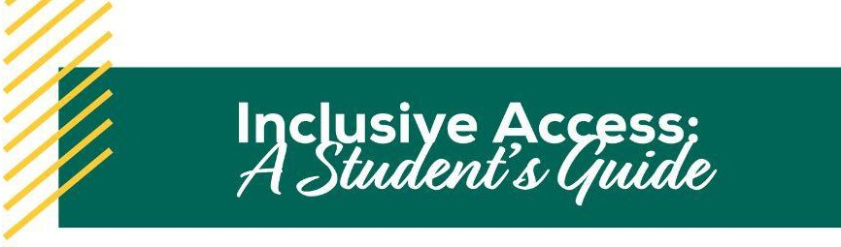

WHAT IS INCLUSIVE ACCESS (IA)?
Farmingdale State College’s Inclusive Access (IA) program ensures that you have immediate access to required course materials on the ﬁrst day of class and at the lowest price possible. You will access your digital course materials directly inside your Brightspace course.

PAYING FOR INCLUSIVE ACCESS COURSE MATERIALS
If your instructor chooses to add course materials to the IA program, you will automatically be opted into the program. Charges will appear on your student account before the start of your classes.
The price varies upon the materials your instructor uses, but IA materials are less expensive than purchasing directly from the publisher or other vendors. You will receive an email with information on which classes are part of the program and how much you will be charged for each material.

OPTING OUT OF THE PROGRAM
If your course is participating in IA, you will be automatically opted into the program, but participation is optional. If you do NOT wish to participate, you have 14 days after the start of your class to opt out and have the charges reversed from your account. You can opt out by accessing the “Course Materials by eCampus” link in your Brightspace course. The Student Accounts Office will be notified and the charge will be reversed from your account.
Please note that if you opt out of the IA program, you will no longer have access to the required course materials through the link in Brightspace. You will be expected to purchase materials elsewhere.

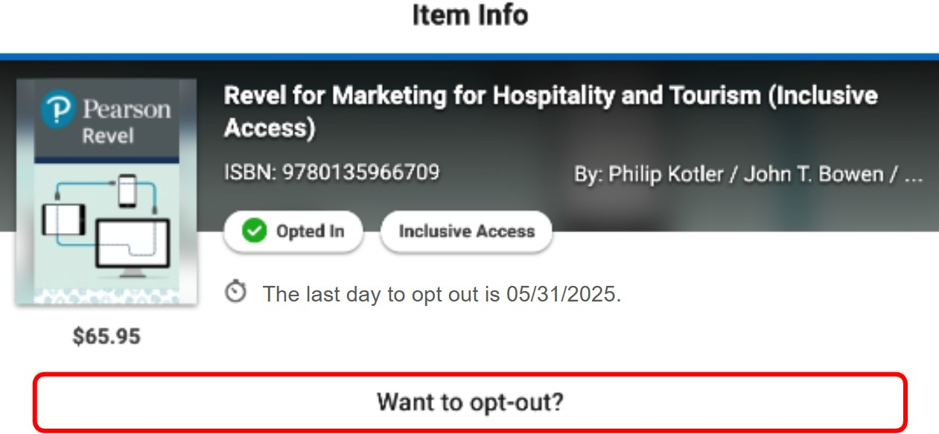
If you are unable to locate the “Want to opt-out?” option, please email iasupport@ecampus.com and include your course information.

CAN I OPT BACK INTO THE IA PROGRAM IF I CHANGE MY MIND?
You can easily opt back into the IA program within the ﬁrst 14 days of your class. If you need to opt back in, navigate to the “Course Materials by eCampus” link found in your Brightspace course and select the “Opt-In” option.

ACCESSING IA MATERIALS
The process to access your material varies slightly depending upon whether your instructor has chosen an eBook or courseware.

To avoid access issues or being prompted for further payment, please make sure you follow the steps below and use the links within your Brightspace course to access the content.

eBooks
- Navigate to your course in Brightspace.
- Locate and select the Course Materials by eCampus link within your course.
- Select Read Now to access the eBook in the Bookshelf eReader. The eReader will allow you to read, highlight, and take notes.
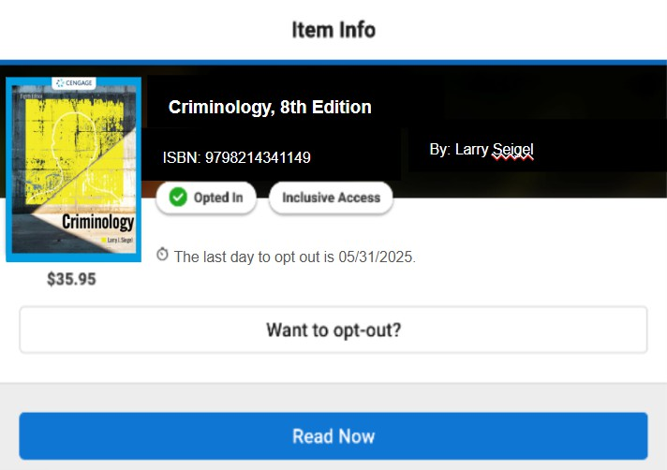

Courseware
- Navigate to your course in Brightspace.
- Locate and select the Course Materials by eCampus link within your course.
  - Codeless Access: Some courseware may not require an access code. In this case, you will access the courseware through a separate link in Brightspace. The Course Materials by eCampus link will only be used for opting out.
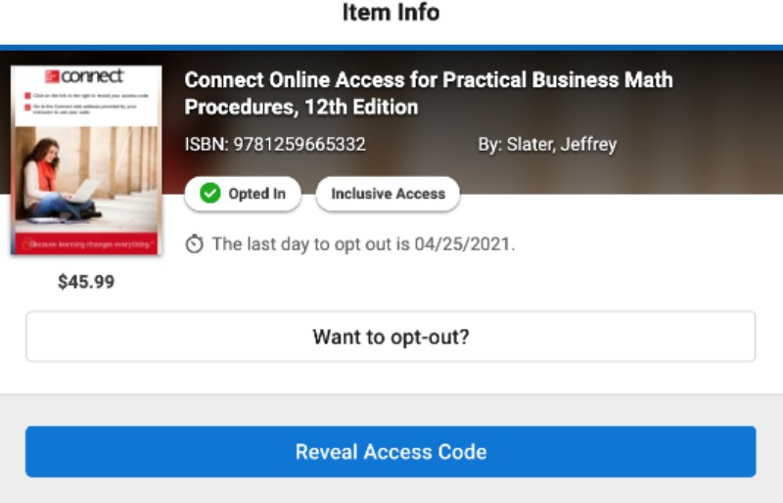
  - Access Codes: For courseware that requires an access code, select Reveal Access Code. You will then need to redeem that revealed code at the publisher’s website provided in your Brightspace course.
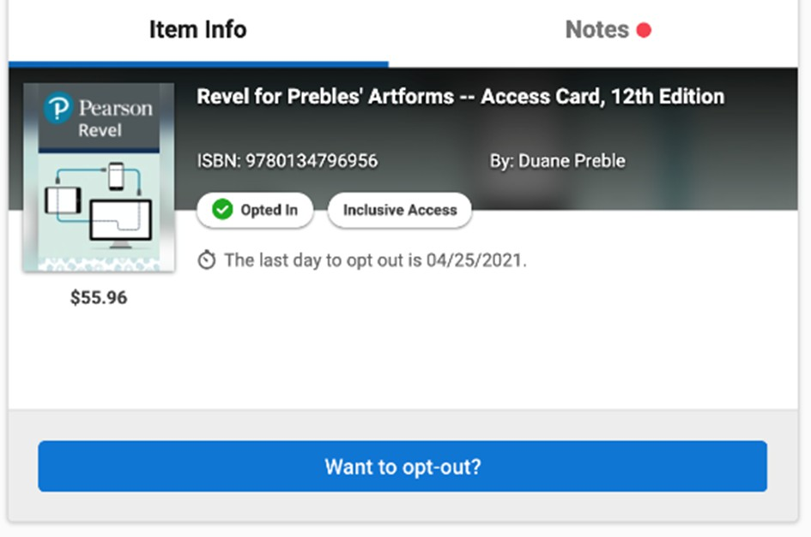
To avoid access issues or being prompted for further payment, please make sure you use the above instructions and access materials through your Brightspace course.

COMMON TROUBLESHOOTING TIPS
- Students will sometimes attempt to access their material directly through publisher websites. For IA material, you must use the links in Brightspace.
- Occasionally device and/or browser settings will prevent students from accessing materials. Recommendations include trying a different browser, clearing cache/cookies, restarting the device, or possibly using a different device.
o For Apple devices, please make sure that “Cross-site tracking” and “Allow tracking cookies” are enabled (especially for vitalsource.com).
- Sometimes students will use the same material in class that they used in a previous term and may receive notice that their access has expired. If this is the case, please contact IA Support at iasupport@ecampus.com.

INCLUSIVE ACCESS SUPPORT
If you have questions or would like more information about the Inclusive Access program, please email us at iasupport@ecampus.com.

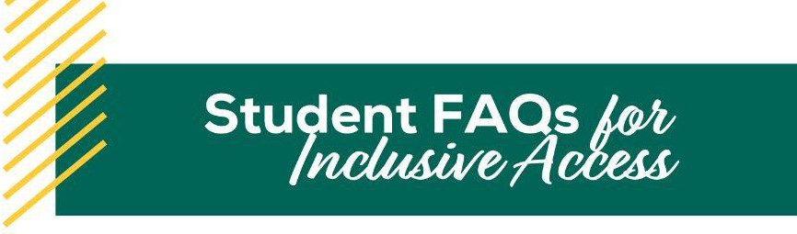

WHAT IS INCLUSIVE ACCESS (IA)?
Farmingdale State College’s Inclusive Access program ensures that you have immediate access to required course materials on the ﬁrst day of class and at the lowest price possible. You will access your digital course materials directly inside your Brightspace course.

HOW DOES INCLUSIVE ACCESS BENEFIT ME?
- You’ll save money! IA is the most cost-effective solution for students.
- You’ll have easy, immediate access to the correct course materials before the ﬁrst day of class.

HOW DO I KNOW IF MY COURSE USES INCLUSIVE ACCESS?
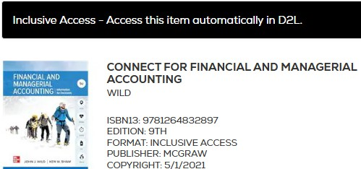
Courses that use Inclusive Access materials will have a notation on the course’s bookstore listing. The notation will indicate if materials are part of the IA program. Additionally, you will receive an email about a week before classes start that will inform you which of your courses are participating in the program.

HOW/WHEN DO I PAY FOR INCLUSIVE ACCESS MATERIAL?
If your instructor chooses to add course materials to the IA program, you will automatically be opted into the program. Charges will appear on your student account before the start of your classes. However, participation is optional and you may choose to opt out of the IA program. Please see the section titled “How do I opt out of IA?” for instructions on opting out.

HOW MUCH WILL I BE CHARGED FOR THE MATERIAL?
The price varies upon the materials your instructor uses, but IA materials are less expensive than purchasing directly from the publisher or other vendors. You will receive an email with information on which classes are part of the program and how much you will be charged for each material.

HOW DO I ACCESS THE IA MATERIAL?
To access the material, you will need to login to Brightspace, access your course, and locate the course materials link. To avoid access issues or being prompted for further payment, please make sure you use the access materials through your Brightspace course. If you are unable to locate the link to your materials, please contact your instructor.

HOW DO I OPT OUT OF INCLUSIVE ACCESS?
If you do not wish to participate in Inclusive Access, you must opt out within 14 days after the start of your class to have the charge(s) reversed from your account. You can opt out by accessing the “Course Materials by eCampus” link found in your Brightspace course.

If you are unable to locate the “Want to opt-out?” option, please email iasupport@ecampus.com and include your course information.

Please note that if you opt out of the IA program, you will no longer have access to the required course materials. You will be expected to purchase materials elsewhere.

CAN I OPT BACK INTO THE IA PROGRAM IF I CHANGE MY MIND?
You can easily opt back into the IA program within the ﬁrst 14 days of your class. If you need to opt back in, navigate to the “Course Materials by eCampus” link found in your Brightspace course and select the “Opt-In” option. The IA charge will be re-assessed to your account.

WHAT ARE PRINT UPGRADES?
Print upgrades are specially priced print versions of textbooks that are provided as optional add-on purchases to your Inclusive Access materials. While IA materials are provided through Brightspace and are typically paid for through fees included with tuition, print upgrades are purchased directly through Farmingdale State College’s bookstore website.

Please note that print upgrades cannot be used to replace Inclusive Access materials.

WHAT HAPPENS IF I DROP AN IA COURSE?
If you drop a course that was participating in the Inclusive Access program, your student account will be refunded according to the Farmingdale State College’s refund policy.

I HAVE MORE QUESTIONS. WHAT SHOULD I DO?
We are happy to help! The eCampus Inclusive Access support team can be reached by email at iasupport@ecampus.com.

