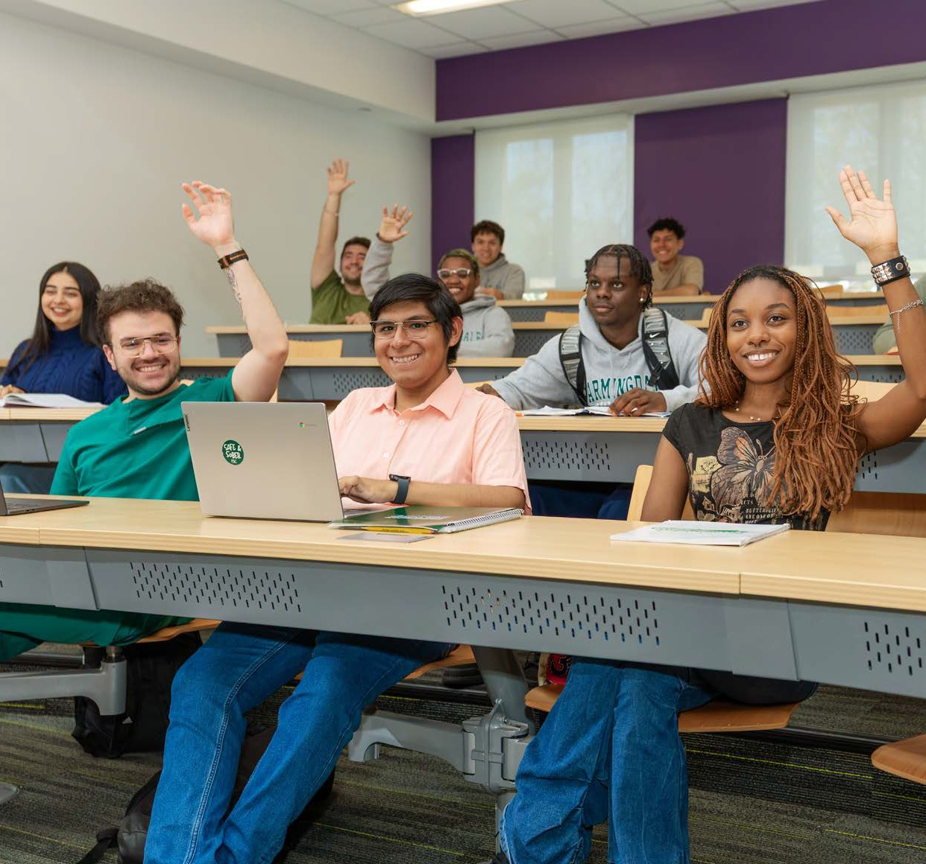

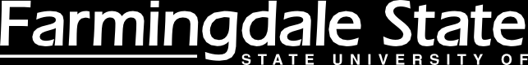



ANNUAL REPORT TO SUNY
2025 – 2026

FARMINGDALE STATE COLLEGE 2350 BROADHOLLOW ROAD, FARMINGDALE, NY 11735 934-420-2000 FARMINGDALE.EDU

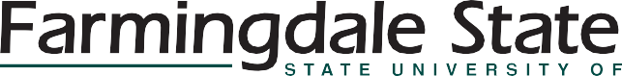

FSC Summary
Farmingdale State College had a record-breaking enrollment at the start of the 2025-26 academic year breaking 10,400 students. The growth
in enrollment, in the face of the Long Island “enrollment cliff”, represents an institution that offers a high-quality education, a caring faculty, applied learning, and strong career focused results. New curriculum, new degrees, new opportunities define the college. The growth of scholarship, extended education, and collaborations with industry and community, defines the aspirational goals of the College.
Organization: Farmingdale implemented several organizational realignments to optimize campus functions and support executive leadership. The college appointed Joakim Nyoni as Vice President for Development and Alumni Engagement, subsequently rebranding the office as the Division
of Institutional Advancement. Oversight for Sponsored Programs and Research Administration was shifted to Academic Affairs to better support faculty. Additionally, student advising operations were consolidated into a comprehensive advising center slated for a new facility in 2027. To ensure strong continuance in serving our students we announced two important transitions: Michael Nembhard moved from Dean of Students to Acting Executive Director of Diversity, Equity,
and Inclusive Excellence. Frank Rampello moved from Assistant Dean of Students to Acting Dean of Students. After an extended search we hired Alice Diaz-Bonhomme as Director of Research and Sponsored Programs. And to ensure best practice and approach to our upcoming Middle States reaccreditation effort, we brought Karen Gelles on
as Associate Provost. Other new hires or transitions are noted on the table below:



FARMINGDALE STATE COLLEGE NEW HIRES AND TRANSITIONS

Title | First Name | Last Name | Department
Director of Strategic Enrollment Initiatives | Noe | Escobar | Enrollment Management
Director of Career Development - Nexus Center | Cheryl | Stratigos | Nexus Center
Director of Academic Affairs Administration | Michael | Londis | Academic Affairs (Provost)
Director of Campus Mental Health Services | Shane | Owens | Campus Mental Health Services
Flight Center Director | Janie | Daly | Aviation Flight Line
Executive Director of LIEOC | Anne Marie | Armstrong | Dean of LIEOC
Dean of Extended and Experiential Learning | Dylan | Gafarian | Extended and Experiential Learning
Director of Research and Sponsored Programs | Alice | Diaz-Bonhomme | Office of Research & Sponsored Prog. Dev.

External Facing/Partnerships: Over a year ago we created two advisory boards, a Community Advisory Board and a Corporate Advisory Board. After a year with both Boards active the decision was made to bring the two Boards together as a
single President’s Advisory Board. The fusion brings
a much more dynamic discussion to the table and creates the potential for new, blended approaches supporting our College. In addition, we added six new members (bold faced in the table below) to the now single Board to round it off at a total of
22 members.

FARMINGDALE STATE COLLEGE PRESIDENT’S ADVISORY BOARD

Name | Title | Home Company / Agency
Kara Cannon | Executive Director | Tesla Science Center at Wardenclyffe
Madeline A. Quintyne-McConney | Chief Diversity, Equity and Inclusion Officer | Town of Babylon
MaryAnn McKeever Alfieri | Vice President R&D Analytical Science & Chemistry | The Estée Lauder Companies
Stuart B. Almer | President and Chief Executive Officer | Gurwin Healthcare System
Karen Boorshtein | President & CEO (ret.) | Family Service League
Michael J. Cinque | General Manager | Curtiss-Wright, Target Rock
Paul Defendini | Superintendent | Farmingdale School District
Ralph Ekstrand | Mayor | Village of Farmingdale
Richard E. Feinbloom | President and Chief Executive Officer | Designs for Vision, Inc.
Steven Gentile | President and Co-Owner / Founder and President | L.I. Adventureland / Adventureland's Helping Hands Foundation
George Gorman | LI Regional Director | NYS Office of Parks, Recreation and Historic Preservation
Stephen Hicks | President | Hicks Nurseries
Joseph Lamantia | Executive Vice President and Chief Strategy and Growth Officer | Catholic Health Long Island
Vanessa Lockel | Executive Director | Cornell Cooperative Extension of Suffolk County (CCE Suffolk)
Christa Lucarelli | Director | Farmingdale Public Library
Serena Martin | Executive Director | New Hour for Women and Children LI
Carla E. Simpson | Founder and Principal | SIMPCo Properties, LLC
Vanessa Baird-Streeter | President & CEO | Health & Welfare Council of Long Island
John Sullivan | Senior Vice President | Skanska, USA Civil
Errol D. Toulon, Jr. | Sheriff | Suffolk County
Michael F. Voltz, | Director, Energy Efficiency and Renewables (ret.) | PSEG Long Island
Bill Zalakar | Executive Director | Long Island Farm Bureau

Our College Council has also undergone some transition. With the Governor focused on reviewing term limits for Council membership, and after many years of outstanding leadership, Dr. Patricia Hill Williams, stepped down as Chair. The new chair is Randi Shubin Dresner, CEO of Island Harvest and
a good friend of Farmingdale State. Also joining the Council is Natalie Ryan, Senior Manager of Government Relations & Corporate Affairs at Henry Schein, Inc. and the Chair of our Student Government Association, Laiba Idrees. Examples of external leadership among members of our Farmingdale State community can be found in Appendix I.
We’ve grown partnerships, collaborations and shared events with Adventureland, PSEG, FourLeaf, H2M, Catholic Health, Gurwin Health, Curtis Wright, Estee Lauder, Taste Long Island Events, and Island Harvest. Importantly many companies continue to support our student interns across Long Island.
Strategic Plan: After several meetings with faculty and staff, cabinet deliberations, and input and guidance from the Committee on Planning and Resource Allocation, we will wrap up the current “Eight for ‘28” strategic plan in June 2027 and launch a new plan, FSC 2030, in Fall 2027. FSC 2030 will be a streamlined with no more than 5 major goals, three-year timelines, and small teams working on the realization of each goal.
Budget: A very tight budget required a reduction of 11% in OTPS. This allowed us to maintain a balanced budget. Historic extensive hiring (correlated with the large covid funds made available as one-time funds by the Federal Government), while good for the campus, created a budget that would clearly force use of reserves going forward. With recent contractual raises, inflation, and ongoing flat tuition, the ability to retain a balanced budget, without serious additional income, will be unlikely.
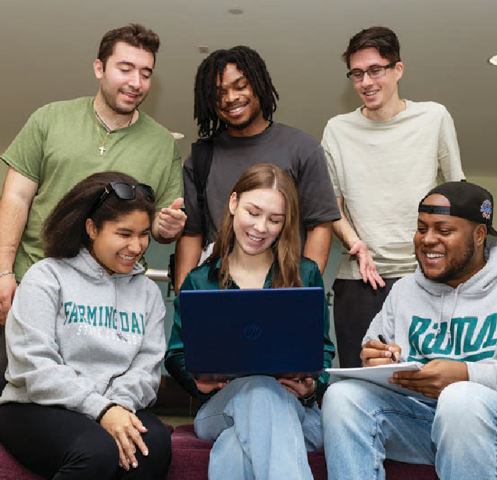

RECENT GRANTS AWARDED

Faculty | Department | Subject | Funding Source | Amount
Nur Dean Xiaojin Ye | Computer Systems | Enhancing Critical Thinking | NSF | $164,178
Megan Henriquez | Biology | Hormones, immunity, and parasitism | Leakey Foundation | $23,508
Svetlana Tlupova | Mathematics | Approaches to solving Multiphysics problems of fluid-porous flow | NSF | $166,323
Wei Shi | Professional Communications | Japan Student Travel Program | Social Science Research Council in conjunction with the Japan Foundation | $32,500

GRANTS IN REVIEW

Faculty | Department | Subject | Funding Source | Amount
Kerry Lutz | Biology | CRISPR/Cas9 for RNA-Guided Engineering of Chloroplast Genome | NSF | $130,407
Baris Cakmak | Physics | STEM Workforce Development in Physics Education for Quantum Computing | NSF – subaward | $95,579
Marj Issapour | Electrical and Computer Engineering | Pathway to Technical Readiness | US DOE | $1,149,416
Betty Feng | Business Management | NSF – IUSE | NSF | $394,644
Carly Tribull | Biology | Parasitic Wasp Study | NSF –Subaward | $253,533
Amanda Shore | Biology | NSF – CAREER – From Wastewater to Wildlife | NSF | $827,979
Jobeda Khanam | Electrical and Computer Engineering | NSF - CAREER - Advancing Multimodal AI for Clinical Decision Intelligence | NSF | $524,922

Enrollment has been strong with over 10,050 students enrolled early in Fall 2025. Efforts across campus has achieved a record enrollment in Fall 2026 of 10,395 (prior to census). Retention has grown from 81.5% inf Fall 2025 to 83.0% in Fall 2026.

Scholarship and Grants: Over 16 external grant proposals were submitted with, to date four funded (including two from NSF) and seven still in review. Total grant dollars requested approached $6M.

Academic Affairs
Current Undergraduate and Graduate Programs: Farmingdale State College (FSC) offers 41 baccalaureate, 5 associate degree, and 3 graduate degree programs. Overall student enrollment has continued to expand, reaching over 10,050 students in Fall 2025.
New and Revised Proposed Programs: The college revamped its academic proposal workflow to require dedicated market analyses and business models before introducing new offerings.
Scheduled launches include Applied Physics (B.S.), Public Administration and Policy (B.S.), and a
revised Construction Management (M.S.) in Fall 2026, followed by M.S. in Quality Assurance and Regulatory Affairs in Spring 2027 and Healthcare Administration (B.S.) in Fall 2027. Lower-enrollment degrees, such as Cybersecurity, Urban Horticulture, Applied Geography and Geospatial Science, and Artificial Intelligence Management, are actively being updated to expand appeal. Additionally, several engineering and criminal justice degrees are currently undergoing formal review at SUNY.
Student Success Efforts: Although a $3 million federal DOE grant for the EMERGE program was canceled in September 2025, college support sustained operations, allowing the program to assist over 200 students and develop new first-year experience (FYE) courses for Fall 2026.
FSC is also aligning operations with the SUNY Academic Momentum Campaign launched in Fall 2025. Campus performance metrics show current retention rates at 75.2% for associate programs and 83% for bachelor programs, compared to targets of 83.1% and 87.2%, respectively. Four-year graduation rates for bachelor’s degrees sit at 41% against a 43.3% target.

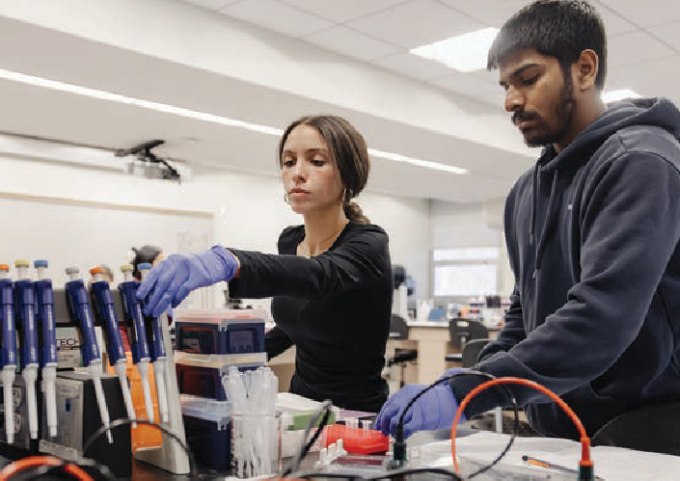

Post-Graduate Survey Results Data: From
2024–2025 graduates six months after completion reflected a tougher overall job market despite steady employment and continuing education
figures. While more students secured pre-graduation employment and starting salaries around $60,000, drops occurred in degree-related employment and career preparation satisfaction. In response, FSC
is expanding internship opportunities, integrating earlier career planning into FYE courses, and creating specialized microcredentials.
Continuing Education and Workforce Development: FSC issued 364 microcredentials in the past academic year—a 69% increase—driven largely by the Direct Support Professional (DSP) initiative in partnership with the NYS Office for People with Developmental Disabilities. The college identified seven existing microcredentials for potential Federal Workforce Pell funding eligibility. Additionally, select credentials in Computer Aided Design and Surveying were reviewed for upcoming SUNY Clean Energy grant opportunities.
Division of Extended and Experiential Learning: Led by Dean Dylan Gafarian, the newly established division unifies pre-college programs, professional education, undergraduate research, lifelong learning, and interinstitutional partnerships. The new Office
of Professional and Continuing Education (PaCE) successfully delivered non-credit corporate and technical training in areas like PSEG Data Awareness and CompTIA. Upcoming non-credit offerings will cover Project Management, AI applications, Certified Nursing Assistant credentials, and Craft Brewing.
Specialized Accreditation: The School of Engineering Technology highlighted its year with
major ABET accreditation achievements. Seven Bachelor of Science programs successfully secured re-accreditation, including Architectural, Civil, Computer, Construction Management, Electrical, Manufacturing, and Mechanical Engineering Technologies.
Furthermore, the Bachelor of Science programs in Computer Science and Computer Security Technology earned initial ABET accreditation.
Faculty Scholarship and Creative Activity: Faculty contributions expanded across disciplines, with journal article authorship growing to 174 publications compared to 164 in the previous year. Increases were also recorded in book publications (10), conference proceedings (54), artistic performances or exhibits (26), and total conference presentations (390).
The School of Arts and Sciences led scholarly outputs with 82 journal articles and 185 conference presentations.
Greenley Library: While overall circulating physical item volume experienced a slight 1% dip, technology borrowing saw gains, including a 7% increase
in laptop checkouts. Librarians delivered 142 Information Literacy instructional sessions reaching 3,068 students, and their online tutorial videos gained substantial global viewership. Technology assistance and facility operational inquiries increased by 10% to 20%, whereas interlibrary loan requests decreased by 10%.
The Library provided faculty and student support regarding open-access publishing, copyright, and grant development. Since October 2025, the Open Access Publishing Support initiative reviewed 14 requests and awarded $16,892 in funding across six applicants. Multiple faculty members also received 2026 Innovative Instruction Technology Grants (IITG) and Open Educational Resources
(OER) funding for projects focused on AI integration and course resources.
University in the High School: The University in the High School (UHS) program partnered with 96 regional high schools across Long Island, New York
City, and Westchester. Over 7,500 unique high school students registered for dual enrollment, completing more than 35,000 credit hours. FSC remains the only four-year SUNY institution accredited by the National Alliance of Concurrent Enrollment Partnerships.
Looking Forward: (Recommendations for Action) FSC plans to strategically expand its academic

degree portfolio using market data to match regional employment demands. The Office of Research

and Sponsored Programs will launch workshops and submission incentives to elevate faculty grant proposals and external funding. The institution will also deepen industry partnerships, build career-
focused degree maps, update curricula, and formally integrate artificial intelligence guidelines into teaching and campus operations.

Student Support, Programs and Development
Marking its first full year back as a unified team, the Division focused on strengthening student support, enhancing campus experience, and building cross-college partnerships. Key accomplishments included creating a Basic Needs Team to address issues like food insecurity, taking over overall responsibility
for Commencement, revamping New Student Orientation, and prioritizing campus accessibility and ADA compliance.
Commencement: FSC celebrated a record 2,053 graduates, with 1,518 participating in a ceremony featuring new traditions, including student school banner carriers, custom regalia, and performances of the College Alma Mater. Special honors were
conferred upon Grand Marshal Lloyd Makarowitz and honorary degree recipient, major donor, and alumnus Murray Pasternack.
Student Recognition: Five Farmingdale students—Jannet Baires, Bryan Cox, Raymond Howard, Natasha Jones, and Joseph Rodriguez—were awarded the SUNY Chancellor’s Award for Student Excellence (CASE), the highest student honor bestowed by the system.
Athletics: Supporting 18 athletic teams and 349 student-athletes, FSC claimed its sixth Skyline Conference Presidents Cup and secured five conference championships. Student-athletes achieved an average 3.01 GPA, earned numerous individual academic honor roll awards, and completed mandatory community service initiatives throughout the year.
Campus Food Pantry: Management shifted to Student Affairs and adopted the Plentiful software system to streamline inventory and check-in procedures. Supported by 35–45 volunteers and Empire State Service Corps interns, the pantry
recorded 5,426 visits across 157 students and 77 faculty/staff members, introducing new cafeteria meal supports and grocery vouchers in early 2026.
Campus Recreation and Club Sports: Campus Recreation engaged thousands of students via the Esports Arena (2,010 sign-ins), intramural sports (1,419 participants), and 15 active club sports. Notable milestones included a third-place
national championship finish by the cheer team and successful high-attendance events like Glow in the Dark Bowling and adaptive wheelchair basketball.
Dean of Students Office: Serving as a hub for Residence Life, Student Conduct, Advocacy, and Case Management, the office launched the
centralized online Basic Needs Hub and advocated for student food-security resources with Island Harvest. Additionally, the Student Advocate gained certification as a Mental Health First Aid Instructor, and the office monitored campus-wide Sexual Harassment Prevention training compliance.
Residence Life: Campus housing reached record occupancy, growing from 418 students in Fall 2021 to 580 in Fall 2025, while maintaining fiscal stability. Key operational enhancements included installing ADA-accessible furniture, upgrading residence hall fire alarms, implementing new Student Assistant desk staffing models, and holding regular student town halls with leadership.
Large-Scale Programming: The Dean of Students and Residence Life offices executed high-impact campus events, including a revamped New Student and Family Orientation that yielded a 90% participant confidence rating. Major programming included an evening with Gaten Matarazzo (star in
Stranger Things) (1,500+ attendees), a Day of Service fireside chat with Olympians Aly Raisman and Laurie Hernandez, educational speaker events for Domestic Violence Awareness and Take Back the Night.
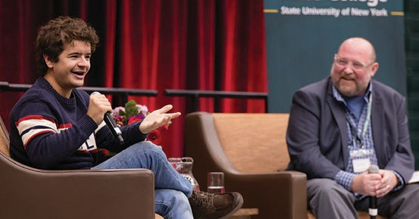

Disability Services Center (DSC): Student registrations hit a peak of 930 students—a 30% increase over four years—driven by earlier diagnoses and reduced stigma. Alternate testing requests surged by 19% to 3,206 appointments, prompting the DSC to expand specialized orientation programs and workshops.

Health and Wellness Center: The center recorded 3,487 patient appointments during the academic year, reflecting minor routine volume fluctuations. Operations ran smoothly with no out-of-the-ordinary health issues reported across the student body.
Campus Mental Health Services: Campus Mental Health Services delivered over 2,000 individual appointments, responded to after-hours crises, and conducted ~850 consultations while addressing
an increase in executive functioning and autism spectrum cases. Highlights included training staff as Mental Health First Aid instructors, co-hosting major guest speakers, and upgrading virtual reality therapy services for specific psychological disorders, earning them the 2026 Insight into Academia Award.
Student Activities: Supporting 64 active organizations and approving seven new ones, the office oversaw 1,503 student-run events (a 22.5% increase) and hosted roughly 100 departmental programs. The annual RamChella festival drew record attendance of 2,448 participants featuring headline performers Jay Sean and Big Sean.
Fraternity and Sorority Life: Membership grew 6% to 335 active members across eight chapters, with 168 new members joining during the year. The community raised $56,257 for philanthropic causes, collected over 71,000 pounds of food, and reported a 92% member satisfaction rating in internal assessments.
Student Government Association: The Student Government Association maintained strong student representation with
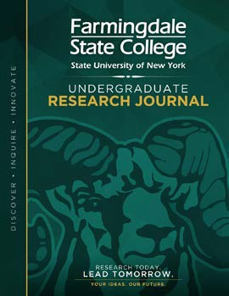

16 filled Senate seats, actively serving
on various shared governance committees and representing FSC at SUNY Advocacy
Day. They expanded financial backing to several academic and student support centers, and gifted new fitness equipment to the campus gym
President’s Student Advisory Council: The President’s Student Advisory Council was created in early 2025 with 10 founding members “hand-picked” by Student Affairs and the President. This
Council brought concerns and ideas to the President for discussion during meetings that are scheduled for every three weeks. One of the major initiatives driven by this Council is a new, peer reviewed Undergraduate Research Journal, a competitive site for sharing FSC student research.
Veterans Services: Serving 198 military-affiliated students, the office processed over $807,000 in VA benefits and expanded textbook exchange programs. Key strategic moves included launching a Veterans Hiring Pipeline with major employers,
offering research internships, and running geofenced digital marketing campaigns targeting military bases.

Enrollment Management
Enrollment Position: Farmingdale State College has achieved a strong post-pandemic recovery, reaching a pre-census total of 10,395 students for fall 2026 and surpassing its goal of 10,200. This progress reflects an 11.6% growth in total enrollment since fall 2022, driven by coordinated recruitment, yield, and financial aid strategies. As the institution transitions from recovery to sustainable growth, the strategy must balance attracting new cohorts with improving retention, diversifying geographic markets, and expanding graduate and online programs. Future success requires aligning this growth directly with campus infrastructure, housing, classroom capacity, staffing, and academic program development.
Applications, Acceptances, and Enrollment Funnel: While Farmingdale’s top-of-funnel applicant pool has expanded significantly over the last five admission cycles, overall yield rates have simultaneously declined. Consequently, application volume is no longer considered a sufficient singular metric for recruitment performance. The primary operational shift for 2026–27 focuses on converting existing demand into enrolled students through personalized communication, earlier engagement, financial aid coordination, and targeted interventions. Utilizing

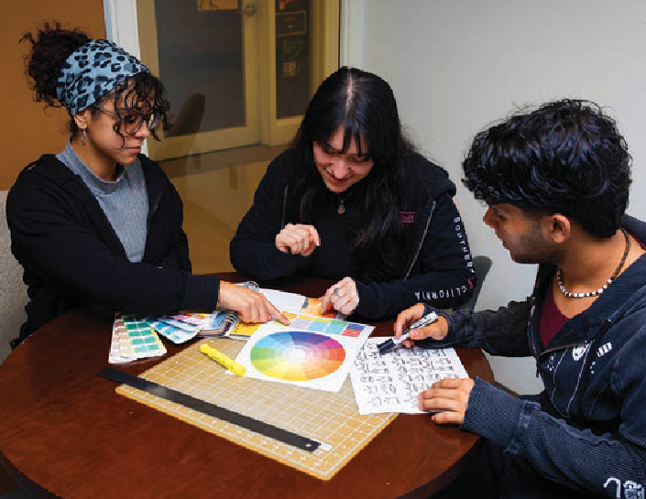
predictive enrollment data will allow the college to identify disengagement points and improve conversion rates from initial interest to final registration.
Recruitment, Market Development, and Enrollment Operations: While traditional primary markets like Nassau, Suffolk, and local community colleges remain strong, regional K-12 population declines present long-term risks that necessitate selective geographic expansion. The college aims to
expand into New York City, northern New Jersey, Connecticut, and the Mid-Hudson Valley through program-driven, ROI-focused digital marketing campaigns. Additional growth avenues include expanding tiny graduate program shares (0.4% in fall 2025) and scaling campus housing beyond its current 600-bed capacity to support non-local recruitment.
Retention and Student Success: Retention is recognized as a vital component of long-term enrollment, with the fall 2024 first-time, full-time bachelor’s cohort reaching an 83.0% one-year retention rate toward an 85.0% institutional goal. Proactive student success mechanisms—such as redesigned Early Alert systems—are being integrated with academic advising, financial aid, and student support services. These retention efforts align with the SUNY Academic Momentum Campaign and the college’s participation in the ACE program, which prioritize gateway course completion, and eliminating completion gaps. Moving toward the 85% retention goal will directly enhance student outcomes while reducing reliance on new student recruitment.
Strategic Priorities for 2026-27 and Beyond: Farmingdale’s immediate priority is preserving a final fall 2026 census enrollment above 10,200 students while optimizing the enrollment funnel. Strategic objectives for 2026–27 include increasing first-year retention to at least 84%, boosting admit-to-deposit conversion, protecting transfer pathways, and formalizing dedicated infrastructure for graduate recruitment. Future growth targets will be strictly tied to holistic assessments of physical and operational institutional capacity, including faculty staffing, housing, and course availability. Ultimately, the college is implementing a Strategic Enrollment Management framework to connect recruitment, retention, and academic planning into a sustainable long-term model.

Marketing and Communications
Operating under reduced advertising budgets, Marketing and Communications pivoted toward high-impact strategies, expanding organic social media, public relations, and government relations. Key accomplishments included integrated launch plans for four new academic programs, an in-house custom website redesign, updated brand guidelines, and the development of new request intake and digital asset management workflows.
Academic Initiatives: MarCom supported the launch of several academic degree tracks, including Public Administration, Applied Physics, Construction Management, and Quality Assurance and Regulatory Affairs. Multi-channel promo plans (such as press releases, search ads, and magazine features) helped highlight how FSC’s curriculum aligns with regional workforce demand.
Advertising and Marketing: Targeted advertising generated over 20 million impressions across bus transit, regional malls, billboards, digital campaigns, and local print publications. Despite impression counts decreasing due to budget cuts, marketing maintained targeted reach using student stories, authentic quotes, and brand video campaigns.
Social and Digital Media: Prioritizing authentic campus experiences yielded major follower growth on Instagram (+21.8%) and LinkedIn (+11.8%). High-performing content focused on major campus traditions, mascot competitions, and high-profile visits from guests like Gaten Matarazzo.

Campus Events: Integrated marketing campaigns were deployed to maximize engagement across key institutional events, including Homecoming, Convocation, Commencement 2026, and high-profile guest speaker series. Continual tracking of

website traffic and registration metrics helped refine outreach strategies per event.
External Outreach & Media Successes: Targeted media coverage rose 16% year-over-year, highlighted by gains in Newsday (up 18%) and News12 (up 7%). Topics driving media attention included economic impact reports, faculty expert commentary on aviation and policy, and NYC television/radio broadcasts.
Government Relations: The department conducted over two dozen meetings and events with government officials and regional groups, securing vital land lease legislation passage and advocacy for operating aid. Highlights included a record-setting Legislative Breakfast with over 100 leaders and delegations sent to Washington D.C. and Albany.
Website & Analytics: The team completed an in-house homepage overhaul featuring card layouts, custom CSS animations, and a dynamic “theater” video section, leading to a 19% increase in views. Additional updates included redesigned Future Students/Parents portals, a new library of CMS training videos for staff, and strict compliance with digital accessibility standards.
Digital Communications Enhancements: Overhauls were applied to the official campus publication FSCToday, improving mobile readability for over 12,000 recipients. MarCom also custom-coded an internal publishing engine within the CMS to launch Ram-Bo’s Rundown, a dedicated monthly Student Affairs newsletter.
Design and Production: Functioning as an internal creative agency, the design team fulfilled 385 projects across print, digital, and environmental formats, saving the college significant agency fees. The team earned six professional design awards from SUNY CUAD and the Educational Advertising Awards.
Media Production: The team completed 10 major institutional video projects, provided video/photo coverage for more than 110 events, and developed a searchable Digital Asset Management (D.A.M.) system to centralize and share visual assets efficiently.

Institutional Advancement
Rebranded from the Division of Development and Alumni Engagement, the Office generated over
$5 million in total revenue, increasing assets under management to $24.5 million. Over $1.5 million in scholarships was awarded to 621 students, and the Foundation secured $3.6 million in new gifts and pledges—making FY2026 the strongest fundraising year on record without a single transformational gift. Key wins included launching the “Farmingdale Fund” annual giving program and the “I Heart Farmingdale” day of giving ($170,000 raised).
To achieve the $4.0 million target for FY2027 across 1,718 projected donors, the report segments contributions across Leadership/Major Gifts ($1.4M
/ 35%), Corporate & Institutional ($750K / 19%),
Mid-Range Annual ($600K / 15%), Mid-Level Annual ($450K / 11%), Farmingdale Fund (<$1K) ($350K
/ 9%), Alumni Events ($250K / 6%), and Realized Planned Giving ($200K / 5%).
Modeling three distinct scenarios for future growth, the recommended Base Case targets cumulative contributions of $31.8 million through FY2031 (scaling from $4.0M in FY27 to $9.0M in FY31). Key base-case assumptions rely on core repeatable revenue growing at a 15% CAGR, converting multi-year corporate sponsorships, and improving annual donor retention from 55% to 65%.

Financial Overview
Farmingdale State College maintains a strong overall financial position supported by stable fall 2025 enrollment and continued New York State resources. Despite reaching record spending levels of $116.4 million, the college achieved an $800,000 operating surplus and improved its cash position by
over $7 million. However, a new collective bargaining agreement poses severe future financial challenges, adding over 20% to payroll costs over the next
five years. To ensure long-term solvency, college leadership emphasizes the need for a rational tuition plan to offset rising operational expenses.

Sponsored Programs Administration
Despite federal funding freezes and program eliminations affecting sponsored research, faculty submitted a record number of grant proposals.
Notably, the college secured two National Science Foundation grants in a single academic year for the first time in its history. FSC’s financial standing


with the Research Foundation remains robust. Moving forward, the college plans to leverage facilities and administrative cost recoveries to fund faculty startup packages, proposal incentives, and academic programs.

Facilities and Infrastructure
The college is currently overseeing more than $500 million in active capital construction, design, and planning projects. Key initiatives include major building renovations such as Roosevelt Hall, Sinclair Hall, and Thompson Hall, alongside the new $75 million Computer Sciences Center. Infrastructural upgrades are also progressing, including an $11 million Welcome Center, a $13.5 million Campus Commons, and a $38 million overhaul of the campus steam distribution system. Additionally, the college is finalizing the purchase of five new training aircraft for nearly $3 million to support the aviation program.

Campus Safety and Security
The University Police Department increased its community involvement across campus events and residence halls to foster a safe environment. Emergency protocols were updated, and 80 new AEDs were deployed across multiple facilities to replace aging units. The department expanded regional collaboration by establishing a standardized Honor Guard program alongside neighboring SUNY campus police departments. Additionally, UPD secured a 19% increase in
Governor’s Traffic Safety grant funding to enhance local traffic safety measures.
Energy Conservation and Beneficial Electrification FSC continues to advance state energy mandates through LED upgrades, HVAC control improvements, and system maintenance across campus.
Participation in the CUNY “CampusCoach” data analytics program reduced energy usage by over 10% in three targeted buildings. Active participation in utility rebate programs generated over $200,000
in incentives last year. The college also hosted an EV Symposium and test-drive event to promote local electric vehicle adoption and clean energy strategies.

Sustainability
The Office for Sustainability executed several green campus programs, including its first campus-wide waste audit and the diversion of 1,100 pounds of mattress waste. Campus biodiversity was expanded through new native tree plantings and pollinator gardens, maintaining FSC’s Tree Campus USA and Bee Campus USA status. FSC hosted the statewide SUNY Sustainability Conference in June 2026, alongside the Long Island Green Jobs Summit and a dynamic Earth Week. Furthermore, the campus food garden produced and donated over 300 pounds of organic produce to the FSC Food Pantry.

Sustainable Transportation
Sustainable transit options expanded with the launch of “Ram Rides,” a new campus bike-share program funded by an $8,000 SUNY grant. The initiative provides students with accessible, active transportation alternatives across campus. FSC also organized Car-Free Day and a Sustainable Mobility Showcase to educate the community on alternative transit.

Corporate Partnerships
FSC is conducting an environmental review and evaluating partner developers for a proposed campus lacrosse facility. The college successfully secured land-lease legislation for an adjacent parcel, initiating an RFQ process for a project intended
to provide both public housing and new student housing. Additionally, FSC maintains a strong partnership with Estee Lauder through the Broad Hollow Bioscience Park, which delivers research space, student internships, and a $350,000 annual gift to the College Foundation.

DIVISION OF ACADEMIC AFFAIRS
- Current Undergraduate and Graduate Programs FSC has 41 baccalaureate, 5 associate degree and 3 graduate degree programs. Overall enrollment has continued to grow. In fall 2025, total enrollment reached 10,106 students. The table below illustrates enrollment figures for all current programs
(undergraduate and graduate) at Farmingdale State College over the last 5 years.

ENROLLMENT 5 YEAR TREND

 | Home Institution Student Count
Academic Program Name | Fall 2020 | Fall 2021 | Fall 2022 | Fall 2023 | Fall 2024 | Fall 2025 | Five Year Enrollm | Five Year % Change
Aeronautical Science: Professional Pilot | 79 | 95 | 71 | 80 | 117 | 132 | 53 | 67.1%
Applied Economics | 91 | 82 | 74 | 64 | 66 | 89 | -2 | -2.2%
Applied Geography and Geospatial Science | 12 | 20 | 20 | 22 | 19 | 20 | 8 | 66.7%
Applied Gerontology | 1 | 8 | 8 | 13 | 11 | 7 | 6 | 600.0%
Applied Mathematics | 48 | 36 | 38 | 30 | 40 | 26 | -22 | -45.8%
Applied Psychology | 199 | 163 | 179 | 185 | 179 | 209 | 10 | 5.0%
Architecture Engineering Technology | 177 | 167 | 174 | 199 | 203 | 211 | 34 | 19.2%
Artificial Intelligence Management |  |  |  |  | 20 | 51 | 51 | 100.0%
Automotive Engineering Technology | 3 |  |  |  |  |  | -3 | -100.0%
Aviation Administration | 151 | 153 | 169 | 180 | 214 | 218 | 67 | 44.4%
Bioscience | 336 | 287 | 275 | 247 | 205 | 192 | -144 | -42.9%
Business Analytics | 75 | 106 | 105 | 142 | 154 | 145 | 70 | 93.3%
Business Management | 1,320 | 1,218 | 1,125 | 1,093 | 1,144 | 1,175 | -145 | -11.0%
Civil Engineering Technology | 32 | 71 | 103 | 127 | 148 | 153 | 121 | 378.1%
Computer Engineering Technology | 167 | 141 | 117 | 104 | 99 | 103 | -64 | -38.3%
Computer Programming & Information Systems | 568 | 477 | 450 | 418 | 373 | 373 | -195 | -34.3%
Computer Science |  | 90 | 227 | 357 | 419 | 342 | 342 | 100.0%
Construction Management Engineering Technology | 213 | 165 | 124 | 99 | 128 | 143 | -70 | -32.9%
Criminal Justice - Law Enforcement | 173 | 151 | 143 | 147 | 182 | 190 | 17 | 9.8%
Criminal Justice: Law Enforcement Technology | 622 | 423 | 349 | 310 | 264 | 220 | -402 | -64.6%
Criminal Justice: Police, Courts, and Corrections | 107 | 232 | 291 | 316 | 325 | 321 | 214 | 200.0%
Cybersecurity | 103 | 117 | 132 | 137 | 156 | 173 | 70 | 68.0%
Dental Hygiene | 97 | 90 | 70 | 85 | 98 | 107 | 10 | 10.3%
Dental Hygiene (Day) | 56 | 60 | 70 | 66 | 52 | 53 | -3 | -5.4%
Electrical Engineering Technology | 185 | 166 | 145 | 170 | 196 | 226 | 41 | 22.2%
Facility Management Technology | 101 | 66 | 58 | 31 | 20 | 12 | -89 | -88.1%
General Horticulture | 21 | 20 | 22 | 24 | 20 | 19 | -2 | -9.5%
Global Business Management | 56 | 60 | 54 | 50 | 52 | 80 | 24 | 42.9%
Health Promotion and Wellness | 107 | 152 | 161 | 171 | 163 | 157 | 50 | 46.7%
Horticultural Technology Management | 55 | 64 | 68 | 60 | 60 | 57 | 2 | 3.6%
Interaction Design | 54 | 57 | 42 | 43 | 43 | 36 | -18 | -33.3%
Landscape Development | 15 | 22 | 18 | 24 | 14 | 11 | -4 | -26.7%
Liberal Arts and Science | 1,329 | 1,145 | 1,076 | 1,001 | 960 | 943 | -386 | -29.0%
Manufacturing Engineering Technology | 48 | 37 | 40 | 40 | 37 | 28 | -20 | -41.7%
Mechanical Engineering Technology | 295 | 272 | 278 | 291 | 308 | 314 | 19 | 6.4%
Medical Laboratory Science | 100 | 85 | 79 | 78 | 85 | 78 | -22 | -22.0%
Nursing | 260 | 282 | 293 | 305 | 324 | 322 | 62 | 23.8%
Nursing RN | 52 | 47 | 47 | 31 | 17 | 32 | -20 | -38.5%
Nutrition Science | 68 | 75 | 105 | 111 | 118 | 119 | 51 | 75.0%
Professional Communications | 200 | 186 | 183 | 167 | 168 | 170 | -30 | -15.0%
Science, Technology, & Society | 1,262 | 1,256 | 1,344 | 1,523 | 1,758 | 1,829 | 567 | 44.9%
Security Systems | 116 | 89 | 108 | 120 | 135 | 131 | 15 | 12.9%
Software Technology | 5 | 5 |  |  |  |  | -5 | -100.0%
Sport Management | 232 | 225 | 216 | 204 | 198 | 187 | -45 | -19.4%
Visual Communication: Art & Graphic Design | 167 | 50 | 14 | 2 | 1 |  | -167 | -100.0%
Visual Communications: Art & Graphic Design |  | 103 | 141 | 158 | 153 | 140 | 140 | 100.0%
Not In a Program | 486 | 366 | 349 | 391 | 457 | 402 | -84 | -17.3%
Grand Total | 9,844 | 9,182 | 9,155 | 9,416 | 9,903 | 9,946 | 102 | 1.0%

FASTEST GROWING PROGRAMS
Academic Program Name | Fall 2023 | Fall 2024 | Fall 2025 | Three Year Enrollment  Change | Three Year % Change
Aeronautical Science: Professional Pilot | 80 | 117 | 132 | 52 | 65%
Global Business Management | 50 | 52 | 80 | 30 | 60%
Construction Management Engineering Technology | 99 | 128 | 143 | 44 | 44%
Applied Economics | 64 | 66 | 89 | 25 | 39%
Electrical Engineering Technology | 170 | 196 | 226 | 56 | 33%
Criminal Justice - Law Enforcement | 147 | 182 | 190 | 43 | 29%
Cybersecurity | 137 | 156 | 173 | 36 | 26%
Dental Hygiene | 85 | 98 | 107 | 22 | 26%
Aviation Administration | 180 | 214 | 218 | 38 | 21%
Civil Engineering Technology | 127 | 148 | 153 | 26 | 20%

New and Revised Proposed Programs

FSC is committed to creating innovative degree programs. Over the past year, we redesigned the academic program proposal process to improve efficiency and effectiveness. The revised process now requires both a business model and market analysis prior to proceeding. Furthermore, we are collaborating with Enrollment Management and Marketing and Communications to provide better support for program launches.
In Fall 2026, we will introduce new offerings in Applied Physics (B.S.), Public Administration and Policy (B.S.), and a revised Construction Management (M.S.) program. In Spring 2027, we plan to launch our M.S. in Quality Assurance and
Regulatory Affairs. Additionally, we have received approval to launch a Health Care Administration (B.S.) program in Fall 2027. The college has also collaborated on revising programs with lower enrollment to make them more appealing, including updates in:
 Construction Management M.S. (formerly Technology Management) – Fall 2026
 Cybersecurity B.S. (formerly Computer Security Technology) – Fall 2027
 Urban Horticulture B.S. (formerly Horticulture Technology Management BTech) – Fall 2027
 Applied Geography and Geospatial Science B.S. (formerly Geographic Information Systems) – Fall 2027
 Artificial Intelligence Management B.S. (moving from a transfer-only program to accepting freshman and transfers) – Expected Fall 2027
Below we list new or revised program proposals that are currently under review at SUNY:
 Civil Engineering B.E.
 Electrical Engineering B.E.
 Mechanical Engineering B.E.
 Criminal Justice M.S.
 Liberal Arts A.A. (revision)

Student Success Efforts
EMERGE and the First-Year Experience. The EMERGE Office of First Year Experience and its ESO student support program were funded by a
$3 million Developing Hispanic-Serving Institutions grant from the U.S. Department of Education.
The federal government canceled that grant in September 2025 — an unprecedented action that cut the program short. The College stepped in to support the program through May 2026, and we are proud of how our team responded.
Despite the challenges faced, the ESO program assisted over 200 students in its first year.
Importantly, the EMERGE team continued their efforts, revising the FYE101 curriculum, training numerous instructors, developing a fully online FYE101 for Fall 2026, and creating an FYE101E “reset” course for students needing another chance to fulfill the graduation requirement meaningfully.

This team refused to let external circumstances limit what was possible for students, and their work will leave a lasting legacy.

SUNY Academic Momentum Campaign. FSC’s past student success efforts dovetail well with SUNY’s campaign, which launched in Fall, 2025. As part
of the campaign, SUNY set system-wide goals for retention, graduation, completion of gateway
courses and 30 credits in the first year, and FAFSA completion. Each campus was given goals in these areas for the incoming Fall 2026 class.
The table below shows FSC’s latest figures for each measure along with the target goals. Note that associate degree students at FSC often transfer
to our bachelor’s programs before earning their associate’s degree, so they are not included in graduation counts even if they eventually graduate with a bachelor’s.
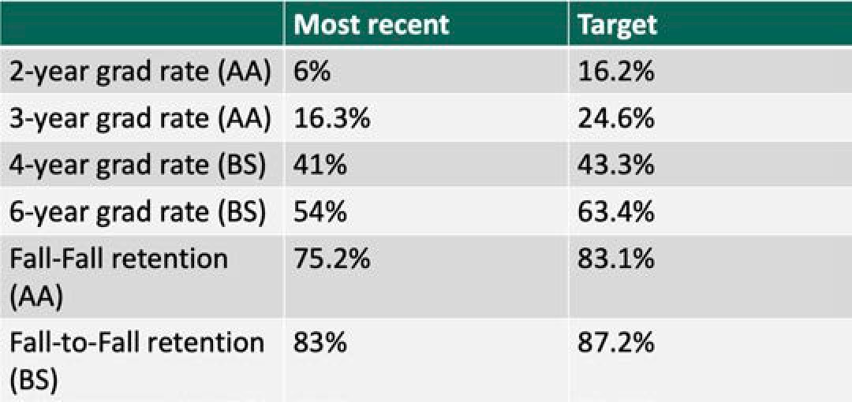

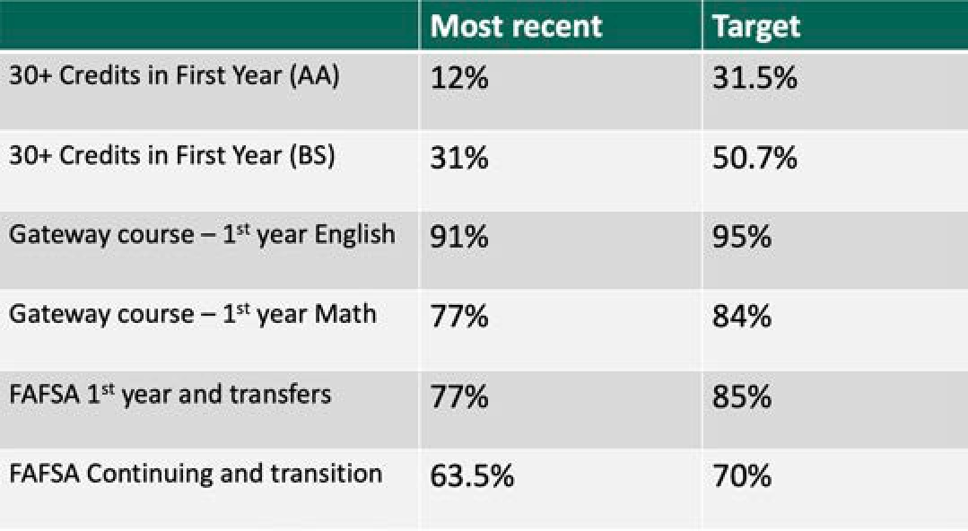

Our Academic Momentum working group created a plan based on eight basic components:
  - Focus on Student Advising and Success Coaching
  - More effective, integrated use of Data and Predictive Analytics
    - Provide targeted student support services such as academic coaching and tutoring based on at-risk identification via predictive analytics

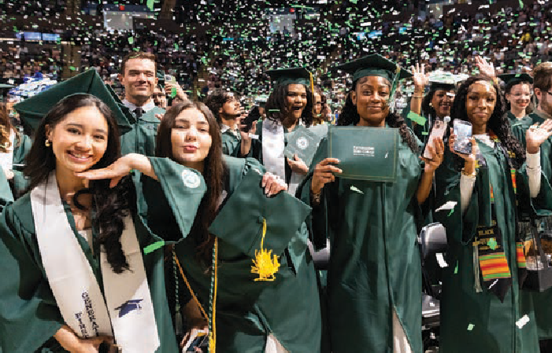
  - Student-Centered Course Scheduling
  - Degree Maps for all majors
  - Focus on Academic Credit Momentum
    - Set students up to succeed in at least 30 credits per year.
  - Support for Students at Risk, and Re-integration of Stopouts
  - FAFSA Completion Initiatives
  - Basic Needs Support and Completion Grants
Student success across the institution – Next steps. Last fall, we formed the Clear the Path task force, made up of operational leaders from student-facing units across campus, who are empowered to promptly address and resolve student success issues.
The task force conducted surveys with faculty, staff, and students across campus to identify major issues and has started working on solutions.
In the spring, we formed an Academic Policy Task Force to develop short-term recommendations related to the Academic Momentum Campaign. The group began by creating a campus-wide degree map template, and recommended expanding summer and winter course offerings, and piloting seven-week “minimester” general education courses to help struggling students to progress.
Starting Fall 2026, the College implemented a centralized advising model for students with 0-60 credits, involving advisors from the AAIC, Liberal Arts, and RAM. Students are assigned dedicated advisors and will receive consistent communication and support. The office is scheduled to relocate to the Campus Commons following renovation in 2027.

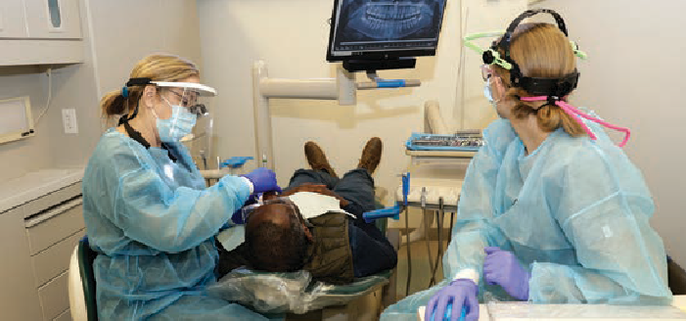
Effective student advising relies on accurate and timely data. Dr. Alex Caviedes has recently taken on the role of Director of Student Success Systems and Analytics. He will oversee the implementation of EAB Navigate 360, which will eventually replace CRM Advise, and will help develop the data infrastructure necessary for making smarter, faster decisions regarding advising, course scheduling, and student retention. Navigate is scheduled to go live by January 1, 2027, and will support:
 Communication with students via text message.
 Better use of predictive analytics to identify at-risk populations based on historic trends.
 Advisor workload management.
 Student access to uniform appointment setting for advising.
In spring, the Provost’s Office conducted three workshops to improve campus awareness of data sources and demonstrate how to use that data for student support.
 Data Dive: Retention and Graduation Rates, March 5, 2026
 Degree Maps and Credit Momentum, March 11, 2026
 Supporting At-Risk Students, March 27, 2026
Students often struggle with gateway courses in English and Math, slowing their progress. EGL101E, and MTH116R have been successful at providing the necessary extra support to get more students through their gateway math and English courses without taking a developmental credit course.
Building upon this model, MTH110R was first created in Spring 2026.
 Increased sections of these enhanced courses will be offered.
 1,178 students earned C or higher in EGL101 or EGL101E in Fall of 2025, up from 1,067 when we only had EGL101 in Fall 2024.
 Planning to provide additional supplemental supports for gateway courses, including embedded tutors.

Post-Graduate Survey Results
The latest graduate outcomes, measured six months after graduation, cover the 2024-2025 period.
This year, graduates encountered a tougher job market compared to previous years. We observed an increase in the percentage of students securing employment before graduating and a substantial increase in the earning potential of our graduates over the past five years, with a 25% increase in graduates earning an annual salary above $60,000. While overall employment and continued education rates after graduation remain strong, we saw declines in employment within students’ degree-related fields and in student satisfaction with their career preparation. To enhance these outcomes, we are taking measures such as expanding internship opportunities, encouraging earlier career planning (for example, integrating it into FYE classes), and developing microcredentials to help students stand out in the job market.

GRADUATE OUTCOMES

Outcomes Six-Months After Graduation | 2020-21 | 2021-22 | 2022-23 | 2023-24 | 2024-25
% employed or continuing education | 85% | 86% | 82% | 81% | 72%
% employed | 79% | 83% | 77% | 78% | 73%
% employed in a job closely or somewhat related to earned degree | 77% | 87% | 77% | 76% | 74%
% secured job prior to graduation, all baccalaureate grads | 40% | 34% | 39% | 39% | 47%
% secured job prior to graduation, baccalaureate grads in a job related to degree | 31% | 27% | 34% | 35% | 38%
% earning an annual salary of $40K or more | 55% | 80% | 80% | 73% | 74%
% earning an annual salary of $60K or more | 27% | 44% | 55% | 46% | 52%
% satisfied with their preparation for employment by FSC, all baccalaureate grads | 81% | 77% | 75% | 75% | 67%
% satisfied with their preparation for employment by FSC, baccalaureate grads in a job related to degree | 86% | 87% | 82% | 83% | 79%
# survey respondents | 363 | 438 | 281 | 285 | 317
% of actual baccalaureate graduates | 16% | 19% | 16% | 15% | 17%

Certificates, Microcredentials, Continuing Education and Workforce Development MICROCREDENTIALS
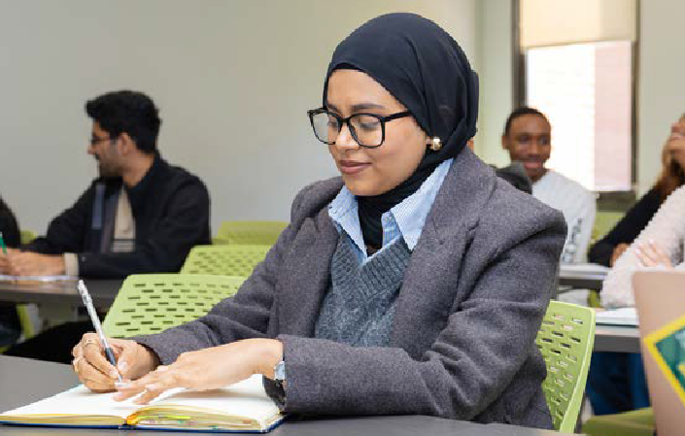

The college’s portfolio of microcredentials is expanding. Over the past two years, in collaboration with SUNY, we have continued to refine and
revise key microcredentials to maximize their effectiveness as short-term workforce development credentials. Additionally, we have made substantial enhancements, such as creating new stackable microcredentials and, for the first time, enabling financial aid eligibility for these credentials.

CURRENT MICROCREDENTIALS

Advanced Speaking and Writing | Economic and Financial Analysis
Basic Manufacturing | Financial Mathematics
Building Construction, MEP, and Energy Systems | Geospatial Thinking for Teachers
Building Graphics and Statics | Geothermal Accredited Installer
Child Development Associate (CDA) | Geographic Information Systems (GIS) for Sports Management
Community and Civic Engagement | Global and Cultural Awareness
Computational Mathematics and Optimization | Hospitality Management
Computer Aided Design (CAD) | Leadership and Communication
Computer Aided Manufacturing | NYS Coaching Certification
Construction Project Costing | Offshore Wind Power Technology
Critically Thinking About Popular Media | Pre-Construction Planning
Data Analytics | Radio Frequency (RF) Technology
DEISJ: Certified Instructor | Spanish Language and Cultural Competence
DEISJ: Sociology and Anthropology | Surveying and Site Planning
Developmental Science: Child Emphasis | Sustainable Horticulture
Direct Support Professional I | Technical Communication
Direct Support Professional II | Undergraduate Research and Experiential Mentorship
Direct Support Professional III | Wind Energy Technology

Microcredentials Awarded: Over the past academic year, 364 microcredentials were awarded by FSC, reflecting a 69% increase over 2024-2025. This growth is largely attributable to the continued success of the Direct Support Professional program, which launched all three levels (DSP Level I, II,
and III) of the certification in partnership with employees from the NY State Office of People with Developmental Disabilities (OPWDD). Farmingdale also saw an increase in the number of students completing our Child Development Associate (CDA) and Developmental Science: Child Emphasis microcredentials. The student acceptance rate for the digital badge was 63% and the share rate was 32%. The top microcredentials issued over the past year included the Direct Support Professional – Level I (98), Direct Support Professional – Level II (85), Direct Support Professional Level III (49), Child Development Associate (36), and Developmental Science: Child Emphasis (21).
Direct Support Professional Initiative Continues: A highlight of this year once again was the significant expansion of the Direct Support Professional,
now actively offered at all three levels of the microcredential (DSP Level I, DSP Level II, and DSP Level II). Farmingdale’s Applied Psychology
Department partnered with the New York Office for People with Developmental Disabilities (OPWDD) to bring a free microcredential to select campuses across SUNY in 2025-2026. This year, we had a record 98 students successfully complete the DSP-I MC, 85 students complete the DSP-Level II MC,
and 49 students complete the DSP-Level III MC.
A special completion ceremony was hosted on campus on June 1, 2026 with representatives from SUNY and OPWDD to celebrate our growing cohort of credentialed DSPs. This success of this program highlights the significant need for training to support direct support professionals in our service area.

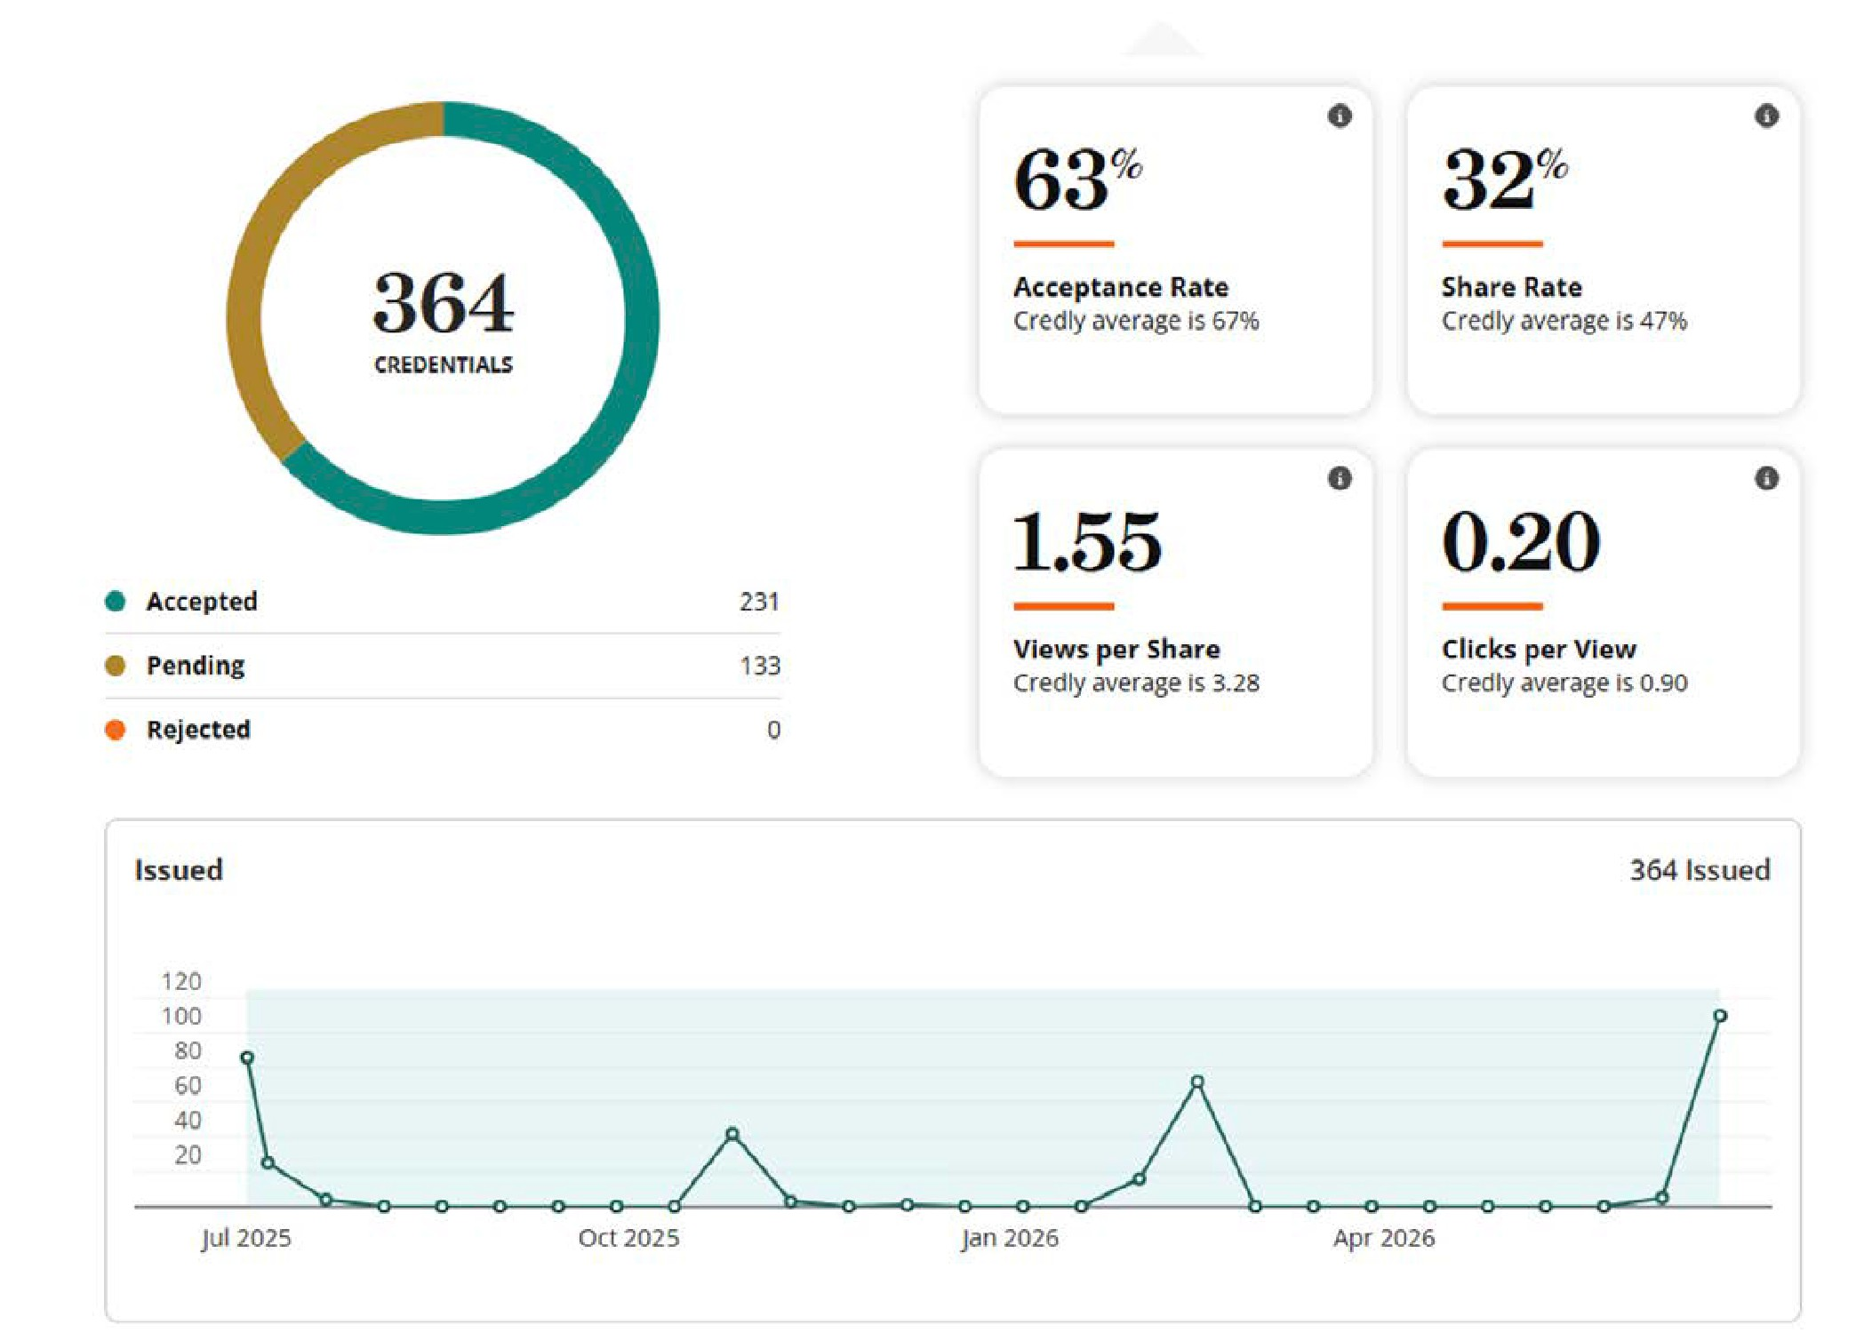
MICROCREDENTIAL EARNERS REPORT, AY2025-2026

Workforce Pell Eligibility: In addition, in April of 2026 we worked with SUNY to identify which of our existing programs would potentially be eligible for Federal Workforce Pell funding. We identified seven of our current microcredential programs and over 200 students who could potentially be eligible for this funding in a sample data request from SUNY. The microcredentials that were selected as potentially eligible for the Workforce Pell included: Computer Aided Design (CAD), Computer Aided Manufacturing, Direct Support Professional I, Direct Support Professional II, Direct Support Professional III, NYS Coaching, and Surveying and Site Planning.

Future SUNY Microcredentials Grant: A number of existing microcredentials were also reviewed in 2025-2026, in anticipation of a future grant to support student registration in identified SUNY Clean Energy Microcredentials in 2026-2027. As part of our review, we reviewed the description of eligible microcredentials to ensure consistency
with our mission and the ability for learners to gain valuable workforce skills on a flexible timeline. In 2025, the following Farmingdale microcredentials were selected for potential inclusion in the future grant program: Computer Aided Design (CAD) and Surveying and Site Planning. We hope to
offer these microcredentials in partnership with industry internship opportunities in the 2026-2027 academic year.
Division of Extended and Experiential Learning The establishment of the Division of Extended and Experiential Learning, led by Dean Dylan Gafarian, marked an important step forward
in Farmingdale State College’s commitment to expanding access, strengthening workforce
development, and creating meaningful educational pathways across the lifespan. The Division brings together the Department of Pre-College Programs, including University in the High School and the Summer Academy; the Office of Professional
and Continuing Education (PaCE); the Office of Undergraduate Research and Scholarship; the Farmingdale Institute for Lifelong Learning; and Interinstitutional Partnerships.
Over the past year, the Division has built significant momentum by developing new professional
and workforce credentials, expanding pre-college and experiential learning opportunities,
increasing engagement in undergraduate research, strengthening partnerships with community and
industry, and reimagining lifelong learning at Farmingdale. Together, these efforts are extending the College’s reach beyond the traditional classroom and positioning FSC as a regional leader in education, workforce development, and lifelong learning on Long Island.
This year marked the creation of PaCE. The goal of the office is to make it easier for students,
professionals, and employers to access high-quality, career-focused learning.
The following non-credit programs were offered this year:
 PSEG Data Awareness - Corporate Training
 Certified Personal Training Program
 COMPTIA Certification Training
 Creative Problem-Solving Certificate
Upcoming programs being offered in the upcoming year:
 Project Management Professionals (PMP)
 AI That Works: From Experimentation to Business Value
 Certified Nursing Assistant (CNA)
 Craft Brewing Certificate
 PSEG AI Primer – Corporate Training
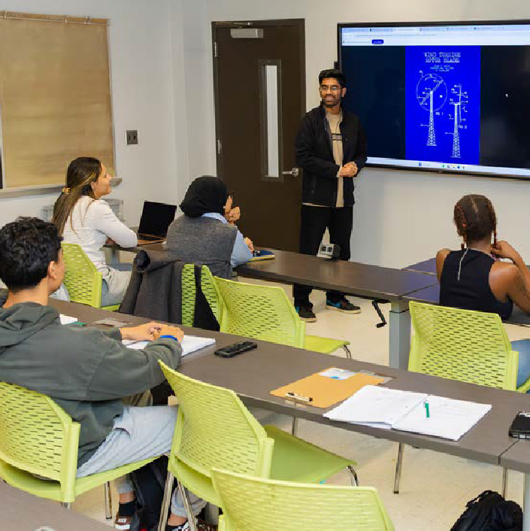

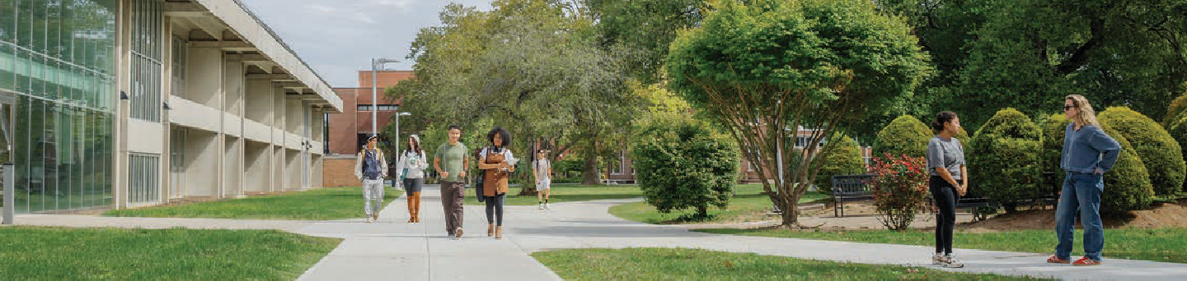

Specialized Accreditation
The highlight of this past academic year was the awarding of ABET accreditation to a number
of programs in our School of Engineering Technology. ABET-accredited schools successfully undergo a rigorous review process conducted
by their peers in the engineering and technology community, ensuring that they provide high-quality educational programs.
The following programs received re-accreditation:
 Architectural Engineering Technology (Bachelor of Science)
 Civil Engineering Technology (Bachelor of Science)
 Computer Engineering Technology (Bachelor of Science)
 Construction Management Engineering Technology (Bachelor of Science)
 Electrical Engineering Technology (Bachelor of Science)
 Manufacturing Engineering Technology (Bachelor of Science)
 Mechanical Engineering Technology (Bachelor of Science)
Two programs received initial accreditation:
 Computer Science (Bachelor of Science)
 Computer Security Technology (Bachelor of Science)
- Faculty Scholarship and Creative Activity Our faculty make important contributions to their scholarly disciplines and actively involve students in their research. The tables below capture the scholarly activity of our faculty, broken down by
school. Journal article authorship increased this year (174 versus 164 last year), as did book authorship (10 versus 7), conference proceedings (54 versus 42 last year), performances/exhibits (26 versus 22) and conference presentations (390 versus 371).

Conference Presentations
Arts and Sciences | 185
Business | 118
Engineering Technology | 57
Health Sciences | 30
Total | 390

Schools | Performance / Exhibits | Journal Articles | Books | Book chapters | Conference Proceedings
Arts and Sciences | 4 | 82 | 7 | 14 | 1
Business | 22 | 42 | 1 | 3 | 9
Engineering Technology | 0 | 36 | 1 | 0 | 44
Health Sciences | 0 | 14 | 1 | 1 | 0
Total | 26 | 174 | 10 | 18 | 54

Greenley Library

The library fully serves both remote and in-person research inquiries, informational and directional questions and one-on-one reference appointments. Online reference/research inquiries and informational directional inquiries were
down over the previous year. Inquiries related to technology support, operations and supplies increased by 10-20%respectively.
Instructional Videos: The Greenley Library YouTube page continues to receive numerous new views each year. Overall, this page features 59 informational videos which have been viewed from locations throughout the United States
and internationally.

Most popular overall videos:
 APA Citation Style: In-Text Citations (7th edition) (47,000 views)
 APA Citation Style: Reference List (7th edition) (13,000 views)
 MLA Citation Style: In-Text Citations (9th edition) (29,000 views)
 MLA Works Cited Video (17,000 views)
 Creating Citations in Google Docs (6700 views)

Informational Literacy (IL)
All Librarians teach information literacy sessions, usually at the request of a particular faculty member. Classes teach library research skills and are customized for the specific subject/ assignment.
In 2025-2026, they taught 142 Information Literacy sessions reaching 3068 students. This includes 33 FYE 101 sessions that were taught this academic year.
Semester | Number of classes | Number of Students | Number of disciplines/ areas
Summer 2025 | 2 | 45 | 2
Fall 2025 | 87 | 1849 | 16
Spring 2026 | 51 | 1126 | 11
External partners | 2 | 48
TOTAL | 142 | 3068

The External partner in the table below represents two classes taught to students from Division
Ave High School that come as part of their AP Literature class for a session in “Literature Resources for AP Senior Thesis.”

REFERENCE SERVICES WERE PROVIDED BY LIBRARIANS

Type of service | 2025-  2026 | 2024-  2025 | 2023-  2024
In-person reference/ research inquires, locating resources and retrieval, database searches, ILL assistance, reserve lookups | 676 | 710 | 639
Online reference/research inquiries via “Ask a Librarian” or reference email | 217 | 286 | 261
Technology support Assisting students & faculty with logins, desktop applications,  Wi-Fi, printing, scanning, posters, Papercut,  Brightspace, Office, etc. | 1969 | 1791 | 1600
Informational and directional questions-About campus, services, other libraries, etc. | 968 | 1017 | 996
Library operations--Lost and found, elevator access, hours, study rooms, web cashier, etc. | 642 | 554 | 558
Other - request for supplies, copiers, connectors, etc. | 798 | 655 | 713

Circulation
Overall, the number of circulating items remained level year over year, with a decrease in books from the circulating collection. This was somewhat offset by modest increases in other collections, especially the circulation of technological items like calculators and laptops.

Type of Material | Change over previous year | Number of Items Circulated
 |  | 2024-  2025 | 2025-  2026
Reserve items (texts, anatomy models, calculator, adapters, etc.) | 0 (.4%) | 2621 | 2634
Circulating books | -11% | 893 | 792
Laptops | 7% | 552 | 588
Other | 25% | 8 | 10
TOTAL | -1% | 4074 | 4024
Renewals |  | 69 | 79

BORROWING AND LENDING DATA

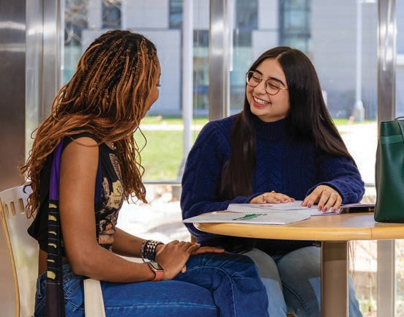

Interlibrary Loan
Overall, there was a 10% drop in ILL requests from patrons. However, the year 24-25 reflected a 25% increase from the prior year, and this year (639 total borrowing requests) is still up relative to 23-24
(562) and 22-23 (603). Fill rates – the percentage of requests successfully filled – remained steady overall in the 87-90% range across those years as well. Lending requests - requests received from other libraries for our material - have decreased in line with recent trends.

 | 2024-2025 |  |  |  | 2025-2026
Borrowing Statistics | Total | Filled | Canceled | Fill Rate | Total | Filled | Canceled | Fill Rate
Books | 274 | 244 | 30 | 89% | 281 | 253 | 28 | 90%
Articles | 428 | 386 | 42 | 90% | 358 | 312 | 46 | 87%
Total | 702 | 630 | 72 | 90% | 639 | 565 | 74 | 88%
Lending Statistics
Books | 916 | 232 | 684 | 25% | 754 | 240 | 514 | 32%
Articles | 448 | 309 | 139 | 69% | 367 | 202 | 165 | 55%
Total | 1364 | 541 | 829 | 40% | 1121 | 442 | 679 | 39%

Database Usage by Students
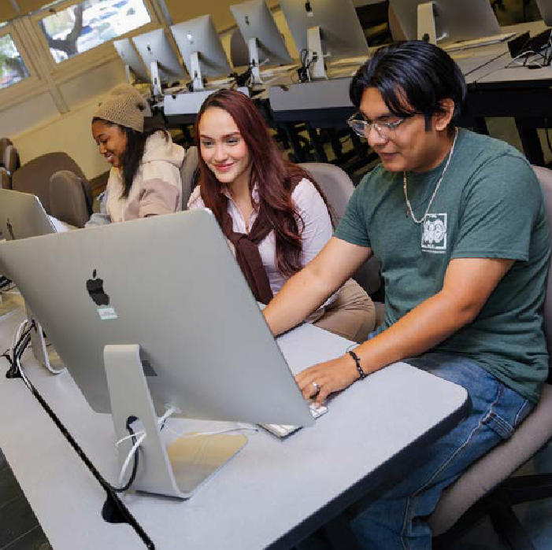

There was an increase in the number of students accessing databases. Here is a sample of
usage statistics.

Popular Databases/ Journals | Searches 2025-2026 | Article Download Requests 2025-  2026
Gale Opposing Viewpoints | 52,140 | 16,948
EBSCO | 119,721 | 252,192
EBSCO eBooks | 4050 | 800
Chronicle of Higher ED | 1,480 | 1,480
PROQUEST | 36,098 | 23,297

IITG RECIPIENTS: 2026

Campus | Principal Investigator | Project Title | Funding | Type of Grant
Brockport | Ning Yu | Integrating Responsible AI into Interdisciplinary Assessment System through Experiential Learning | $43,900.00 | IITG
Farmingdale | Saeedeh Anvari | Applied Civic Discourse through Open Educational Resources: An Innovative General Education Model for Computer Science and Business Programs | $14,894.80 | OER  Impact
Farmingdale | Zhou Zhang | Developing an Open Educational Resource for Applied Machine Learning in Engineering Technology Education | $15,000.00 | OER  Impact
Farmingdale | Lisa Frazier | Investigation into Generative AI Video Creation and Workflow in Creating Targeted Course Content | $14,925.94 | IITG
Farmingdale | Khosro Shirvani | MET 308 AI Design Coach (Machine and Product Design) | $14,800.00 | IITG
Oswego | Isabelle Bichindaritz | AI-RA2: AI-enhanced Research and Creative Activities Microcredentials and Advanced Certificate | $34,682.00 | IITG
Stony Brook | Shyam Sharma | Promoting Writing-to-Learn Pedagogies Across the Disciplines by Using Critical AI Literacy | $56,000.00 | IITG

IITG RECIPIENTS: 2025

Campus | Principal Investigator | Project Title | Funding | Type of Grant
Buffalo State College | William Yates | AI-Enhanced Creative Problem-Solving Tools for Higher Education and the Workforce | $49,266.00 | IITG
Oswego | Isabelle Bichindaritz | AI-RA: an AI Powered Research Assistant to Optimize Generative AI Tools for Research | $40,700.00 | IITG
Farmingdale | Kimberly Riegel | Co-Intelligent Classrooms: An Openly Licensed Toolkit for Responsible & Creative Learning With AI Agents | $30,000.00 | IITG
Farmingdale | Alireza Dalili | Enhancing Multi-Disciplinary Education with an AI-Powered Conversational Teaching Assistant | $15,000.00 | IITG
Farmingdale | Paulo Castillo | Real-world Circuit Design Optimization and Analysis using AI tools-OER | $15,000.00 | OER
Brockport | Ning Yu | Scaling AI-Powered Education: Sustainable Enhancement and Implementation of Multi-Disciplinary AI Toolkits Across SUNY Campuses | $55,200.00 | ITG

Scholarly Communication
As in past years, Scholarly Communications continued to provide publishing, grant-seeking, copyright,
and research support to faculty, staff, and students through workshops and consultations during the 2025-2026 academic year. The department also continued to provide coaching for FSC applicants developing Innovative Instruction Technology Grant (IITG) and OER proposals. The IITG and OER recipients for 2025 and 2026 are listed below.

Open Access Publishing Support
Since the launch of the Open Access Publishing Support initiative in October 2025, the board has reviewed 14 requests for support and awarded
$16,892.91 in funding to support 6 applicants in open access publishing.

Applicant | Department | Journal | Funding Awarded
Douglas E. Johnston | Mathematics | Journal of Risk and Financial Management | $1,735.27
Yu Chen | Business Management | Journal of Strategic Marketing | 3,650
Shan Siddiqui | Sociology & Anthropology | Journal of International Students | $2,400
Supriyo Karmakar | Electrical & Computer Engineering Technology | IET Circuits, Devices & Systems | $2,540
Sue Moon | Business Management | Gender, Work & Organization | $4,880
Emre Tokgoz | Computer Security | Logistics | $1,688

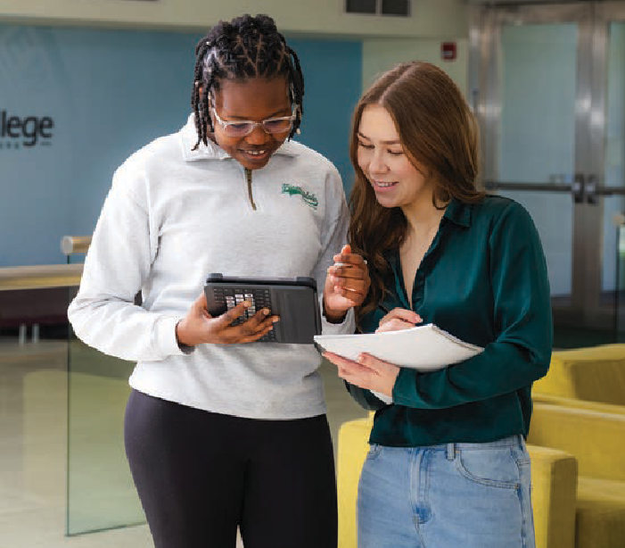

VI. University in the High School
Our University in the High School Program (UHS) offers concurrent enrollment credits in partnership with 96 high schools in Nassau and Suffolk Counties, as well as in and around New York City and Westchester. More than 7,500 unique students registered for credit in our courses during the 2025-26 academic year, earning over 35,000 credit hours in courses from 20 academic departments. We
are currently the only four-year SUNY school to be accredited by the National Alliance of Concurrent Enrollment Partnerships (or NACEP), which shows that the program adheres to the 16 Concurrent Enrollment Program standards of academic quality. The charts below break UHS data down by high school and courses.

VII. Looking Forward (Recommendations for Action)
 Grow a targeted portfolio of new graduate and undergraduate programs. The new proposal process described above gives us a clearly defined path from idea to launch, and early results are encouraging. In the coming year, we will use it to work more closely with faculty, deans, Enrollment Management, Marketing and Communications, and industry partners to identify programs with demonstrated regional demand and ensure every proposal advances
with a workable marketing and enrollment plan.
 Expand faculty research and scholarship, focusing on increasing external funding support. The Office of Research and Sponsored Programs has
now been integrated into Academic Affairs under new director Alice Diaz Bonhomme. This year, the Office will launch a series of workshops on proposal development, reintroduce the Proposal Incentive Program—which offers course releases to support proposal writing—and introduce a new Proposal Submission Incentive for faculty who submit external funding proposals. The aim is to boost both the number and the ambition of proposals coming from the College.
 Deepen industry and community partnerships, with workforce development as the organizing focus. Regional employers are our most direct source of information about what students need to succeed in the workplace, and we will continue to solicit their advice and partnership.
PaCE will continue to develop non-credit courses and credentials aligned to identified workforce needs, and we will work to convert more of these relationships into durable arrangements: internship and applied-learning placements, advisory board participation, and credit pathways out of non-credit offerings.
 Enhance the link between academic success and career opportunities post-graduation. All departments will create career-focused degree maps, enabling students to see from their first semester which courses, experiences, and credentials will prepare them for their careers. Entry-level job expectations are rising, making it crucial for students to acquire advanced skills to remain competitive. To achieve this, we will update our curriculum and expand hands-on learning experiences, including internships, certificates, and other opportunities, to help students develop these key skills.
 Establish a coherent institutional approach to artificial intelligence in teaching, learning, and academic operations. Artificial intelligence
is already being used in our classrooms and workflows, and the question is not whether to engage it but whether we do so intentionally. Academic Affairs will align College practice with SUNY’s systemwide AI guidance, provide faculty with practical support for course and assignment design, and work together to identify where AI competency belongs in disciplinary curriculum.
As a technology-focused institution, Farmingdale should be a leader in this area.

SCHOOL ENROLLMENT
Yonke� Montessori Academy Wyandanch M�morial High School -
William Floyd Hi11h School ■
Wh,...atl�School • West Babylon Senior Hiilh Sdlool
WeUingtOn C Mepham High School • Ward Melville Hiilh School ■
Walter GO'Connell Copiailue Hi11h School
Walt W'hitman High School -
WTresperClarkeHi11hSchool 1 Vall�S1�11m South High School Valley Stream North Hli;:h School
VillleyStr....amCenm,IHighSchool I
Uniondale Hillh School Thomas Edison Career and Technical Hiilh- ■
Sv<Js.s.!t High School •
Southold JuniDf-Senior Hi11h School 1 Smithtown High School-West,...mCampu� ■ Smithtown High School - Eastern Campus ■ Shoreham-Wadin11River Hi11h School ■
Sewanhaka High School ■
5ayvill,...HighSchool ■
Sanford H Calhoun Hi11h School
Sad!Nn North High School I Sadiem Hiih School Ecst
Roy C �tcham 5Mi0f High School I
Roosevi:lt Hi11h School Rocky Poirn Junior-�nior High School ■
RobmF K,...rmedv Community High School
RiverheadHi1hSchool Richmond Hill High School
Plainview-Old 8ethpa11e John F Kennedy -

PlaiOMgeHighSchool ■
f'aul D Schreiber Senior Hi11h School f'athwav-; College Preparatory School: A Patchogue-MfilfordHigh School
Oyster 8<1Y Ht11h Sdlool ■
Northport High School ■
North Shore Hebrew Academy Ht11h School ■
North Bab'ylon High School -
N- Utrecht High School ■
Nassau BOCES: Pro1@m of Alternative
Mount Sinai High School Mineola High School I
Miller Place Hi1h School Midu!elJ f'euides School -
Mattituck Ht11h School 1
Mathematics and Science Riesearch ■
Massapequa Hi1h School MatvemeHighSchool ■
Mahopac High School Lynbrook Senioc Ht11h School
Longwood Senior High School - Lindenhurst Senior Hi11h School
LawrenceHighSchool 1
La Wilson Technolo11icalCenter Kings Park High School I
John L Miller-Great Neck North High School

VIS 260
VIS 215
-
-
VIS 105
-

VIS 101
--
SST 115 SP/1141
soc 150
SMT225 SMT110 PSY 101 I
-
-
POL 265
POL 250

POL 110 POL105 PED 203 NTR 200T NTR110 MTH 150
-
--
-
-
MTH 130
MTH 129 MTH116 MTH110 MTH103 MET 202T MET150T MET 127T MET 117T MET 105L MET215 MET109 HPW 105
-
-
-
-
-
HPW 101
HIS 270 ■
HIS 233 ■
HIS 219 I
HIS 131 I
HIS 122

HIS 121

HIS 118
--

HIS 117

HIS 115
HIS 114 GE0222
-
GE0201 I ENV101 ■ ECO 157

John Jay Senior Hi1h School ■
John F l<ennei:ly High School - John Adams Hi1h School
Islip Hillh School - Island Tree� High School -
Iris Wolfson Ht11h School ■
In-Tech Academy lnstiruteHealth Professions At Cambria -
ECO 156
ECO 120
-
-
ECO 110
CSC 111
CSC 101 ■
-
CRJ 205 ■
CRJ 204
--

Huntin11Wn Hi11h School
Hillcr�t High School -
Hiih School of World Cultures ■
High School For Law Enforc....mentAnd ■
Hicl::s\lllle Senior Hi11h School
Henick5SeniorHi11hSchool HauppaugeHighSchool
Hampton Bays Hi11h School ■
Great Ned:: South High School - Glen Cove Hi11h School 1
�ralDouglas MacArthur High School -
FreeportHi11h School Francis Lewis Hi11h School fam,ingdale High School
EpicHi11hSchoolNorth East Rockaway High School -
East Meadow Hi11h School 1
East Islip Hi11h School Divi-.ionAVffiue -
Deer Park Hi11h School
Connetquot Hi11h School Comse111ogue High School ■
Cold Spfin11Harbor Junioc-Senior Hi11h School ■
Chart� E Gorton High School CEntrallslipHi11hSchool -
Center Morich....s High School •
CarlePlaceHi1hSchool Cambria Heillfits Academy
Brentwuod High School - BixhornTechnicalCenter
Bayside High School Bay Shore Hi11h School
Baldwin Senior High School - Babylon Junioc-Senior Hi11h School
Academy Charter School - HempstEild
o 100 200 100 400 soo 600 100 soo
CRJ 102 I
CRJ 101
CRJ 100
CPS 100
-
BUS 141
BUS 131
BUS 121
-
-
BUS 111
BUS 109
BUS 102
BUS 101 BIO 123T BIO 120T I
-
BIO 197 BCS 209T
-
BCS 208T ■
BCSBO
-
BCS 109 I
-
BCS 102
-
BCS 101
AVN 202
-
I\VN 100
-
ARC 121 ■
-
ARC 111
-
ARC 101
ARC 100
/\NT 100

200 400 600 800 1000

DIVISION OF STUDENT AFFAIRS

This past year marked an important milestone for the Division of Student Affairs at Farmingdale State College as the Division completed its
first full year back together as a unified team. Throughout the year, the Division focused on strengthening student support, enhancing the student experience, and building partnerships across the College. A major accomplishment was the development and implementation of a Basic Needs Team, creating a more coordinated approach to addressing food insecurity, emergency needs, and other barriers that
can affect student success. The Division also expanded services through the Food Pantry, providing students with greater access to groceries and other essential resources.
The Division assumed overall responsibility for the Commencement ceremony, successfully coordinating this signature institutional event and creating an experience that celebrated the accomplishments of our graduates, their families, and the entire College community. In
partnership with Academic Affairs and Enrollment Management, Student Affairs also revamped
New Student Orientation, creating a more comprehensive and welcoming experience for new students while intentionally engaging family
members as important partners in student success.
Throughout the year, the Division brought notable speakers and programs to campus, enriching the educational and co-curricular experience and creating opportunities for students to engage with diverse perspectives and inspiring leaders.
We also placed a strong emphasis on accessibility and ADA compliance, working to identify barriers, improve campus resources, and advance a more inclusive environment for all students.
After one year of being reunited as a Division, Student Affairs has established a strong foundation for continued growth. Our work has been guided by a simple commitment: to ensure that every student has the resources, opportunities, and support needed to Reach. Achieve. Matter. The past year demonstrated what can be accomplished when Student Affairs works collaboratively across the College, and it positions the Division well for an even greater impact in the year ahead.

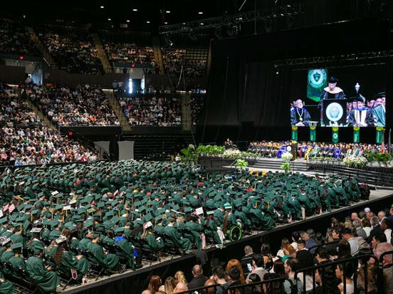

Commencement
FSC had a record 2,053 graduates, surpassing the previous year’s graduating class and marking another significant milestone for the College.
A total of 1,518 graduates participated in the commencement ceremony which featured several meaningful new traditions and special recognitions. Each academic school selected a graduating student to serve as its banner
carrier, symbolically representing the school and its graduating class. The College also proudly infused the Farmingdale State College Alma Mater into the ceremony, with two graduating seniors selected to perform both the National Anthem and the Alma Mater.
The College honored Lloyd Makarowitz as Grand Marshal in recognition of his retirement and his years of dedicated service to Farmingdale State College.
Murray Pasternack was presented with an honorary degree, Doctor of Humane Letters, recognizing his distinguished contributions and service.
The 2026 ceremony also introduced custom regalia for all students, adding a distinctive and unified element to the celebration. Adding to the College’s connection with the local community, students from Farmingdale High School served as the musicians for the ceremony.
Overall, the 2026 Commencement combined tradition, innovation, community, and celebration to honor the accomplishments of the largest graduating class in Farmingdale State College’s history and to create a meaningful and memorable experience for graduates, families, faculty, staff, and guests.

Student Achievements

Five students were awarded with the State University of New York (SUNY) Chancellor’s Award for Student Excellence (CASE), the highest honor bestowed upon a student by SUNY for demonstrating the integration of SUNY excellence within many aspects of their lives in areas such
as academics, campus involvement, community service, or the arts.
 Jannet Baires ‘26
 Bryan Cox ’26
 Raymond Howard ‘26
 Natasha Jones ‘26
 Joseph Rodriguez ‘25

Athletics
During the last academic year, FSC had 18 intercollegiate athletic teams with 349
student-athletes. Five teams captured Skyline Conference Championships, with four earning a spot to compete in the 2026 NCAA Division III Championships (Baseball, Men’s Golf, Men’s
Tennis, and Women’s Lacrosse). We are proud that Assistant Athletic Director and Head Men’s Golf Coach Ryan Williams was selected to serve on the NCAA Division III Men’s Golf Committee, helping guide the sport on a national level. Additionally, Men’s Lacrosse Head Coach Sean Chamberlain was named the People’s Arc of Suffolk Candlelight Ball Honoree for his community service work at the children’s school.
FSC captured the Skyline Conference Presidents Cup for the record-tying sixth time in school history, recognizing athletic achievement across all conference sports. In addition to a conference-best

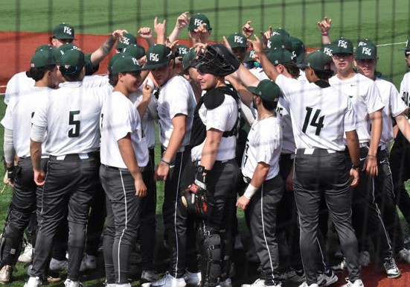
five championships, the Rams earned four runner-up finishes (Women’s Tennis, Men’s Outdoor Track & Field, Softball, Men’s Basketball) and several
top three marks. FSC student-athletes also earned numerous individual accolades throughout the year.
Academic success is heavily emphasized by athletics, which is demonstrated by the student-athletes’ 88% academic success rate (This means that any incoming student either graduates
or transfers out holding successful academic progress.), 89% retention rate (general student body is 81.1%), and 70% graduation rate (general student body is 57%).
The average GPA for student-athletes was a 3.01 with 10 teams averaging a 3.00 GPA or higher.
These teams include:
 Women’s Cross Country: 3.28
 Men’s Golf: 3.28
 Women’s Volleyball: 3.26
 Women’s Soccer: 3.22
 Softball: 3.13
 Men’s Cross Country: 3.05
 Women’s Tennis: 3.05
 Women’s Lacrosse: 3.03
 Men’s Basketball: 3.02
 Women’s Track & Field (Indoor/Outdoor): 3.01
Given their academic prowess, FSC student-athletes also earned accolades for their academic achievements.
 FSC Athletics placed 143 student-athletes on the Skyline Conference Fall, Winter & Spring Academic Honor Roll.
 FSC Athletics joined Chi Alpha Sigma, the National College Athlete Honor Society, with 54 student-athletes inducted into the College’s inaugural chapter.
 18 Rams selected to CSC Academic All-District Team (nine at-large, four volleyball, two softball, one baseball, one men’s basketball, one women’s soccer).
 Richie Heyder earned CSC First Team Academic All-America honors, becoming the fourth Academic All-American in FSC Athletics history, the second First Team selection, and the first for the baseball program.

 Men’s Golf claimed the GCAA Team Academic Award; three golfers named NCAA Division III Scholar All-Americans.

 Twelve softball student-athletes earned NFCA Scholar-Athlete recognition.
 Tommy Mai was selected as USILA Scholar All-American, becoming the fifth Ram honoree in last four seasons (Men’s Lacrosse).
 Women’s Soccer claimed the United Soccer Coaches Academic Achievement Award for second consecutive year.
 Men’s and Women’s Tennis earned ITA All-Academic Team Awards; nine women & four men claimed ITA Scholar-Athlete honors.
 Raymond Howard received the SUNY Chancellor’s Award for Student Excellence (Men’s Golf).
Award | # Of Students | Compared to 2024-25
Academic All-American | 1 | Plus-1
Academic All-District | 18
Scholar All-American | 5 | Plus-1
SUNY Student-Athlete of the Year | 2
All-American | 1
All-Region | 7
All-ECAC | 3
ECAC Player of the Year | 2 | Plus-1
Conference Player of the Year | 7
Conference Rookie of the Year | 2
Conference Coach of the Year | 6
All-Conference First Team | 57
All-Conference Second Team | 34
Skyline Elite 19 | 4 | Plus-1

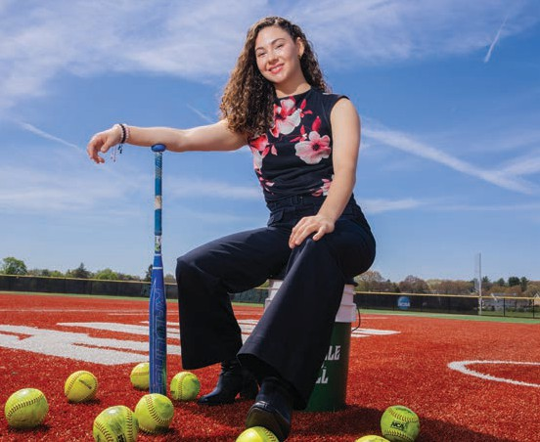
In addition to achieving highly on the field of play and in the classroom, each team must complete at least two community service activities each academic year. FSCC SAAC hosted its fourth annual Island Harvest food drive and Toys for Tots Drive; Softball student-athlete Madison DeMaio collaborated with Campus Recreation
to organize a wheelchair basketball game at the Henry Viscardi School, promoting inclusion
through adaptive sports; the Men’s Lacrosse team continued its partnership with the Long Island Metro Lacrosse Foundation (LIMLF) by hosting a wheelchair lacrosse game to raise awareness and foster inclusion in sports; the Women’s Lacrosse team participated in Wreaths Across America at Long Island National Cemetery; and the Men’s and Women’s Tennis teams hosted USTA Campus Kids Day and adopted a family for the holidays through Options for Community Living, just to name a few.

Campus Food Pantry
In October 2025, management of the Food Pantry transitioned from Academic Affairs to Student Affairs and is now a key component of our Basic Needs Team. Improvements were made to the inventory and check-in process, resulting in the implementation of a new software program called Plentiful. This system is utilized heavily by Island Harvest Food Bank supplemented locations and allows for a more efficient check-in and intake process. It also allows us the ability for data analysis of usage and student outcomes.

The Food Pantry is kept operational by a dedicated group of 35-45 faculty/staff and student volunteers, as well as students completing an internship as

part of the Empire State Service Corps. In addition to weekly operating hours, the Food Pantry also included special holiday meal distributions, food drives and awareness events, and the growth of microgreens and herbs from our hydroponic Garden Tower. These items complement the array of freshly grown vegetables from our Campus Sustainability Garden, which is also cared for by a group of dedicated faculty/staff and student volunteers.
Between May 2025 and May 2026, the Food Pantry served 157 students and 77 faculty/staff and averaged 115 visitors per month totaling 5,426 individual visits. New food insecurity supports were developed and launched in March 2026 which provided hot meals at our campus ‘pay one price’
cafeteria and grocery store vouchers for students to supplement their home food supply with items that cannot be obtained in the campus pantry. SUNY also expanded the usage of its food insecurity funds to include toiletries and basic residential supplies
in Spring 2026. These expanded supports will be launched in Fall 2026.

Campus Mental Health Services
In the 2025-2026 academic year, there were approximately 1,855 in-person and 156 remote individual appointments. CMHS staff responded to 17 after-hours crisis calls and conducted approximately 850 consultations with students, faculty, and staff. The overall diagnostic breakdown remains stable except for a continued increase in autism spectrum and executive functioning disorders.
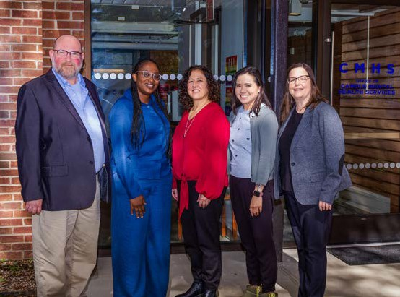

CMHS continues to see the effects of the COVID-19 pandemic as well as population health efforts to decrease stigma about mental health, increase awareness of mental health and wellness services, and normalize conversations about the importance of emotional and behavioral health.
More students are seeking guidance and support. While some turn to online and artificial intelligence platforms, the overwhelming majority of students seeking services have a history of seeking in-person help before arriving on campus and come to campus with a desire for immediate, in-person mental health and wellness support that fits their academic schedule and off-campus responsibilities.
Evidence indicates that mental health outreach and prevention activities are important factors in determining student success. CMHS participated in frequent outreach activities, including national awareness days, such as Suicide Prevention Awareness Day, and student services and activities events. Three of our staff members and one staff member from the Dean of Students Office were trained as Mental Health First Aid instructors.
This course will teach students, faculty, and staff effective and empathetic ways to recognize and address mental, emotional, and behavioral health difficulties and to refer people experiencing these difficulties to appropriate care. Finally, CMHS co-sponsored with the Dean of Students Office and Student Government Association two large-scale speaker events that brought nationally recognized personalities to campus to speak about mental health-related issues: Gaten Matarazzo, star of Stranger Things, and Olympic gold medalists Aly Raisman and Laurie Hernandez.
With an eye toward innovation, CMHS staff engaged in several hours of continuing education focused on artificial intelligence and the treatment of psychological disorders through virtual reality. CMHS also recently upgraded their virtual reality services to include the treatment of specific phobias, obsessive-compulsive disorder, post-traumatic disorder, and anger disorders. CMHS was awarded the 2026 Insight into Academia Excellence in Mental Health and Well-Being Award for their efforts.

Campus Recreation and Club Sports
Campus Recreation at FSC continued to provide engaging opportunities that promoted student

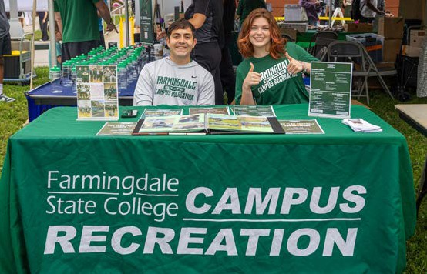
wellness, involvement, school spirit, and community during the academic year. The Esports Arena remained a popular destination on campus, recording 2,010 student sign-ins and offering a dynamic space for recreation and connection.
Intramural sports also experienced strong participation with 1,419 students taking part in a variety of competitive and recreational activities. The College supported 15 active club sports, providing students with opportunities for leadership development, teamwork, and athletic participation beyond the classroom.
FSC’s cheer team achieved national recognition by earning third place in the Open Small Co-Ed Game Day division at the national championships, highlighting the talent and dedication of our
student-athletes. Campus Recreation also expanded inclusive programming by hosting an adaptive sports wheelchair basketball event in partnership with the Henry Viscardi Center, promoting accessibility and awareness through experiential learning opportunities.
Special events continued to enhance campus life and foster student engagement. Glow in the
Dark Roller Skating and Glow in the Dark Bowling attracted more than 200 participants each and proved to be two of the year’s most successful programs. Due to their popularity and positive student feedback, both events are scheduled
to return during the 2026–2027 academic year. Through a diverse range of recreational,
competitive, and inclusive experiences, Campus Recreation and Club Sports played a vital role in supporting student success and strengthening the Farmingdale community.

Dean of Students Office
The Office of the Dean of Students (DOS) serves as a cornerstone of Farmingdale State College’s Division of Student Affairs, providing leadership for key functional areas including Residence Life, Student Conduct, Student Advocacy, and Case Management. Since assuming oversight
of the Residence Life Office (RLO) in 2022, the portfolio has expanded significantly, driven by growing residential occupancy, enhanced student engagement initiatives, and a renewed investment in campus traditions and signature programming. At the same time, the DOS has strengthened operational effectiveness, student support systems, and cross-campus collaboration, ensuring students receive holistic support while advancing the College’s commitment to student success, well-being, and belonging.
The Dean of Students Office expanded its focus on Student Advocacy and Case Management by strengthening its capacity to identify student concerns early, coordinating support services,
and facilitating timely interventions that promote student success and well-being. Through proactive outreach, individualized case management,
and collaborative problem-solving with campus partners, the office has enhanced its ability to address complex student needs, connect individuals with appropriate resources, and foster a supportive campus environment where students can thrive.
 The Dean of Students Office advanced its student advocacy and case management efforts through the creation of FSC’s Basic Needs
Hub, a centralized online resource designed to connect students with essential services that support their academic success and personal well-being. By consolidating information on food security, emergency housing, clothing assistance, healthcare, mental health services, transportation, and other critical resources into a single, accessible platform, the Basic Needs Hub strengthened the College’s ability to address student needs holistically while
providing streamlined pathways to campus and community support.
 Participated in the Network Advisory Council through Island Harvest, a campus partner and trusted Long Island Food Bank, where FSC staff advocated for additional resource allocation for individuals enrolled in college, a demographic

which is typically overlooked in large scale food and basic need support conversations.

 Case Management continued to provide students with information and guidance regarding resources dedicated to addressing housing instability, food insecurity, financial insecurity, and healthcare insecurity.
 The Student Advocate in the Dean of Students Office earned certification as a Mental Health First Aid (MHFA) Higher Education Instructor in June 2026. This certification positions the office, in partnership with Campus Mental Health Services, to expand mental health education and support by offering MHFA certification training to faculty, staff, students, and student leaders such as RAs. Participants will develop the knowledge, language, and communication skills necessary to recognize signs of mental health challenges, respond effectively in crisis situations, provide initial support, and connect individuals with appropriate campus resources.
 Developed and monitored compliance for mandatory Sexual Harassment Prevention training for all FSC faculty and staff.

Residence Life
From a residential cohort of 418 students in Fall 2021 to a record 580 students in Fall 2025, FSC’s campus housing operation has experienced sustained growth while achieving fiscal stability through near-full occupancy. Although the residential population experienced expected mid-year attrition, enrollment remained strong at 556 residents in Spring 2026, reflecting the continued demand for on-campus living and the success of the College’s residential experience. Since the publication of the College’s annual report, FSC’s Residence Life program has:
 Collaborated with the Disability Services Center to procure and install ADA-accessible furniture in residence hall rooms, community kitchens, and outdoor patio spaces, improving accessibility and inclusion for students.
 Created meaningful opportunities for student dialogue and shared governance through semesterly Town Halls and Dinner Conversations with President Prezant.
 Upgraded the residence hall fire alarm system, eliminating nuisance alarms that
previously triggered unnecessary building-wide
evacuations and improving overall resident safety and operational efficiency.
 Developed and implemented a Student Assistant staffing model for residence hall desk operations, surging vital lobby supervision in Dewey during evenings and overnight hours and in Orchard
on weekends. Increased coverage strengthened guest pass oversight, enhanced policy education, and improved resource referrals.

CAMPUS HOUSING ENROLLMENT GROWTH FALL 2021 – SPRING 2026
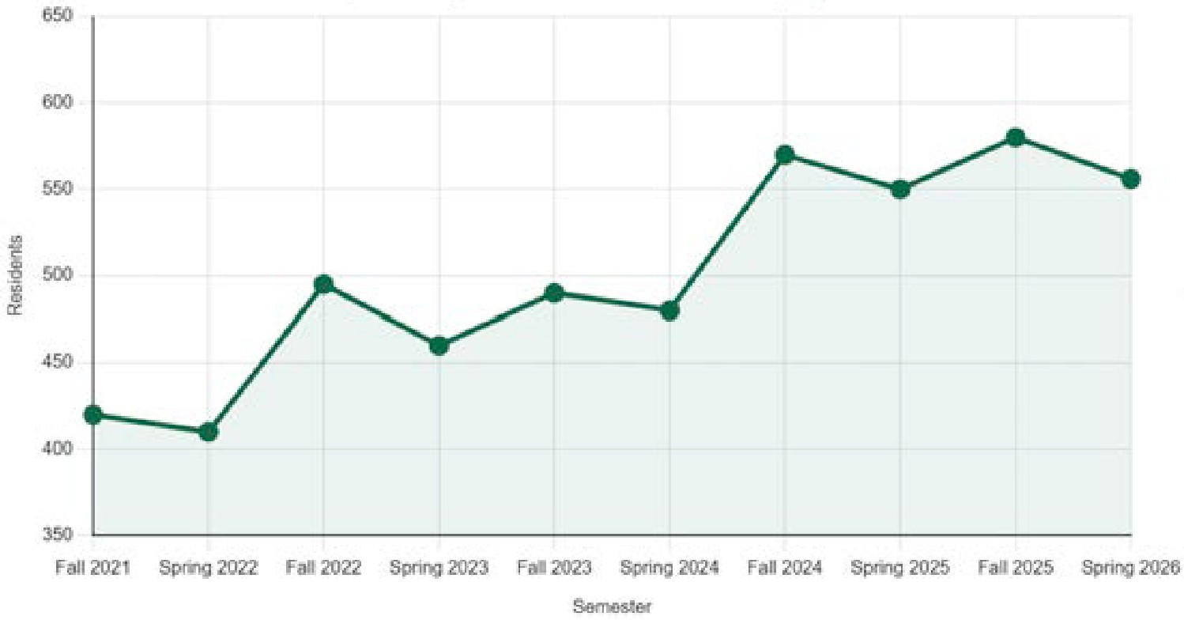

Large-Scale Programming
The Dean of Students Office and Residence Life Office continued to raise the bar on student engagement by delivering a dynamic portfolio of large-scale programs, signature traditions, and high-impact experiences that strengthened community, fostered belonging, and enhanced
campus life. Through intentional collaboration and innovative programming, both offices expanded opportunities for students to connect, learn, and engage with one another, resulting in record-breaking participation across many of the year’s hallmark initiatives.
 The Dean of Students Office led a comprehensive reimagining of Farmingdale State College’s New Student and Family Orientation program, expanding opportunities for engagement, family involvement, and cross-divisional collaboration. The enhanced experience welcomed incoming students through workshops, resource fairs, campus tours, student panels, and community-building activities, with approximately 90%
of participants reporting greater confidence in their decision to attend FSC and feeling welcomed by the campus community.

 The Dean of Students Office successfully hosted Finding Balance in the Upside Down: An Evening with Gaten Matarazzo, one of the largest and most highly anticipated student programs in recent campus history. The event attracted more than 1,500 attendees and generated record-breaking social media engagement, resulting in tens of thousands of impressions across college platforms while expanding opportunities for student connection, mental health awareness, and meaningful campus engagement.

 Enhanced student access to cultural and experiential learning opportunities through organized excursions, including attendance at Stranger Things: The First Shadow on Broadway in New York City.
 As part of the College’s annual Day of Service celebration, the Dean of Students Office brought Olympic gold medalists Aly Raisman and Laurie Hernandez to campus for a signature
fireside conversation focused on perseverance, advocacy, mental wellness, and leadership.
The well-attended event complemented a broader day of community service initiatives and reinforced the Office’s dedication to creating meaningful learning experiences beyond the classroom.
 The Dean of Students Office, through its supervision of Title IX at the time, partnered with campus stakeholders to host Katrina Brownlee, a nationally recognized domestic violence survivor, retired NYPD officer, author, and advocate, in recognition of Domestic Violence Awareness Month.
 Under the Dean of Students Office’s former oversight of Title IX, FSC hosted its annual Take Back the Night event to educate the campus community about sexual violence prevention
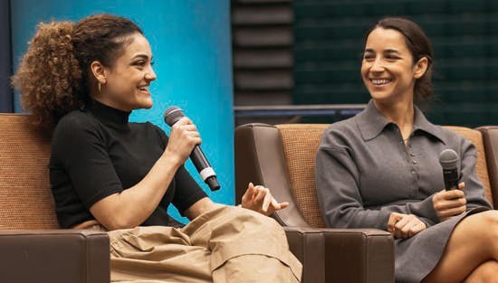

and survivor support. Through a keynote address by Kimberly Corban, interactive educational opportunities, and a campus-wide awareness march, the program reinforced the College’s commitment to safety, advocacy, and community engagement.
 Expanded signature traditions, including Hispanic Heritage Month events, Ramtober Fest, Late Night Breakfast, Super Bowl Viewing Party, Read Across America, and Green & Gold Casino Night.

Disability Services Center
The Disability Services Center (DSC) reached a new peak of 930 registered students in the
2025–2026 academic year. This reflects a steady 2.2% year-over-year increase from 910 students in 2024–2025. Over a broader four-year horizon
(academic year 2021–2022 to academic year 2025–2026), total student registration has expanded by nearly 30%, growing from 717 to 930 students and demonstrating a permanent shift toward higher baseline demand for support services.
The demographic composition of disability categories reported by registered students has remained consistent with overall institutional and national higher education trends. Attention-Deficit/Hyperactivity Disorder (ADHD), Learning Disabilities (LD), and Mental Health (MH) conditions remain the top three disability-related categories presented by students.
Alternate testing services continue to represent the most common approved academic accommodation provided by the DSC. Demands on the testing facility surged substantially during the 2025–2026 academic year, with total testing appointment requests growing by 19% year-over-year from 2,684 requests in 2024–2025 to 3,206 requests in the current cycle. This operational growth highlights an increasing reliance on distraction-reduced testing environments, extended time accommodations, and specialized proctoring.
Several ongoing structural and cultural factors continue to drive student registration and support utilization at the DSC. Increasing societal awareness and early clinical diagnoses in K–12 education allows students to arrive at college already familiar with their learning needs and accustomed to receiving accommodations.
Decreased stigma surrounding disability support

encourages incoming students to self-disclose and actively register upon matriculation. In response, the DSC continues to evolve its student engagement by hosting its own specialized orientation tailored specifically for students with disabilities, alongside interactive workshops and regular check-ins to ensure timely, comprehensive support throughout their academic journey.

Health and Wellness Center
During the 2025–2026 reporting period, the Health and Wellness Center recorded a total of 3,487 patient appointments, representing a slight decrease in visits compared to the previous year. This minor fluctuation in overall volume reflects standard annual variations in student utilization patterns. Throughout the year, no out-of-the-ordinary presenting issues were observed and the center continued to successfully meet the routine health and wellness needs of the
campus community.

Student Activities
The Office of Student Activities (OSA) continues to serve as a central hub for student engagement, leadership development, and campus involvement. OSA supports student organizations, campus programming, the Student Government Association, Fraternity and Sorority Life, Quintyne Hall, and Ram-Bo, the College mascot. Through these initiatives, OSA promotes a sense of belonging and connection that enhances the overall student experience.
During the 2025–2026 academic year, OSA supported 64 active student organizations and approved seven new organizations, reflecting continued student interest in involvement opportunities and leadership development. In accordance with SUNY requirements, all student organization Executive Board officers must complete Title VI Training once during their tenure at Farmingdale State College, with the training available to all students through Brightspace.
Student organizations hosted 1,503 events throughout the academic year, representing a 22.49% increase from the previous year. Popular programming included social events, cultural celebrations, educational workshops, guest speakers, and community-building activities.
The Office of Student Activities also hosted approximately 100 programs throughout the

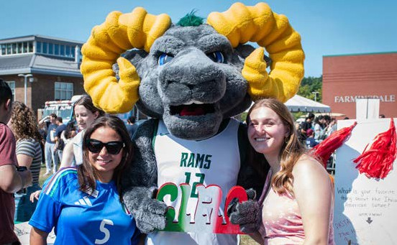
academic year. Signature events include Welcome Back BBQ, Fall Fest, Winter Wonderland, Campus Life Awards, Fountain Fest and RamChella. This year’s RamChella welcomed recording artists
Jay Sean and Big Sean and achieved record attendance with 2,448 participants, including 2,023 Farmingdale students and 425 approved guests.
Student Programming Assistants remained integral to the success of the office’s programming efforts. OSA employed eight student assistants during the fall semester and seven during the spring semester. OSA’s Instagram account increased by 21.1% during the academic year to nearly 5,500 followers.

Fraternity and Sorority Life
Fraternity and Sorority Life (FSL) continues to play a significant role in student engagement and leadership development at Farmingdale State
College. The community consists of five fraternities and three sororities and concluded the academic year with 335 active members, representing a 6% increase from the previous year. During the 2025–2026 academic year, 168 new members joined the community across all organizations.
FSL demonstrated a strong commitment to service and philanthropy. During the 2025-2026 academic year, fraternity and sorority organizations raised
$56,257 for charitable and educational causes. Delta Phi Epsilon led fundraising efforts with more than $18,000 raised for organizations including the Cystic Fibrosis Foundation, ANAD, NAMI, and the DPHIE Educational Foundation. Sigma Delta Tau raised more than $11,000 through breast cancer awareness and community-based initiatives,
while Tau Kappa Epsilon and Kappa Sigma each contributed more than $8,000 to charitable organizations and local causes. In addition, the community collected over 71,000 pounds of food

for Long Island Cares, Island Harvest, and our local FSC Food Pantry via their annual Can Castle Competition. Alpha Sigma Phi Fraternity was awarded the Grand Senior Presidents Cup for a medium sized school by their Grand Chapter for their efforts throughout the year.

The Office of Student Activities conducted a comprehensive assessment of the Fraternity and Sorority Life community during the spring semester. With an 82% response rate, results demonstrated strong student outcomes. Ninety-two percent of respondents reported feeling welcomed and included within their chapter, 92% expressed overall satisfaction with their FSL experience, and 98% reported feeling safe attending chapter events.

Student Government Association
The Student Government Association (SGA) remains an integral component of student governance and student advocacy at Farmingdale State College. During the 2025–2026 academic year, SGA maintained strong membership with 16 of 17 Senate seats filled for most of the year.
SGA members actively participated in shared governance through service on campus committees including the Student Affairs Student Services Committee, Multicultural Committee, Health and Safety Committee, First Generation Committee, ASC Board of Directors, and various campus search and advisory committees.
Beginning in Fall 2025, SGA expanded financial support to the Health and Wellness Center, Writing Center, RAM Program, and Center for Academic Success and Tutoring, reinforcing its commitment to student success, wellness, and engagement.
In 2026–2027, SGA will further strengthen this partnership by providing funding for the new Student Success & Advisement Center and supporting the Distance Learning Office. These
investments reflect SGA’s dedication to enhancing the student experience and increasing access to essential support services.
The organization also continued its strong relationship with the SUNY Student Assembly. Additionally, outgoing SGA Executive Board Members Michelle Torres, Natasha Jones, and Brionna Babcock represented Farmingdale at SUNY Advocacy Day, ensuring FSC’s campus voice was heard at the state level.
As part of its annual campus gift initiative, SGA partnered with Athletics and Campus Recreation to purchase new fitness equipment for the student gym facility in Nold Hall, including three treadmills and three stair climbers. The organization also expanded financial support to student success initiatives and campus departments.

Veterans Services
The Office of Veterans’ Services served 198 military-affiliated students during the year and the College processed $807,587 in VA educational benefits, including 90 post-9/11 GI Bill (Chapter 33), 35 Dependents’ Educational Assistance
(Chapter 35), 52 VR&E (Chapter 31), 8 Selected Reserve (Chapter 1606), and 13 active National Guard/Reserve students. Key initiatives included expanding the student veteran textbook exchange program, and establishing a Veterans Hiring Pipeline with veteran-friendly employers such
as Northwell Health and PSE&G. The office also partnered with the SUNY Research Foundation to provide Veterans’ Internships that support outreach and recruitment of military-affiliated students, while expanding the Student Veterans
of America (SVA) to include non-veteran students to strengthen campus integration. Collaboration with the Student Advisement and Success Center ensured staff were knowledgeable about GI Bill requirements, while Hofstra Army ROTC continued to expand its presence at FSC, enrolling 12 cadets and graduating three in 2025–26. Marketing efforts with Marketing and Communications targeted military installations through digital geofencing campaigns, generating more than 1,000 visits
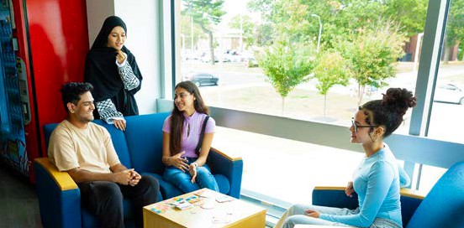

to Farmingdale State College’s landing page. Veterans Services is partnering with the Dean of Students Office to establish a targeted orientation program for incoming military-connected students.

Recommendations for Action 2026-2027

- Further develop first year programming and initiatives.
  - Reimagine new student orientation with the revamped advisement structure
  - Review and revamp the family orientation program
  - First generation student programming and initiatives
  - Leadership development initiatives
  - Programming for first year residential students
  - Infuse career exploration
  - Review and revise early alert initiatives
  - Veterans Student Orientation
- Further develop Basic Needs Support
  - Seek opportunities to relocate or renovate the Food Pantry
  - Add clothing closet in collaboration with LI Coalition for the Homeless
  - Establish a Basic Needs Support Network
  - Assess and analyze student usage of the Food Pantry as basis for other funding opportunities
  - Establish a marketing strategy to encourage students to seek help when needed
- Create more opportunities to build community
  - Examine campus spaces
  - Increase accessibility across campus
  - Establish a Living and Learning Center within the Residence Hall
  - Increase collaborations with Aramark
  - Develop and implement more cultural programming
  - Utilize cars as a programmatic space
  - Improve services provided to military-connected students
  - Explore the expansion of the residence halls
  - Review outdoor space surrounding the residence halls to determine areas for outdoor engagement

DIVERSITY, EQUITY, & INCLUSIVE EXCELLENCE
During the 2025-2026 academic year, Farmingdale State College continued to strengthen its commitment to creating a campus where students, faculty, and staff feel welcomed, respected, supported, and able to participate fully in the life of the College. That work extended beyond individual programs and events. It included strengthening civil rights compliance, expanding prevention and education efforts, creating opportunities for connection and belonging, and building partnerships that support access, engagement, and student success.
During this period, Title VI and Title IX functions returned to the Diversity, Equity, and Inclusive Excellence portfolio. Their inclusion created
a more coordinated approach to civil rights compliance, education, prevention, campus safety, and support. At the same time, DEIE continued to invest in programs that brought members of the campus community together and reflected Farmingdale State College’s broader emphasis on applied learning, community engagement, access to opportunity, and preparation for an increasingly diverse workforce.

Civil Rights & Compliance
A welcoming and inclusive campus depends on having clear systems in place to protect the rights of students and employees and to respond effectively when concerns arise. During 2025-2026, integrating Title VI and Title IX into the DEIE portfolio strengthened coordination among compliance, education, prevention, and campus support.
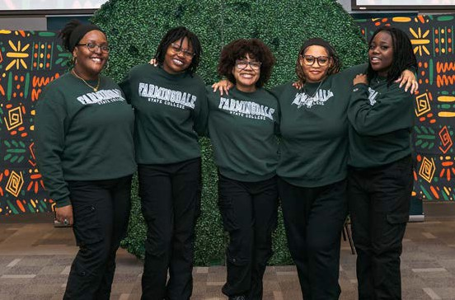

The College also successfully completed a system-wide SUNY Title VI audit and incorporated feedback from SUNY’s Office of General Counsel to strengthen reporting, referral, and case-review practices.

Additional improvements included implementation of SUNY’s revised discrimination complaint procedure, expanded Title VI resources, and clearer reporting pathways for the campus community.
Participation in required training remained strong. The College achieved a 94.8% completion rate for Title VI training and 90% employee compliance with required Sexual Harassment Prevention Training. These results reflected continued attention to ensuring that members of the campus community understand their rights, responsibilities, and the resources available to them.
Through its Title VI and Title IX responsibilities, DEIE also supported the College’s response to concerns involving discrimination, harassment, retaliation,
sex discrimination, and related civil rights matters. This work included education, outreach, prevention, case management, and collaboration with offices throughout the institution.
Together, these efforts supported the broader goal of maintaining a campus environment in which students and employees can focus on learning, working, participating, and contributing to the College community.

Education & Prevention
Education and prevention remained central to the work of the Title IX Office throughout the academic year. Rather than limiting outreach to the required training, the Office maintained a visible presence across campus and created repeated opportunities for students and employees to engage with topics related to safety, healthy relationships, respect, and inclusion.
During 2025-2026, the Title IX Coordinator delivered 52 workshops and training sessions reaching 2,538 participants. The Office also facilitated 10 Safe Space workshops focused on LGBTQ+ inclusion and awareness.
Campus outreach included 30 information tables addressing topics such as Title IX, healthy relationships, sexual assault prevention, dating violence, stalking, bystander intervention, and

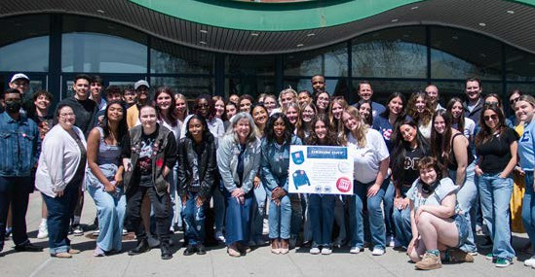
LGBTQ+ awareness. These efforts allowed the Office to reach members of the campus community in informal settings and reinforce prevention messages throughout the year.
Several signature programs further expanded education and engagement. As part of Domestic Violence Awareness Month, Farmingdale State College hosted keynote speaker Katrina Brownlee, drawing approximately 150 attendees.
The annual Take Back the Night program engaged more than 200 members of the campus community and included a campus march with approximately 100 participants, an information fair, survivor affirmation activities, keynote speaker Marlee Liss, and a clothing drive benefiting local SAFE Centers.
Taken together, these initiatives created multiple points of connection throughout the year
and reinforced the College’s commitment to prevention, awareness, healthy relationships, and shared responsibility for maintaining a safe and respectful community.

Campus Inclusion & Engagement
Creating a sense of belonging is not limited to a single program or event. It is built through repeated opportunities for students, faculty, and staff to connect with one another, learn across differences, celebrate culture and identity, and see themselves reflected in the life of the institution. Throughout 2025-2026, DEIE supported programs that created those opportunities while also connecting inclusion to Farmingdale State College’s academic and community-focused mission.
One example was the 2026 STEM Diversity Summit, held in March 2026. The Summit engaged approximately 150 students in grades

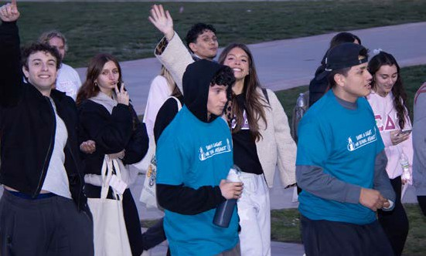
6-12 through interactive STEM programming, research presentations, and exposure to academic and career pathways in science, technology, engineering, and related fields. Developed through collaboration across the College and
with community partners, the Summit reflected Farmingdale’s broader focus on applied learning, research, innovation, and career preparation.
DEIE also supported several signature campus programs focused on connection, culture,
and belonging. The 2025 Day of Belonging, themed Celebrating Me + You = Us!, created opportunities for students to connect with campus organizations and resources, hear student perspectives on identity and resilience, and participate in activities centered on belonging and community.
The Fifth Annual First-Generation College Student Celebration featured a week of programming recognizing the achievements and experiences
of FSC’s first-generation students. Events included a First-Generation Freshmen Fest, the Tri-Alpha Honor Society Induction Ceremony, a campus celebration of first-generation pride, and a mentoring program connecting high school students with first-generation college students.
Cultural and heritage programming also included International Mother Language Day, the FSC Football World Cup, a Native American Heritage Month program featuring the Chankas of Peru and artist and educator Denise Silva-Dennis, and the 2026 Black Excellence Gala, which celebrated Black culture, achievement, creativity, and student voices through performances, fashion, music, and community-building.
During Women’s History Month, Bound by Brilliance: Celebrating FSC’s Women Authors
highlighted the scholarship and published works of Farmingdale’s women faculty and provided opportunities for members of the campus community to engage with their research, writing, and creative contributions.
Together, these programs created meaningful opportunities for members of the Farmingdale community to connect, learn from one another, and build relationships across campus.

DEIE Innovation Grant Program
The DEIE Innovation Grant Program provided faculty and staff with resources to turn ideas for strengthening inclusion, belonging, access, and engagement into action.
Through these grants, faculty and staff were able to turn ideas into practical initiatives that strengthened inclusion, access, and engagement
across the College. In doing so, the grant program helped extend responsibility for inclusion
beyond the DEIE office and encouraged broader participation in shaping the campus experience.

2025-2026 DEIE Innovation Grant Recipients
 Suzelle Zamore, PhD – Farmingdale Roots: Voices of Belonging in Motion
🕥 A short-film project highlighting campus stories of belonging, cultural heritage, and identity through student and community voices.
 Yaping Li, PhD – Growth and Success from Diversity, Equity, and Inclusion in the AAPI Community
🕥 A campus-wide initiative supporting engagement, inclusion, and growth within Farmingdale’s AAPI community.
 Jaime Hartless, PhD and Tony DeSimone – Count Me In! Gender and Sexual Identity
Representation in Research Recruitment and Data Collection
🕥 A project focused on more inclusive approaches to gender and sexual identity data collection in research.
 Jennifer Ackerman – Campus Pride Index Speaks
🕥 A career-readiness initiative connecting students with LGBTQIA+ affirming employers, mentors, internships, and professional pathways.

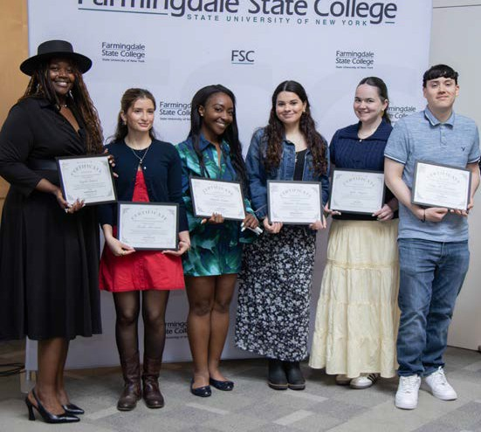
 Fatoma Rad – Professional Headshot Event
🕥 A complimentary headshot event expanding access to professional resources for LinkedIn, job applications, and networking.
 Tevin Foster – Reflected Right: Equitable Representation Through Campus Imagery
🕥 A project focused on creating campus imagery that more accurately reflects the diversity of Farmingdale’s student community.
Together, these projects helped extend inclusive excellence across academic, professional, and student-facing areas of the College.
Institutional Recognition & Partnerships Farmingdale State College’s continued commitment to diversity and inclusion was also recognized nationally through its selection as a 2026 HEED Award recipient, marking the College’s fourth time receiving the distinction.
The College also recognized members of the campus community whose work reflected its commitment to diversity and inclusion. At the 2025 President’s DEI Award Ceremony,
Farmingdale honored Tevin Foster, Associate Director of Digital Content, and Michelle Torres-Ventura, Bioscience major and SGA President, for their contributions to the campus community.
Much of the work advanced through DEIE depended on partnership. Programs and initiatives throughout 2025-2026 brought
together academic schools, administrative offices, and student-facing departments around shared goals related to access, education, prevention, belonging, and student success.
The STEM Diversity Summit, Title VI and Title IX education, Safe Space workshops, prevention initiatives, Innovation Grants, and signature campus events all reflected the importance of collaboration in extending the reach of DEIE work across the College.
These partnerships also reinforced the understanding that inclusion and belonging are shared institutional responsibilities. While DEIE provides leadership, coordination, education, and support, meaningful progress depends on the participation of individuals and departments throughout the campus community.
Together, these efforts helped build a more welcoming, connected, and inclusive Farmingdale community while creating momentum for continued progress in the year ahead.

 | Fall 2024 | Fall 2025
Race/Ethnicity- Total Enrollment
Total Students | 10,039 | 10,106
White Non-Hispanic | 3,776 | 3,619
Black Non-Hispanic | 1,146 | 1,125
Hispanic | 2,970 | 3,177
Native Hawaiian  or Other Pacific Islander | 25 | 19
Asian | 1,338 | 1,323
American Indian/ Alaska Native | 37 | 42
Two or More Races | 373 | 394
U.S. Non-Resident | 289 | 330
Unknown | 85 | 77
Campus % All Minorities | 58.7% | 60.2%

ENROLLMENT MANAGEMENT

Enrollment Position
Farmingdale State College continued its strong post-pandemic enrollment recovery during 2025-26 and enters fall 2026 from a position of
considerable strength. Total enrollment has grown from 9,314 students in fall 2022 to 10,039 in fall 2024 and 10,106 in fall 2025. As of September
10, 2026, enrollment stands at 10,395 students, surpassing the College’s fall 2026 goal of 10,200 by 195 students and representing approximately
11.6 percent growth since fall 2022.
This progress reflects sustained efforts across recruitment and enrollment at all levels and cohorts, yield, student engagement, financial aid, and coordinated enrollment planning.
While the September 10 figure remains pre-census and some normal attrition is anticipated through schedule adjustments, non-payment cancellations, and other census-related activity, Farmingdale enters the final census period well ahead of its stated enrollment goal.
The College’s enrollment trajectory represents both a significant institutional accomplishment and an important transition in enrollment strategy. Farmingdale has moved beyond simply recovering from pandemic-era enrollment losses and has entered a new phase in which the focus must increasingly shift from recovery to intentional,
sustainable growth. Continued success will depend not only on attracting additional students, but also on improving retention and persistence, diversifying recruitment pipelines and geographic markets, strengthening transfer pathways, expanding graduate and online enrollment,
and aligning enrollment growth with academic programs and institutional capacity.
This next phase will require enrollment planning to remain closely connected to decisions involving academic program development, housing, classroom capacity, staffing, student services, technology, and other infrastructure necessary to support a growing and increasingly diverse student population. During 2026-27,
the Division of Enrollment Management will build upon the College’s current momentum with a continued focus on sustainable growth, enrollment diversification, student success, and the institutional capacity necessary to support Farmingdale’s long-term enrollment strength.

Year | Total Enrollment | Annual % Change
Fall 2020 | 10,018 | —
Fall 2021 | 9,348 | -6.7%
Fall 2022 | 9,314 | -0.4%
Fall 2023 | 9,541 | +2.4%
Fall 2024 | 10,039 | +5.2%
Fall 2025 | 10,106 | +0.7%
Fall 2026* | 10,395 | +2.9%

*Fall 2026 enrollment is as of September 10, 2026 and remains pre-census
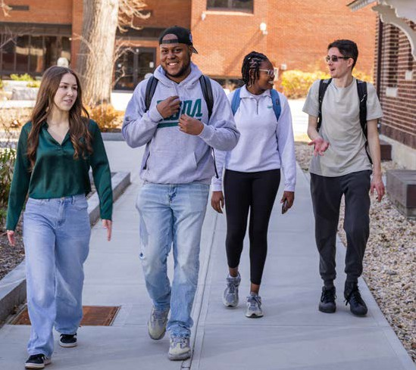

Applications, Acceptances, and Enrollment Funnel
Farmingdale’s first-time student enrollment funnel has changed considerably over the past five admission cycles. The top of the funnel has expanded significantly, generating a substantially larger applicant pool and broadening the College’s reach among prospective students. As application volume has grown, however, yield rates have declined. Some of this movement
is a natural consequence of a larger and more diverse applicant pool, but it also reinforces

an important shift in how the College should evaluate recruitment performance. Application volume alone is no longer an adequate measure of enrollment success.

The next opportunity is to convert more of the demand Farmingdale has already generated into enrolled students. Accordingly, the operational emphasis for 2026-27 will shift more intentionally toward yield, engagement, and conversion throughout the enrollment funnel. This will include greater use of segmented and personalized admitted-student communications, earlier and more frequent campus engagement, enhanced admitted-student programming, financial aid coordination, parent and family outreach,
and targeted interventions for students who demonstrate interest but have not yet completed critical enrollment steps.
Greater attention will also be placed on understanding where students disengage from the funnel and using enrollment data to inform timely interventions. Deposit behavior, financial aid completion, event participation, registration activity, communication engagement, and other indicators can help identify opportunities to improve conversion before students are lost from the pipeline.
As Farmingdale enters its next phase of enrollment growth, the objective is not simply to generate more applications, but to build a more productive enrollment funnel in which increased student interest translates more consistently into deposits, registrations, and ultimately enrolled students.

Recruitment, Market Development, and Enrollment Operations
Recruitment operations continued to become more systematic, integrated, and data-informed during 2025-26. Enrollment
Management strengthened its use of forecasting, funnel analysis, student search, segmented communications, digital marketing, territory management, campus visits, Open Houses, Admitted Students Day, financial aid engagement, and parent and family communications. Together, these efforts are advancing a recruitment model that treats enrollment as a continuous cycle rather than a series of seasonal campaigns. Earlier engagement with high school sophomores and

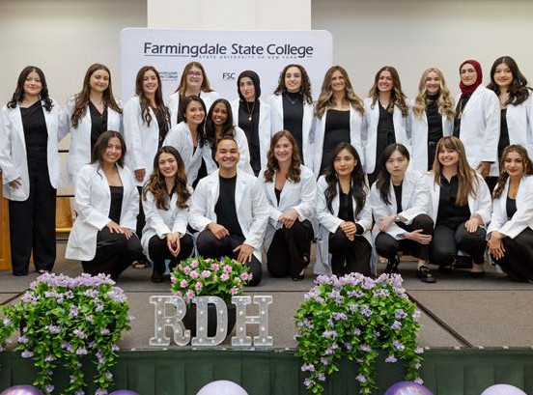
juniors is also becoming an increasingly important component of this strategy, allowing Farmingdale to build awareness, interest, and inquiry volume well before students enter the traditional senior-year recruitment cycle.
Farmingdale continues to draw the overwhelming majority of its undergraduate students from Long Island and New York City. Nassau and Suffolk counties remain the College’s dominant markets, while Suffolk County Community College and Nassau Community College together account
for approximately 55 percent of new transfer students. These relationships represent a significant enrollment strength and must continue to be cultivated and protected. At the same time, this geographic concentration presents long-term risk as the regional K-12 population contracts and competition for college-going students intensifies.
The next phase of Farmingdale’s recruitment strategy will balance continued strength in its core markets with selective geographic expansion.
New York City, Westchester and the Mid-Hudson Valley, northern New Jersey, Connecticut, and eventually other Northeast markets represent opportunities for measured growth. Expansion will be program-driven rather than geography-driven alone, concentrating resources around academic offerings with the strongest potential to attract students beyond Farmingdale’s traditional Long Island commuter market.
Supporting this expansion will require an increasingly sophisticated enrollment marketing strategy. Enrollment marketing will need to begin moving toward measurable inquiry

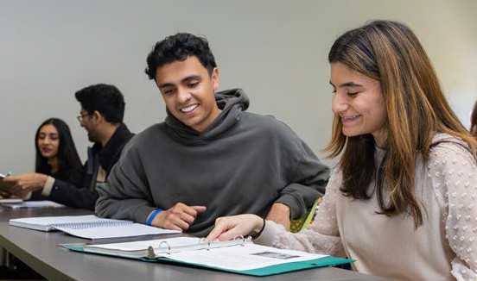
and application generation, program-specific campaigns, audience segmentation, retargeting, conversion-focused digital strategies, and documented return on investment. Broad institutional awareness remains important, but enrollment marketing must increasingly connect investment to measurable movement through the enrollment funnel, from prospects and inquiries to applications, deposits, registrations, and enrolled students. This approach will allow the College
to better understand which markets, programs, audiences, and strategies are producing enrollment results and where resources can be deployed most effectively.
Graduate enrollment represents another significant opportunity for institutional growth and diversification. In fall 2025, graduate students represented only approximately 0.4 percent of total College enrollment, leaving considerable room for expansion. The launch of the online
M.S. in Nursing Administration demonstrated the potential for carefully selected programs and delivery models to reach students beyond Farmingdale’s traditional commuter market. Sustained graduate growth, however, will require more than the introduction of new academic programs. It will require dedicated recruitment, lead generation, admissions support, targeted
marketing, streamlined enrollment processes, and a clearly defined institutional point of responsibility for graduate enrollment development.
Housing is also increasingly connected to the College’s broader enrollment strategy. Residence hall enrollment grew from 418 students in fall 2021 to approximately 580 in fall 2025, bringing the College close to the capacity of its roughly 600-bed residential system and resulting in a housing waitlist. This growth signals both demand
and opportunity. Additional residential capacity could strengthen recruitment from New York City and emerging regional markets, extend Farmingdale’s geographic reach, enhance the College’s competitiveness, and provide students with greater opportunities for engagement, connection, and persistence. As Farmingdale considers its future enrollment capacity, housing
will remain an important component of long-term enrollment strategy, extending beyond student-life and facilities considerations.

Retention and Student Success
Enrollment growth cannot be sustained through recruitment alone. As Farmingdale’s enrollment continues to grow, retaining and supporting the students already enrolled becomes increasingly important to the College’s long-term enrollment strength. One-year retention for the fall 2024
first-time, full-time bachelor’s cohort reached 83.0 percent. This continues the upward movement from approximately 80 percent earlier in the decade and brings Farmingdale closer to its institutional goal of 85 percent.
The College has continued strengthening proactive approaches to student persistence and success. Redesigned Early Alert and Academic Warning initiatives are helping identify students who may be experiencing academic or other challenges earlier, creating opportunities for intervention before those challenges become barriers to continued enrollment. This work reflects a broader shift toward a more proactive and coordinated approach to retention, with enrollment, academic, advising, and student-support functions increasingly connected around student success.
These priorities align closely with SUNY’s Academic Momentum Campaign, launched in fall 2025, which calls for measurable improvements in one-year retention, credit accumulation, gateway English and mathematics completion, FAFSA completion, graduation, and the elimination
of completion gaps for Pell-eligible and other student populations. Farmingdale’s participation as an ACE campus beginning in fall 2024 further strengthens this work by connecting the College to one of SUNY’s most significant systemwide initiatives focused on persistence, timely degree completion, and student success.

Looking ahead, Farmingdale will continue developing a more integrated student-success model that connects recruitment, enrollment, financial aid, advising, academic support, and student engagement throughout the student lifecycle. Particular attention will be given to points where students are most vulnerable to stopping out and to populations experiencing persistence gaps. First-Year Experience, proactive advising, peer mentoring, wellness and basic-needs support, student engagement and belonging, financial aid outreach, and early academic intervention all represent important components of this work.

As Farmingdale moves from enrollment recovery toward sustained growth, retention will become an increasingly important part of the enrollment equation. Moving from the current 83 percent retention rate toward and ultimately beyond
the College’s 85 percent goal would strengthen student outcomes while also reducing the number of new students the College must recruit each year simply to offset attrition. In this sense, retention is not separate from enrollment growth. It is one of the most important strategies for sustaining it.
Strategic Priorities for 2026-27 and Beyond Farmingdale enters 2026-27 from a position of enrollment strength. The College has moved beyond recovery from pandemic-era enrollment losses, surpassed 10,000 students, expanded its applicant pool, strengthened recruitment
operations, and improved first-year retention. The next phase will move beyond a primary focus on enrollment volume toward a broader Strategic Enrollment Management framework centered on sustainable growth, diversification, conversion, persistence, and institutional capacity.
The immediate priority is to preserve a fall 2026 census enrollment of at least 10,200 students while continuing to strengthen the enrollment funnel. Recruitment will focus on improving admit-to-deposit and deposit-to-enrollment conversion, selectively expanding into new geographic markets, and protecting and growing Farmingdale’s strong transfer pipeline. The College will target first-year retention of at least 84 percent in the next measured cohort, with continued progress toward the established 85 percent goal.
Graduate enrollment will become a more deliberate institutional growth priority as new programs and delivery models are developed. This will require dedicated recruitment, lead generation, marketing, admissions support, and clearly defined institutional responsibility for graduate enrollment development.
Finally, future enrollment goals will be connected to a comprehensive assessment of institutional capacity, including housing, classrooms,
course availability, faculty and staffing, student services, technology, and academic program mix. Enrollment growth must be accompanied by the infrastructure necessary to support student success and maintain the quality of the Farmingdale experience.
Farmingdale’s recent enrollment performance demonstrates strong demand for the institution. The challenge ahead is not simply to enroll more students, but to convert that demand into a more diversified, persistent, and successful student population. Strategic Enrollment Management provides the framework for connecting recruitment, retention, student success, academic planning, and institutional capacity around that shared goal.
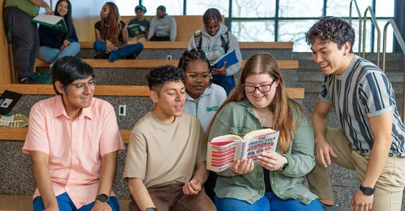

MARKETING AND COMMUNICATIONS

Major Initiatives / Successes in 2025-2026
In the 2025-2026 academic year, Marketing and Communications continued to build momentum in brand-specific and visual storytelling, visibility, and awareness.

The team drove communications with fully integrated launch plans for four new academic programs, including two master’s programs which are a high strategic priority for Farmingdale as we build our graduate programs.

With a cut to advertising and marketing budgets, the team focused on high-impact strategies while building other channels, such as social media, media outreach, and government relations for continued visibility and engagement with key audiences.
A homepage redesign, custom coded and completed in-house by the web development staff, created a more engaging user interface with vibrant and compelling visuals. Several new features, including scrolling homepage “hero” stories, graphic animation, and a “movie theater” style video section provided visually persuasive links to important and relevant pages.
Brand guidelines were updated and expanded to include photography and logo and color usage, while emphasizing the brand message constructs.
With growing demand and reduced resources in both media production and design departments, processes are being adjusted to streamline workflow. New intake forms will provide up-front information to assist in the evaluation and planning stage for video and design requests. In addition, a new digital asset management system is in development, to digitize and greatly simplify
organization, storage, and sharing of visual assets. These initiatives are designed to add efficiencies in the development of marketing materials and help Marketing & Communications better support the campus community.
The Marketing and Communications department at Farmingdale State College continues to perform at the level of a much larger team, producing
integrated materials, quickly pivoting when needed, and continuing to serve the College’s overarching goals and campus-wide departments.

Academic Initiatives
During 2025–26, Marketing and Communications expanded its support for new and evolving academic programs, working with Academic Affairs to ensure programs were effectively incorporated into the College’s marketing, communications, and recruitment efforts.

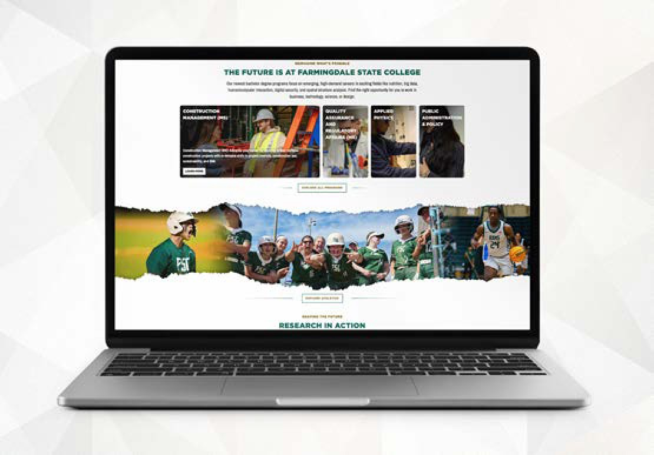
During the year, Marketing and Communications supported the launch and promotion of several new and evolving academic programs, including the BS in Public Administration and Policy, BS in Applied Physics, Health Promotion and Wellness – Exercise Professions Track, MS in Construction Management, MS in Quality Assurance and Regulatory Affairs (QARA), and the fully online

B.S. in Applied Economics.
The MS in Construction Management was one of the first programs to receive an updated, integrated marketing rollout, with homepage promotion, a Newsroom story, press and media outreach, social media, updates to the Academic Programs listing and department page, external signage, and Google Search support. The program launch also received earned media coverage from Long Island Business News.
Marketing for the MS in Quality Assurance and Regulatory Affairs (QARA) was also launched during 2025–26 in advance of the program’s Fall 2027 start. Marketing efforts introduced the new graduate program and its focus on preparing students for careers in highly regulated industries, including pharmaceuticals, biotechnology, medical devices, cosmetics, food, and manufacturing.
In addition to individual program launches, MarCom developed the Academic Programs Reimagined story for the FSCNow annual magazine to bring these new and evolving programs together under a broader institutional narrative. The story highlights how FSC’s academic portfolio continues to respond to student needs, workforce demand, emerging technologies, and new career opportunities.

Together, these efforts created a more consistent approach to marketing new and evolving academic programs and strengthened coordination between academic areas and Marketing and Communications, while ensuring students and prospective students receive clear, accurate, and timely information.

Advertising and Marketing
Marketing and Communications launched more focused advertising campaigns aimed at specific audiences and geographic regions to support the College’s goals of expanding its reach and visibility, supporting enrollment, and promoting key academic and initiatives.
Total advertising generated more than 20 million impressions during the reporting period, compared to 34.6 million impressions in 2024–25. The decrease in impressions was due to a reduced advertising budget which necessitated shorter campaign durations, and fewer high-volume media placements.

INTEGRATED MARKETING PLAN: OCTOBER 1, 2025 – JUNE 1, 2026
CAMPAIGN | LOCATION/ NOTES | IMPRESSIONS
Suffolk Bus Transit | Suffolk County | 3,520,000
Mall Advertising (3 locations) | Roosevelt Field, Smith Haven, Walt Whitman | 4,935,469
Clear Channel Static Billboard | Van Wyck Expy ES 0@ East Rd F/S | 2,334,559
Admissions Guide (Print + Digital) | Distributed to LI schools, libraries, fairs | 115,000
Newsday (Print  + Digital) | Four Education Issues | 1,430,000
NY Giants/Jets Yearbooks | In-stadium sales | 1,425,000*
Digital Advertising Campaigns | Event-based, branding, program-specific | 6,250,691
TOTAL IMPRESSIONS  (October 1, 2025 – June 1, 2026) |  | 20,010,719

Despite the reduced advertising budget, FSC continued to maintain a strong presence across multiple advertising channels, while focusing available resources on priority audiences, geographic areas, enrollment initiatives, academic programs, and institutional branding. Digital advertising was used throughout the year to support enrollment events, institutional branding, academic programs, and targeted outreach.
Advertising continued to focus on telling the Farmingdale story and creating a stronger connection with prospective students. Student stories and personal quotes were incorporated into branding campaigns to highlight the student’s
experience and provide a more personal connection to the College.
Brand video content, including the new “Mantra 2.0” and “Hype” videos, were also used in digital advertising to showcase Farmingdale’s students, academic opportunities, campus experience, and overall, College identity.
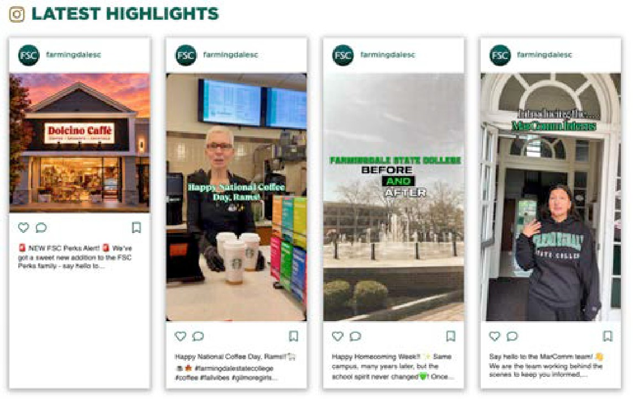

Social and Digital Media
Our social media channels continue to experience strong growth, driven by a more authentic content strategy that emphasizes real campus experiences, compelling storytelling, and engaging photos and graphics.
Audience growth on priority social media channels included:
 Instagram: +21.8%
 LinkedIn: +11.8% (up from 9% last year)
Social media promotion focuses on large-scale, high-impact events that resonate with broad audiences, including FSC’s Ramchella carnival

and musical performance, commencement, prominent guest speakers, and institutional observances such as Women’s History Month and Black History Month. Marketing & Communications will continue to collaborate

with campus partners to coordinate promotional efforts and maximize visibility. Strategically planned videos and reels highlight authentic student experiences and timely campus moments including the first week of classes, traditions, student life, athletics, end-of-semester activities and “behind-the-scenes” campus experiences.
For example, on LinkedIn, posts with the highest engagements included Gaten Matarazzo’s campus lecture, the 2026 commencement,
and a partnership with Catholic Health. Highest engagement on Instagram were also from the Gaten Matarazzo’s event, a Ram-Bo / Wolfie partnership in Mascot Madness, and FSC’s lavender graduation ceremony.
The goal is to cultivate a visually engaging, story-driven feed featuring authentic student experiences, compelling photography, and strategically produced video content, while reducing the emphasis on low-engagement event promotion.

Campus Events
MarComm collaborated with Events Management,
Institutional Advancement, and Student Affairs in promoting many of the College’s signature events, with integrated marketing strategies that combined social media, email marketing, web content, print collateral, photography and video, media outreach, campus signage, and creative design to maximize awareness and audience engagement. These events included:
 Homecoming
 Convocation
 FSCNOW 2025
 Finding Balance in the Upsidedown with Gaten Matarazzo
 Gold Medal Mindset: A Conversation
with Olympic Gold Medalists Aly Raisman & Laurie Hernandez
 Inspiring Leadership: Our Collective Reality: Challenges and Opportunities Facing Higher Education Today
 Commencement 2026
Each event’s “campaign” was tailored to its target audience to optimize engagement and expand reach. Performance metrics—including website traffic, social media reach, and event registrations—were continuously monitored to refine campaign strategies and maximize engagement and attendance.

External Outreach & Media Successes
Throughout the 2025-2026 academic year,
FSC garnered media attention through campus initiatives, FSC-generated news, and expert quotes in topical news stories. The Communications team’s commitment to relationship building and responsiveness to media over the last several years, combined with faculty expertise in areas relevant to Long Island and the metropolitan areas, have garnered results.
Targeted media coverage has increased 16% over the prior academic year. This included an 18% increase in coverage in Newsday, and a 7% increase in News12, two important and highly relevant media outlets given our current and prospective students are primarily local to Long Island. In a highly competitive media market, with several neighboring higher education institutions, FSC successfully leveraged the following initiatives and events into news media coverage:
 Farmingdale’s economic impact report, with the Long Island Association (LIA)
 Long Island RailRoad strike contingency planning for students, faculty and staff
 FSC graduate Matt Seelinger’s Major League Baseball debut with the NY Mets
 Island Harvest food drive on FSC’s campus during the government shutdown
In addition, faculty were interviewed on topics such as: aviation incidents including the LaGuardia runway collision and Hudson River emergency landing; buildings, bridges, and roadway
infrastructure; government and politics; tariffs, taxes and union wages; and “Knicks mania” during the NBA playoffs. News12 continues to support Ram-Bo in SUNY’s annual Mascot Madness competition.
Newsday attended and ran a “daily” story on the President’s leadership panel FSC hosted, with Presidents from four Long Island higher education institutions. Two guest essays by President Prezant were pitched to Newsday and ran in the Opinions section.

New media outlets were added in the New York City metropolitan market, with segments

featuring Farmingdale or faculty spokespeople in CBS New York, NBC New York, Fox 5, WPIX, and 1010 Wins radio.

Government Relations
FSC has continued to grow its relationships with government and key external partners. Notably, FSC’s government relations team has organized more than two dozen meetings, events, and new collaborations with elected officials, government offices, and community organizations, including the Long Island Association, Queens Borough President Donovan Richards, Catholic Health, Island Harvest, JetBlue, and the Association of Mental Health and Wellness. These influential engagements have led to valuable partnerships and projects that directly benefit FSC’s diverse student body, including support for campus projects and student internship opportunities.
The 2026 Legislative Breakfast underscored FSC’s successful relationship-building efforts, attracting strong representation from more than a dozen village, town, county, state, and federal offices and drawing a record-setting crowd of more than 100 business and community leaders from across the region.
Other FSC initiatives included a SUNY Advocacy Day in Washington, D.C., where the College’s government relations team met with federal officials from more than 10 congressional offices, including the entire Long Island congressional delegation. The team also participated in SUNY’s Ag & Tech Advocacy Day in Albany, meeting with representatives from eight New York State offices
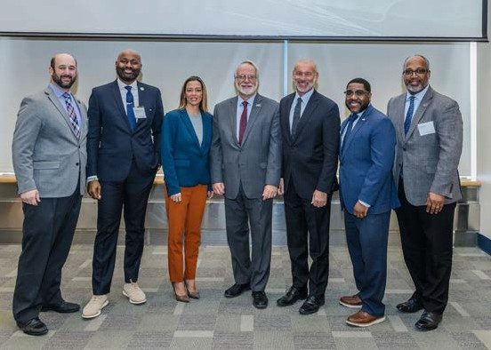

to advocate for key campus priorities, including funding for FSC’s EOP and ACE programs, critical operating aid, and vital land lease legislation. These important efforts contributed to the successful passage of the land lease legislation and continued state support for the campus.
Additionally, FSC continued its advocacy efforts in support of the Empire State Licensing Act, the Engineering Technology Licensure Parity Act,
federal appropriations, and initiatives benefiting the College’s Department of Aviation.
As FSC continues to cultivate these partnerships and pursue new opportunities for engagement, the College is well-positioned to expand its impact during the upcoming 2026-27 academic year.

Website & Analytics
The College website continued to evolve throughout the 2025-2026 academic year, with a strong emphasis on recruitment, user experience, accessibility, and digital communications. Several high-impact webpages and communication platforms were redesigned using modern design principles, improved delivery of information, and enhanced accessibility standards to better serve current students, prospective students and parents, faculty, staff, and the broader community.
The College homepage received a comprehensive refresh designed to better reflect the institution’s evolving brand, strategic priorities, and campus community. The redesign modernized several sections of the homepage while improving user engagement and high-priority content. The new homepage garnered a 19% increase in views over the previous academic year.
The homepage enhancements include a redesigned Academic Programs section with a modern
card-based layout that highlights new academic offerings; new Athletics section with a custom animated page transition that visually “tears” the page; Research feature that link to faculty and student research stories; a video section enhanced by transforming the hompeage into a “theater” that darkens and lightens depending on where the user is on the page.
Two important but outdated recruitment resources, the Future Students and Parents webpages, underwent comprehensive redesigns to better support prospective students and their families

throughout the college search process. Both pages were custom coded with stronger visual storytelling, authentic photography, interactive page elements, and clear calls to action that guide visitors toward applying or requesting additional information.

To improve support for the College’s more than 150 website content contributors, Marketing and Communications developed a new library of
on-demand CMS training videos for faculty and staff. The videos provide step-by-step instruction on essential CMS functions, allowing content contributors to access training videos whenever needed, rather than waiting for scheduled in-person training sessions. These readily available resources reduce response time for ticket requests and allows the web team to dedicate more time to website enhancements and complex projects.
With accessibility as a central focus across all website initiatives, every new feature was
developed with accessibility in mind, ensuring that navigation, content structure, color contrast, interactive components, images, and page layouts support users of varying abilities. These efforts advance the College’s ongoing commitment to providing an inclusive digital experience while preparing for evolving federal accessibility requirements.
Digital Communications Enhancements Marketing and Communications continued to expand and improve the College’s digital
communication platforms through significant enhancements to its campus e-publications.
FSCToday, the official newsletter of Farmingdale State College distributed to more than 12,000 students, faculty, staff, retirees and SUNY leadership, received a complete redesign that aligns with the College’s broader web design standards. The updated experience improves readability, mobile responsiveness, content organization, and accessibility while providing
a cleaner and more engaging presentation of campus news and announcements.
This year also marked the launch of Ram-Bo’s Rundown, a new student-focused newsletter developed entirely in-house for the Division of Student Activities. Rather than relying on
third-party newsletter software, Marketing and

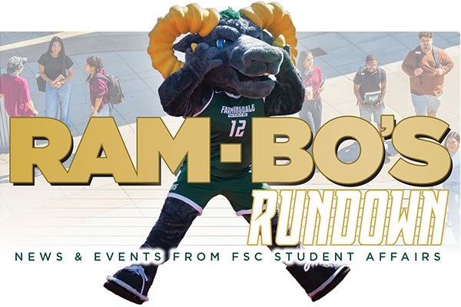

Communications designed and developed a custom coded newsletter publishing system integrated directly into the College’s content management system (CMS). This allows staff to create, manage, archive, and publish each monthly edition through familiar CMS workflows while reducing manual production time.

Design and Production
The in-house design and production team supported Marketing and Communications initiatives and departments across campus, completing 385 projects in the 2025–2026 academic year. Operating as an in-house creative agency, the team provided strategic design support while helping the College avoid significant external creative costs. With the loss of a senior team member due to reorganization, the design team was restructured and work streamlined to ensure maximum efficiency and productivity.
Through close collaboration with Marketing and Communications staff and campus partners, the team delivered a wide range of print, digital, and environmental projects, including:
 Presentation materials, table takeaways, and marketing collateral for the annual Legislative Breakfast.
 Recruitment materials, including a travel brochure, 36-page viewbook, acceptance package, and a variety of supporting materials.
 The President’s Newsletter distributed each semester to high school principals.
 The FSCNow magazine and accompanying microsite.

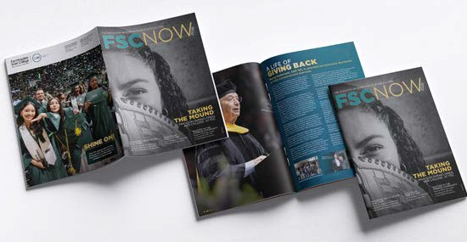
 Numerous print and digital pieces promoting Continuing Education and University in the High School programs.
 Graphics for various website projects and redesigns.
The team was recognized with six design awards from SUNY CUAD and the Educational Advertising Awards, recognizing outstanding work across print and digital media. Recognized projects included FSC’s Next Steps brochure, FSCNow 2025 magazine, Greenley Library signage, and the President’s Newsletter.
As the College continues to expand its advertising reach, the design and production team remains focused on ensuring that graphics, designs, and illustrations effectively engage target audiences while maintaining the integrity and consistency of the College’s visual identity at every touchpoint.

Media Production
Throughout the 2025-2026 academic year, the media production team continued to strengthen FSC’s visual storytelling through video production, strategic photography, event coverage, and improved digital asset management. These
efforts supported recruitment, institutional communications, academic storytelling, advertising, social media, news coverage, and the documentation of significant College events and accomplishments.
Ten video projects were completed during 2026 supported major institutional moments, student engagement, recruitment, and academic-program promotion across seven major academic and administrative areas. Featured productions included two distinct 2026 Commencement videos, an Admitted Students welcome video, Open House coverage, the “I Heart FSC” giving day campaign,
and program-focused videos highlighting Visual Communications, Nursing, and the Nursing Administration M.S. degree. Selected examples are linked below.
More than 110 College events were photographed or filmed during the 2025-2026 academic year by media production staff, interns, and freelance professionals. Original photography was used across recruitment, out-of-home and digital advertising, and digital assets in addition to the FSCNow annual magazine, College news stories, academic-program promotions, social media, institutional publications, and executive and faculty portraits.
A significant advancement was the implementation and development of a digital asset management (D.A.M.) system to provide a centralized and searchable location for storing, organizing, sharing, and preserving the College’s most valuable marketing photography. This was developed in response to a dated categorization system and
time-consuming searches for photo requests, video, and design projects. The D.A.M. will enable campus departments to search and download photography, adding efficiency to the media projection and design teams, which have lost both student and staff resources.
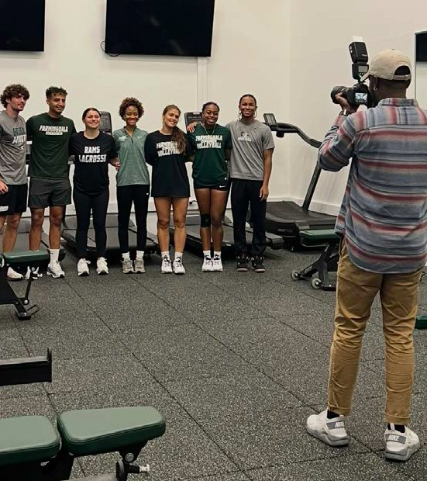

Recommendations for Actions

The ongoing transformation of the FSC website remains a top priority in today’s competitive market. Significant marketing resources, including web development, photography, video, and graphic design, combine to ensure pages remain current, align with institutional priorities, and meet constantly evolving campus needs.
Budget for advertising continues to be reduced, as we approach the enrollment cliff, and as many on campus site reputation and identity issues, and the ongoing perception that FSC is “still” a community college. With consistent budget and resource reductions, this will remain a persistent challenge.
Media production at Farmingdale is in high demand, including Presidential requests, marketing initiatives, and campus-wide support. With only one FTE and the loss of a staff member due to reorganization, adding a content producer in any capacity would strengthen the College’s capacity while ensuring work is produced at the quality and volume that addresses, meets, and exceeds college-wide goals.

INSTITUTIONAL ADVANCEMENT
The Division of Development and Alumni Engagement was renamed as the Office of Institutional Advancement, to best reflect its role in advancing the philanthropic mission of Farmingdale State College, through engagement and fundraising. Private philanthropy plays a critical role in supporting the College’s mission. In FY 2026, the Farmingdale College Foundation generated over $5 million in revenue that directly impacted every aspect of Farmingdale State College. The Foundation’s assets under management grew from $21.8 million to over
$24.5 million, a reflection of the stable and scalable investments and contributions that have been realized year over year in the last five years. The Office of Institutional Advancement expanded its philanthropic outreach efforts to engage new prospective donors and build on capacity for future support. From an alumni engagement perspective, the Office advanced new partnerships with internal constituents and the community at large, with signature events held to grow affinity to the College.

Highlights
 621 students received over $1.5 million in scholarship awards. Additionally, nine new scholarship funds were added to FSC’s portfolio
 $3.6 million in new gifts and pledges received by the Farmingdale College Foundation, on behalf of FSC
 FSC launched the Farmingdale Fund, its first ever annual giving program that is focused on growing the number of donors who support the College at all levels
 FSC held its first-ever day of giving, I Heart Farmingdale, that was successful in raising over $170,000 in gifts from 1,951 donors, that supported a wide range of campus program
 FSC launched a challenge to raise $1 million in student support that would be matched by a gift from alumnus Murray Pasternack
 Alumnus Kevin Spiegel was honored at the President’s Gala
 FSC held the 1st Pre-Law Society Gala featuring key alumni speakers
 The Rambition Award – an award-winning alumni engagement program that recognizes rising entrepreneurs, in its second year of existence, saw four winners recognized in December
 FSC Day was hosted at Brookhaven National Lab, bringing together over 100 alumni employees, faculty, college leadership
and leaders from the national lab
 Alumnus Murray Pasternack was bestowed an Honorary Doctorate of Humane Letters for his deep commitment to academic excellence
at FSC
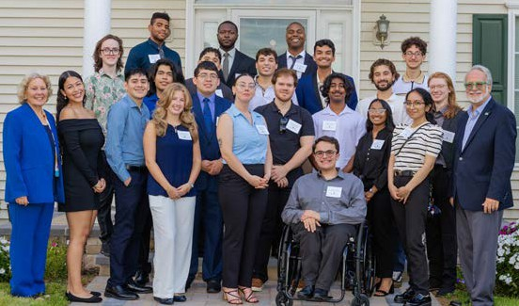

 1st FSC Hockey Hall of Fame dinner was held in May, featuring the induction of the 2007-08 inaugural team that won the first conference championship in the program’s history.
 FSC’s 50th Reunion Class was honored at the 2025 Commencement ceremonies in Nassau Coliseum
 Two Industry Partner dinners were held for Department of Architecture construction management and civil engineering, and the Department of Mechanical & Electrical Engineering Technology
 FSC added nine new corporate partners that are part of a growing network of industry supporters that support the College’s applied learning mission

Recommendation for Action – Fiscal Year 2026–2027
FY2026 closed at $3.6M in commitments — the strongest year on record that did not contain a transformational gift. For FY2027, the goal is to reach $4.0M in commitments, an 11% increase over FY2026, only 2.3% above the FY2022–FY2026 average of $3,910,218.
Our goal is structured as $3.0M core plus $1.0M in transformational gifts.

The Five-Year Record
FY2026’s $3.6M is the most important data point that set against comparable years, is the best result the Office of Institutional Advancement has produced.
Two of the last five years contained transformational gifts: FY2023 ($4,853,271) and FY2025 ($6,344,628). The three that did not
— FY2022 ($2,628,867), FY2024 ($2,124,322),
and FY2026 ($3.6M) — describe the underlying operation. Against those, FY2026 is 37% above FY2022, 69% above FY2024, and 51% above their average. The repeatable base has genuinely risen, and that is what makes a $4.0M goal a growth target rather than a wish.
The balance sheet supports the same reading. Net assets grew from $10,146,242 at the close of FY2021 to $21,769,981 at the close of FY2025 — a 21.0% compound annual growth rate. Investment income rose sixfold over the same period, to
$1,784,953, and against an endowment of roughly
$11.9M at a 4% spending rate, the Foundation now carries approximately $476,000 in annually available support that does not depend on the current-year fundraising result.

CONTRIBUTIONS TO THE FARMINGDALE COLLEGE FOUNDATION, FY 2021-FY2027
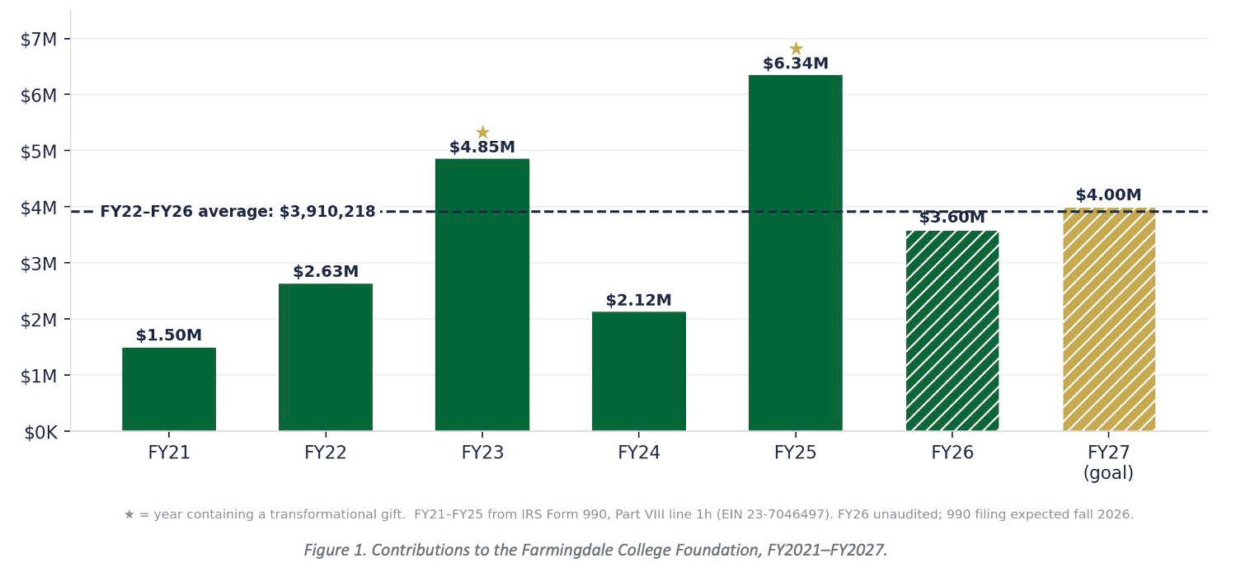

Allocating the Goal
To reach the $4M goal for FY2027, the Office of Institutional Advancement has segmented its donor allocation as follows:

Donor Segment | Donors | Avg. Gift | Plan | Revised | % of Goal
Leadership /  Major Gifts ($25K+) | 14 | $100,000 | $750,000 | $1,400,000 | 35%
Corporate & Institutional | 20 | $37,500 | $450,000 | $750,000 | 19%
Mid-Range Annual ($1K–$9,999) | 200 | $3,000 | $450,000 | $600,000 | 15%
Mid-Level Annual ($10K–$24,999) | 30 | $15,000 | $300,000 | $450,000 | 11%
Farmingdale Fund (<$1K) | 1,000 | $350 | $280,000 | $350,000 | 9%
Alumni Events & Engagement | 450 | $556 | $175,000 | $250,000 | 6%
Planned Giving (realized) | 4 | $50,000 | $95,000 | $200,000 | 5%
TOTAL | 1,718 | — | $2,500,000 | $4,000,000 | 100%

Five-Year Projection, FY2027–FY2031
These are modeled scenarios on stated assumptions, not forecasts. They are presented in three cases, so the Board chooses among possibilities rather than receiving a single number that implies precision the data does not support.
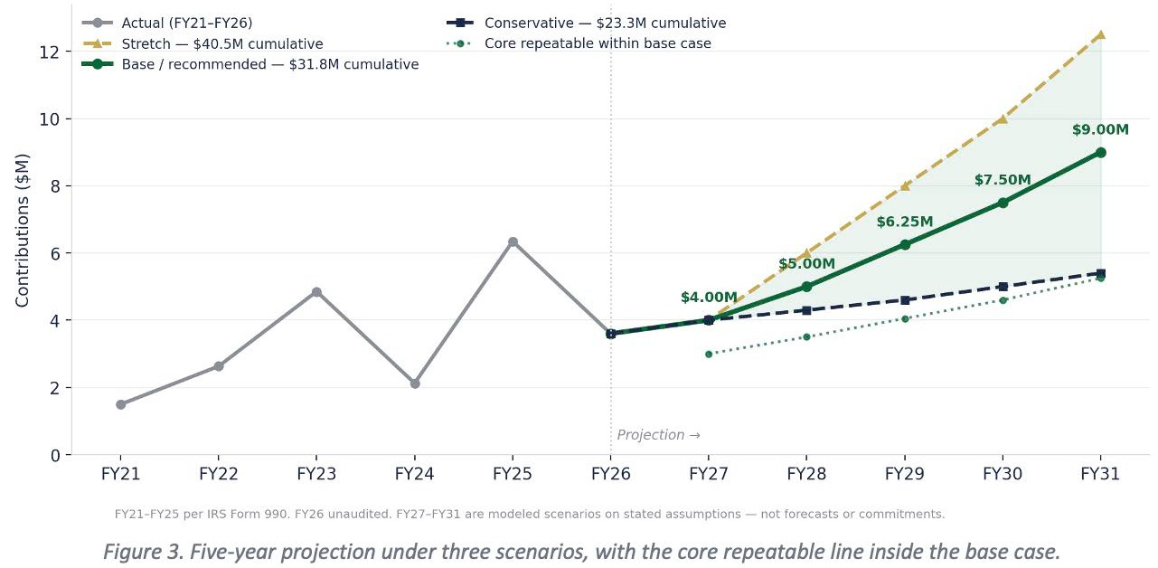

Scenario | FY27 | FY28 | FY29 | FY30 | FY31 | 5-Yr Total
Conservative | $4.00M | $4.30M | $4.60M | $5.00M | $5.40M | $23.3M
Base (recommended) | $4.00M | $5.00M | $6.25M | $7.50M | $9.00M | $31.8M
— core repeatable | $3.00M | $3.50M | $4.05M | $4.60M | $5.25M | $20.4M
— transformational | $1.00M | $1.50M | $2.20M | $2.90M | $3.75M | $11.4M
Stretch | $4.00M | $6.00M | $8.00M | $10.00M | $12.50M | $40.5M

What the base case assumes
 Core repeatable revenue grows from $3.0M to $5.25M — a 15.0% CAGR. Aggressive for a mature shop, reasonable for one installing its first modern annual giving platform, first structured planned giving program, and first
clean prospect database. It is the least visible line in the projection and the one that determines everything else.
 The corporate line compounds rather than resetting each July. Sponsorship is resold from zero every year; a written multi-year agreement is not. Four agreements at $75,000 would move $300,000 into the repeatable column permanently.

 Annual Donor Retention improves from 55% to 65% across the annual and mid-range
segments. Each point compounds. This depends on the stewardship commitments already in
the plan — 60-day impact reporting, named scholarship stewardship, the phonathon thank-you program — being executed rather than deferred when the year gets tight.
No investment return is included; these are contributions only. The base case does not require the institution to outperform its history — FY2023 and FY2025 both exceeded it. It requires a floor underneath that history. On standard CASE counting conventions, a $31.8M five-year base would support a comprehensive campaign in the
$50–60M range.
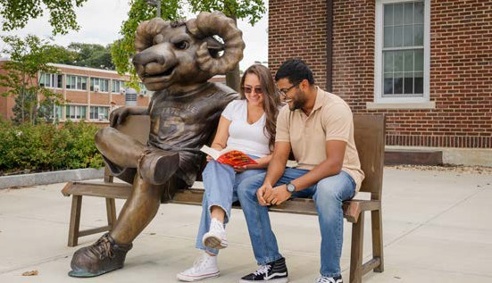

ADMINISTRATION AND FINANCE

Financial Overview
The current overall financial position of Farmingdale State College remains strong, but we have needed to make a number of important decisions in order to protect this position. We once-again exceeded the benchmark 10,000 student level in fall 2025 and so tuition revenue remained stable, but flat.
In addition, NYS support continued over the prior year and provided much-needed resources to address increasing pressure on the campus
budget as driven by rising payroll costs and other economic forces.
During AY 25/26 the College spent $116.4 million across all categories. This is an all-time high in terms of spending and the revenue supporting this level of spending has also reached a record level. While the College had forecast an operating deficit during the academic year, fiscal constraints were successful in achieving an operating surplus of $800,000 and an improvement to our cash position of over $7 million, driven largely by one-time infusions of cash for specific projects.

However, as we look into the future, collective bargaining has placed a significant challenge on our ability to operate. This latest contract includes an over 20% compounded impact on the campus payroll over the next 5 years. Without a dramatic shift in our funding model this will have disastrous implications on campus cash flow and, ultimately, financial viability.
We mentioned in last year’s report that these economic conditions are not sustainable. With the ever-rising cost of operation, much of which is outside our control, and in tthe absence of a tuition increase for now over 6 years, we need to continue to adjust our budgetary approach in
order to ensure fiscal solvency. We’re anticipating another strong year from an enrollment perspective but with even more pressure on
our financial environment driven by negotiated increases we cannot avoid reductions in support for other campus programs and services.
While we had success this past year in closing a budget gap and our overall position remains
healthy, this approach is not sustainable if we are to expect to continue to provide the outstanding college experience our students
have come to expect here at Farmingdale. We need the legislature and the Governor to support a rational tuition plan that will authorize the Board of Trustees to not only provide for modest
adjustments to tuition and fees which would serve as huge relief to SUNY’s campuses and allow students and their families to plan for increases over time.

Organization
With the close of AY 25/26 Farmingdale’s administration identified a number of key organizational changes that would position the College for continued success and best align resources and functions to support our new president.
First, we completed a search for a new Vice President for Development and Alumni Engagement last fall. Joakim Nyoni joined the leadership team at Farmingdale and has

FLAT REVENUE CONSUMED BY INCREASING PAYROLL AND THE IMPACT ON CASH RESERVES
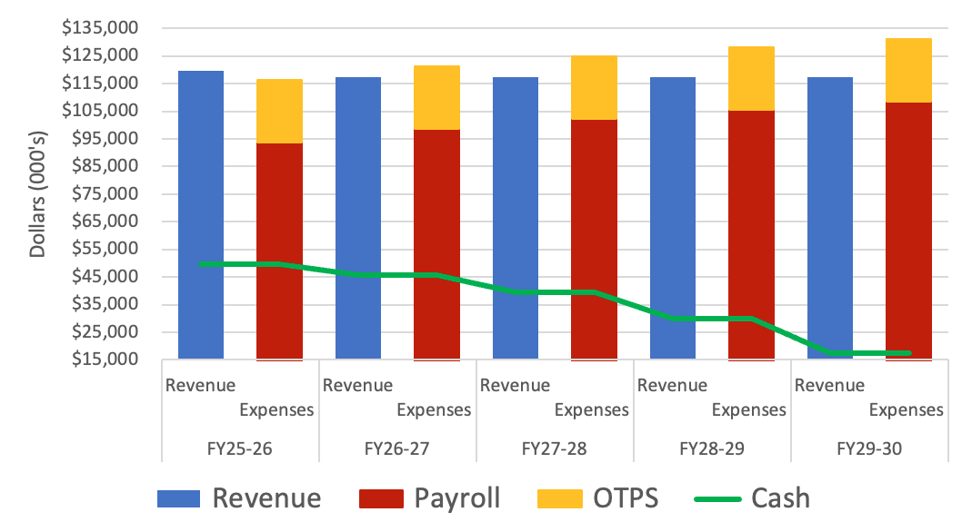

made immediate impact on campus. We have rebranded the office as the Division of Institutional Advancement and have picked up on a number of key relationships that promise to yield significant support for the College and our future.

Second, following the departure of the Director of Sponsored Programs and Research Administration last summer, the College completed a search for a new Director and aligned this function within Academic Affairs in order to provide the greatest support for our faculty as we’re able. We will maintain a dotted line relationship between this office and the
EVP/CFO on campus in order to ensure financial oversight and accountability.
Finally, the College has made a significant adjustment to the approach to student advising, leveraging what we have learned through years of targeted cohort advising, and combining the capacity of a number of disparate offices into a comprehensive advising center, complete with a newly renovated facility anticipated in 2027.

Sponsored Programs Administration
As discussed last year, continued changes at the federal level have had dramatic impact on the current environment around sponsored research as well as the availability of funds. Numerous programs to which FSC had submitted, or planned to submit, application have been frozen or eliminated. However, faculty submitted a record number of proposals this year across all sponsors and, for the first time in College history, we were awarded two grants from the National Science Foundation (NSF) in a single academic year.
FSC’s overall financial position with the Research Foundation remains strong. The College is looking

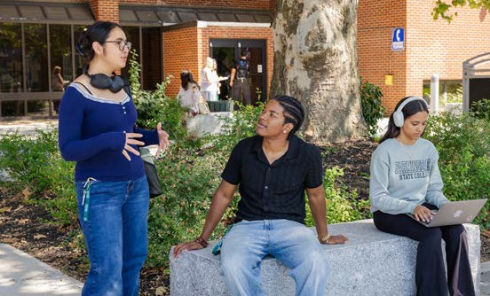
forward to potential opportunities to recover facilities and administrative costs in support of campus priorities, faculty start-up packages, incentives for proposal development, and discretionary funds in support of academic programs.

Facilities and Infrastructure
We are working through the final contract negotiations with Piper Aircraft for the purchase of 5 new aircraft at a cost of nearly $3 million.
The price of aircraft has risen dramatically since we last purchased planes in 2020. Fortunately, we have had the benefit of additional support from our legislative delegation that will assist in offsetting some of this expense, as well as the opportunity to utilize a previously authorized infrastructure and transportation security grant through the State University Construction Fund. We need to be considering the long-term sustainability of this program not only with respect to operational costs but also a phased approach to aircraft replacement in order to
spread this cost out over time and ensure we have continued availability of aircraft to support our aviation students.
FSC continues to receive outstanding support through the capital appropriations process. We currently have over $500 million in construction projects at some phase of the process (planning, design, construction) underway on campus.
This includes complete gut renovation of three significant buildings as well as ongoing construction of the new Computer Sciences Center.
The following is a brief synopsis of the current active construction projects and their status as of this report:
 Roosevelt Hall – This $41 million total gut rehab has reached a significant turning point over the last year. The prime contractor was terminated and responsibility for completing the project was assumed by the Construction Fund. At present we expect substantial completion sometime in September 2026 with building occupancy slated for later this fall.
 Computer Sciences Center – Construction of this
$75 million building is well underway with steel expected to start going up this fall.
 Sinclair Hall – This $47 million gut rehab will be the new home of the Center for Criminal Justice Studies. The project is nearing completion with estimated occupancy in mid-2027.

 University Police Headquarters – This is partial renovation of campus UPD headquarters including construction of an additional support building to house storage, quartermaster, UTV parking, and a brand-new state-of-the-art Emergency Operations Center complete with communications systems and infrastructure that would support emergency response to any campus emergency or would be available to outside law enforcement agencies in need of additional support. Total project cost $3 million was completed early this spring.

 Thompson Hall – Another gut renovation well underway on campus with estimated budget of $33 million. This project will modernize the interior of one of the campus’ 1930s-era classic Georgian style buildings in order to provide a home for horticulture, psychology, sociology, and anthropology.
 Campus Commons – This $13.5 million project is working through the final approvals with NYS in order to begin moving forward with demolition and construction. This project is well underway on campus and, as we engaged discussions among key stakeholders, the College decided to focus this building on student engagement leadership and academic advising, in concert with a new approach to wholistic advising on campus as described above.
 Laffin Hall Welcome Center – This $11 million first-floor renovation began last fall and, when completed, will provide a dedicated welcome center that will support a new tour room and other student-facing functions.
 Campus Steam Distribution – Finally, the College steam infrastructure is incredibly old and was in much need of repair and improvement in order to continue to support existing facilities as well as any new projects planned for the future. This project is replacing the entire steam distribution network on campus at an estimated cost of
$38 million with completion currently slated for January of 2028. The College has also started discussion with SUCF about replacing the “head end” of the steam system including a phased project to update the boilers in the central heating plant.

Campus Safety and Security
The University Police Department has had an amazing year of growth and an increased
involvement in the day-to-day activities of the campus community as well as the surrounding area. Whether it is our presence at athletic events, new student orientation, special events, or in the residence halls, the University Police Department helps to ensure that each member of the FSC community feels safe and are comfortable approaching an officer at any time.
We continue to update emergency procedures, communications protocol, and response training for all campus employees and for our UPD officers as well; ensuring situational readiness for any number of emergencies we may face each day.
A total of 80 brand new Cardiac Science AEDs have been placed around the entire campus, as well as the Aerospace facility and the Brentwood EOC building. These replace older ones that were fully functional but whose warranties were expiring.
Police Officer Dominic Barget further enhanced our department’s Honor Guard. He developed a comprehensive Standard Operating Procedure and handbook to establish clear procedures,
expectations, and standards for its members. He also proactively reached out to local police department honor guards to gather best practices, build professional relationships, and create opportunities for collaboration with other agencies. This included coordinating with the University Police Departments at SUNY Stony Brook and SUNY Old Westbury, resulting in both departments designating members to participate in this regional effort. PO Barget has been nominated for this year’s SUNY Police Chiefs Association Award for Professionalism.
Lt. Joseph Tringali secured an additional 19% in funding from the Governor’s Traffic Safety grant. This grant assists the department in its efforts to increase traffic safety on campus.
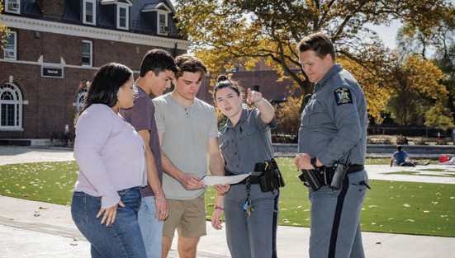



Energy Conservation and Beneficial Electrification
Farmingdale State College has continued making significant strides towards achieving energy efficiency goals. These goals incorporate state mandates such as the Climate Leadership and Community Protection Act, which includes reductions in greenhouse gas emissions of 40% by 2030 and 85% by 2050; Executive Order #22, which requires 100% renewable electricity by 2030, the elimination of fossil fuel consuming equipment in new construction, and zero emission fleet vehicles by 2035, and the successful implementation of the energy efficiency measures required by BuildSmart 2025. The campus continued implementing opportunities identified in our Clean Energy Master Plan, including:
 Upgraded thousands of lights to energy efficient LEDs
 Steam trap inspections and repairs throughout campus
 High voltage electrical distribution system testing and preventive maintenance
 Controls upgrades for HVAC systems
 Additional energy submeters at numerous buildings
FSC works closely with other state agencies and our utility companies to take advantage of incentives and rebates associated with energy efficiency and electrification projects, reducing
upfront costs and accelerating progress towards
our goals. Last year, energy efficiency projects generated utility rebates totaling over $200,000.
Other initiatives implemented over the past year include:
 CUNY Building Performance Lab – “CampusCoach”
🕥 A collaborative training program that analyzes data from our Building Management System to identify opportunities to save energy
and improve occupant comfort. Energy consumption in the three buildings included in this program was reduced by more than 10%.
 Retro-Commissioning
🕥 Comprehensive assessments of building HVAC and control systems to identify and implement opportunities to optimize energy efficiency and occupant comfort.
 EV Symposium and Ride & Drive
🕥 Supported the planning and implementation of the EV Symposium in collaboration with FSC staff and non-profits. The EV Symposium brings together local organizations, municipalities, EV dealers, manufacturers and
local residents to educate attendees on current incentives, charging strategies, as well as EV basics. Attendees also had the opportunity to test drive the latest EV models on campus.
Over the next year, FSC will continue to focus on building out its energy management program, developing new infrastructure and capital projects, as well as improving building system efficiency and occupant comfort.

Sustainability
During the 2025-2026 academic year, the Office for Sustainability (OFS) advanced a broad range of campus-wide initiatives focused on waste reduction, biodiversity, sustainability education, community engagement, and food security.
Waste Management:
In Spring 2026, OFS completed Farmingdale State College’s first campus-wide waste audit, establishing a baseline for waste generation and identifying opportunities to improve waste optimization, efficiency, diversion, and overall
campus waste management practices. Additional waste-reduction efforts included the annual Move-

Out Donation Program and Green Giveaways, where items collected during move-out are recirculated back to the campus community at no cost. OFS also worked with Residence Life to recycle mattresses from the dorms, keeping 1,100lbs of waste out of the landfill.

Biodiversity and Habitat Protection:
The College expanded its commitment to biodiversity through new native tree plantings behind Nold Hall, done in partnership with the Athletics Department. Pollinator habitats were also expanded through the successful establishment and continued development of
the ReWild Garden, Giving Garden, and Xerces Pollinator Garden, increasing opportunities
for native plants and pollinators to thrive on campus while providing hands-on educational opportunities for the campus community. In recognition of these dedicated green spaces, the campus received Tree Campus USA and Bee Campus USA designations for the ninth and fourth consecutive years, respectively.
Sustainability Education and Campus Programming:
OFS significantly expanded sustainability education and engagement opportunities throughout the year. In June 2026, Farmingdale State College hosted the SUNY Sustainability Conference, bringing more than 110 sustainability professionals from across New York State to campus. The conference featured keynote speaker David Wallace-Wells from The New York Times and provided opportunities for professional networking, knowledge-sharing, and connection across higher education.
Additional educational and outreach initiatives included hosting the Long Island Green Jobs Summit, participating in the Visiting Scholars Program, and creating a robust Earth Week program. Earth Week activities included a kickoff event, Giving Garden volunteer day, Weigh the Waste event, Ram Rides bike-share launch, Earth Day Festival, native tree giveaway and planting, and an Electric Vehicle (EV) Symposium.
OFS further supported student engagement and experiential learning through its student
internship program, employing three interns over the course of the academic year and providing

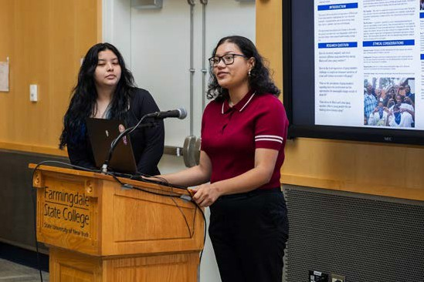
opportunities for students to gain practical experience in campus sustainability initiatives.
Sustainable Transportation:
OFS expanded the College’s sustainable transportation initiatives through the launch of Ram Rides, a new campus bike share program supported by an $8,000 Outdoors for All grant awarded by SUNY. The program provides students and the campus community with increased access to bicycles as an alternative mode of transportation and supports the College’s broader goals of promoting active transportation. The College also hosted
Car-Free Day and the Sustainable Mobility Showcase, providing opportunities for the campus community to learn about sustainable transportation options and experience alternative forms of mobility.
Food Pantry and Community Engagement:
The Giving Garden continued to connect sustainability, food production, and campus food security. During the academic year, the garden produced and donated more than 300 pounds of organic produce to the FSC Food Pantry. The program also engaged more than 50 volunteers, providing hands-on opportunities for students, faculty, staff, and community members to participate in hands-on gardening.
Collectively, these initiatives demonstrate FSC’s continued commitment to advancing sustainability across campus operations, educational programming, and the overall campus experience.

Corporate Partnerships
Following a request from the SUNY Board of Trustees FSC is currently working with an external

service provider to complete an environmental review of the proposed lacrosse project on campus. During the last academic year, FSDC completed an RFP process to select a partner developer to move forward with this project.
We anticipate bringing the final proposal, with selected developer and environmental review, to the BOT this fall.
During the last academic year the College also successfully advocated for additional land-lease legislation for a parcel of land adjacent to the main campus that has been identified as a potential location for a housing development. The College is working through an RFQ process to identify a partner who will help structure a
transaction that would result in publicly available housing on this parcel along with additional new housing for FSC resident students on campus.
In addition, the College continues its beneficial partnership with Estee Lauder through the Broad Hollow Bioscience Park which provides over 60,000 sf of research and development space for Estee Lauder, rental revenue to BHBP, ample opportunity for internships for FSC students and an annual gift to the College Foundation in the amount of $350,000. This relationship represents a perfect marriage of opportunity and timing
and is a result of steadfast advocacy efforts and negotiation by College leadership with both the BHBP Board and Estee Lauder.

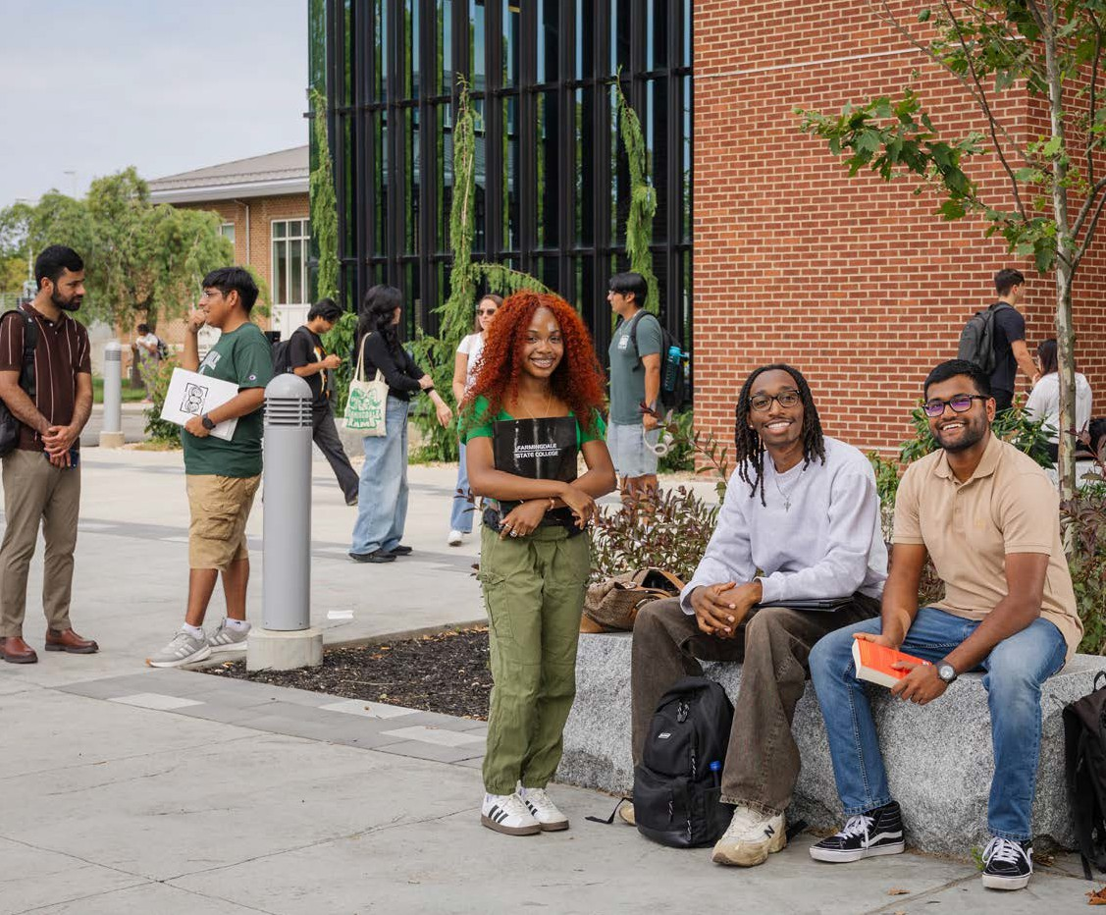

APPENDIX

FARMINGDALE STATE COLLEGE
BOARD, COUNCIL & MAJOR COMMITTEE SERVICE

Eric Anderson,

Architecture and Construction Management
 American Institute of Architects, New York State

Michael Berrell,
Visual Communications
 Long Island Disc Golf, President and Board of Directors

Joseph Betz,
Architecture and Construction Management
 Three Village Civic Association Board

Matthew Brown,
Sociology & Anthropology
 Board Member - Treasurer for American Institute of Archaeology - New York Society

Kate Calabrese,
Director of Finance and Data Analytics
 SUNY Accounting Budget & Bursars (ABB) Executive Board, Chair of Accounting/Budget

Daniel Daugherty,
Chief, FSC University Police
 First Vice President – SUNY Police Chief Association (incoming President as of December 2026)

Keri Franklin,
AVP for Finance and Controller
 Broad Hollow Bioscience Park Board, Treasurer
 Farmingdale Auxiliary Services Corporation (ASC) Board, Treasurer
 SUNY SUBOA, Liaison to ABB and Liaison to Financial Aid

Dorothy Hughes,
AVP for Administration
 Broad Hollow Bioscience Park, Secretary
 Farmingdale State Development Corporation, Secretary
 Children’s Center at Farmingdale State College Board, Board member

Marjaneh Issapour,
Director of Renewable Energy and Sustainability Center, FSC
 Manufacturing and Technology Resource Consortium Advisory Board

Jennifer Jaiswal,
Director of the Faculty Center
 SUNY Center for Professional Development, Advisory Board

Mimi Johnson,
Executive Director, Alumni Engagement & Annual Giving
 Board member, SUNY Conference on University Advancement (SUNYCUAD)

Jonathan Lehrer,
Urban Horticulture Chair
 Nassau County Tree Advisory Board

Orla LoPiccolo,
Architecture and Construction Management
 National Architectural Registration Board

Marybeth McCloskey,
AVP for Human Resources
 Vice President & Conference Committee Chair for 2022 & 2023
 President 2024 & 2025
 Immediate Past President current (Actual SUHRA Executive Board Title) for 2026 & 2027

John Meindi,
Sports Management
 Liam’s Legacy Athletic Association, Board of Directors

Ann Marie Moresky,
Purchasing Manager
 Children’s Center at Farmingdale State College Board, President

APPENDIX

FARMINGDALE STATE COLLEGE
BOARD, COUNCIL & MAJOR COMMITTEE SERVICE

Kim Nyoni,

Vice President for Institutional Advancement
 Advisory Committee Member, Men of Color in Development (MOCID)
 Member, Rotary International
Gregory O’Connor, EVP and CFO
 Broad Hollow Bioscience Park, Inc – President
 Farmingdale State Development Corporation – President

Shane Owens,
Director Campus Mental Health Services
 President, American Board of Behavioral and Cognitive Psychology
 Fellow, Association for Behavioral and Cognitive Psychology

Robert Prezant,
President
 Long Island Regional Economic Development Council (Governor appointed)
 Long Island Association Board of Directors
 Long Island Regional Advisory Council on Higher Education
 Broad Hollow Bioscience Park, Inc. Board of Directors (Chair)
 Farmingdale State College Foundation Board
 Presidents Council for the Skyline Conference
 Executive Committee and Vice Chair, Skyline Conference
 Gurwin Healthcare System 2026 Gala Committee
 NewYorkBIO Long Island Leadership & Planning Committee

Maria Randazzo-Davis,
Business Management
 ISBE-SIEC International Society of Business Educators, Vice President

Sarbjit Singh,
Sports Management
 South Asians in Sports, Board of Directors

Sean Son,
Sports Management
 Journal of Applied Sport Management, Editorial Review Board

Richard Vogel,
Dean, School of Business
 Academy of Economics & Finance, Treasurer
 AACSB, Board member and Vice Chair, Small Schools Network Affinity Group

Amy Zambrana,
Associate Director, Human Resources
 SUHRA Executive Board Member for Technical Colleges 2021-present
 Co-Chair Payroll Conference Committee 2025-present

Xu Zhang,
Economics
 Academy of Economics and Finance, Board of Directors

