Time and Attendance System

UUP Faculty Employee

Sign On:

Employees will sign into the Time and Attendance System (TAS) using the link below and enter their existing user id and password.

* <https://www.suny.edu/time>

TAS Home Page:



* Select Current Employment Role (shown above).
* Click on Time and Attendance button to work on your Time Record

To Complete Time and Attendance Record:

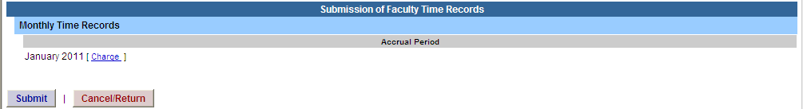

* Hit Submit if not using any sick time for the accrual period shown.
* If using sick time, click on *Charge Time/View Calendar*.
* To charge sick leave, double click on a day to add or update sick time off on the calendar
* A separate pop up box will open (shown above) to enter a single day leave. The from date will be automatically populated from the date clicked on.
* Click on the multi-day box in the top right corner for multiple, consecutive days
* If time record is not complete, click Save which will allow you to go back into your time record to add or update before submitting to supervisor.
* Once time record is complete, check the box to certify that the information entered is accurate.
* If time record is complete and you wish to send to your supervisor, click on Submit to Supervisor.
* If you do not wish to save or submit your time record simply click Cancel/Return to Home.

Notes:

* If a Time Record is disapproved by the supervisor, the time record will show back in the Accrual Period drop down in work status. You will then be able to choose the month, make any changes as appropriate and resubmit to your supervisor.
* PDF Report – allows employees ability to print time record.
* Audit Details – keeps an audit trail of add/updates to time record.
* Message Board – automatic messages to employee making them aware of overdue time records, expiring holidays, and approaching max limit by year end

History:

* Shows a 12 month Employee history of all accrual balances.

.