Time and Attendance System
UUP Faculty Employee

Sign On:
Employees will sign into the Time and Attendance System (TAS) using the link below and enter their existing user id and password. The first time you sign on, you will be asked to verify your First/Last Name, Date of Birth and SUNY ID. This verification is to authenticate your user id and SUNY ID.
- https://www.suny.edu/time
If EduPerson has been established at the campus, employees will simply sign into the link above and entering their existing user id and password. The verification process is not necessary.

TAS Home Page:
- Select Current Employment Role (shown above).
- Click on Time and Attendance button to work on your Time Record or Time off Request.
- If you wish to view your paycheck click the View Paycheck button. Paycheck information will be available the Monday before payday.

To Complete Time and Attendance Record:
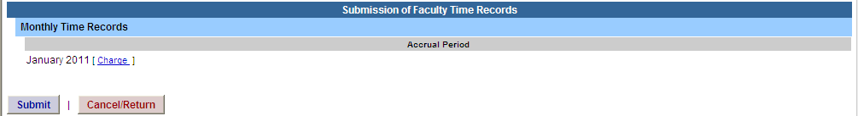
- Hit Submit if not using any sick time for the accrual period shown.
- If using sick time, click on Charge button (shown above) then select the Accrual Period (month) from the drop down menu, click on change period.
- To charge sick leave, double click on a day to add or update sick time off on the calendar

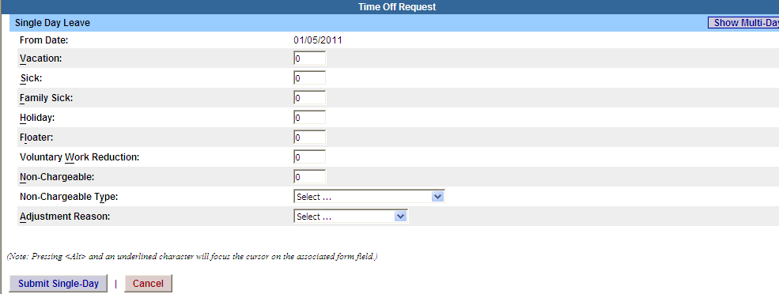
- A separate pop up box will open (shown above) to enter a single day leave. The from date will be automatically populated from the date clicked on.
- Enter appropriate number of days (increments no less than .25 days) on appropriate accrual field.
- To submit multiple day requests, click on Show Multi-day button on the upper right hand corner from the time off request. To Date field will now be available to enter a range of dates.
- For Non-Chargeable time, enter appropriate number of days and select the non-chargeable type from the drop down selection.
- Click on Submit. After submitting, you will be brought back to your time record you were previously working on. The time off will now appear on your monthly calendar.
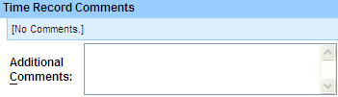

- Time Record Comments (shown above) – available if employee would like to submit comments attached to the time record for their supervisor.

- Once time record is complete (shown above), check the box to certify that the information entered is accurate before submitting to supervisor.
- If time record is complete and you wish to send to your supervisor, click on Submit to Supervisor. If time record is not complete, click Save which will allow you to go back into your time record to add or update before submitting to supervisor.
- If you do not wish to save or submit your time record simply click Cancel/Return to Home.

Notes:
- If a Time Record is disapproved by the supervisor, the time record will show back in the Accrual Period drop down in work status. You will then be able to choose the month, make any changes as appropriate and resubmit to your supervisor.
- If employee has a positive vacation balance from previous obligation, employee will be able to charge vacation accruals accordingly.
- PDF Report – allows employees ability to print time record.
- Audit Details – keeps an audit trail of add/updates to time record.
- Message Board – automatic messages to employee making them aware of overdue time records, expiring holidays, and approaching max limit by year end.

History:
- Shows a 12 month Employee history of all accrual balances.

To Complete a Time Off Request:
- Select Request Time Off from the menu bar located at the top of the screen (shown above).
- To request time off from your supervisor, double click on the day you wish to request off or update on the calendar.
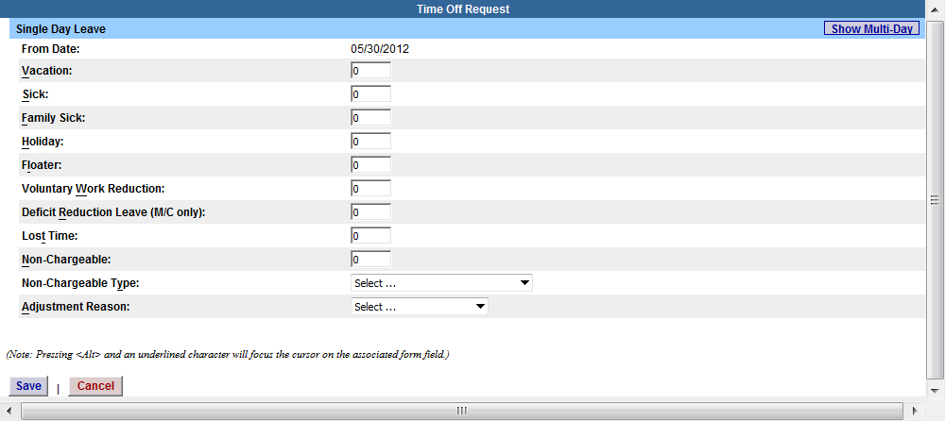

- A separate Time off Request pop up box will open (shown above). From date will be automatically populated from the date clicked on.
- Enter appropriate number of days (increments of .25 days) in accrual category.
- To submit multiple day requests, click on Show Multi-day button on the upper right hand corner from the time off request. To Date field will now be available to enter a range of dates.
- For Non-Chargeable time, enter appropriate number of days (increments of .25 days) and select the non-chargeable type from the drop down selection.
- Click on SAVE.
- The day/s requested will now appear on your time off request calendar and be listed below under Previously Submitted Leave Requests.
- To submit your request to your supervisor, clicks on the radio button next to the appropriate time off request then click submit to supervisor.

- Previously Submitted Leave Requests
 | Leave Dates | Status | # of  Days | Leave  Type | Reason | Date  Submitted | Date  Approved
 | 11/25/2011-11/25/2011 | Saved | 1 | Vacation Leave
 | 03/28/2011-03/31/2011 | Charged | 4 | Vacation Leave |  | 03/17/2011 | 04/01/2011
 | 05/30/2011-05/30/2011 | Pending | 1 | Vacation Leave |  | 05/16/2011

- Saved – time off request has been saved, not yet submitted to supervisor.
- Pending – submitted to supervisor pending approval.
- Approve – time off request has been approved by the supervisor.
- Charged – has been approved and charged to the appropriate monthly time record.

Notes:
- Time off Request is optional and not required.
- If a time off request is submitted and approved by the supervisor, the approved days will automatically appear on appropriate time record.
- If you need to change a time off request and it has not been approved by your supervisor, please go back into your Time off Request and delete and/or update your request.
- Employees are unable to submit a time record that has pending time off request. These requests will need to be deleted by the employee and manually entered on to the time record or approved by the supervisor.

.

