Time and Attendance System

Supervisor Role

Sign On:

Employees will sign into the Time and Attendance System (TAS) using the link below and enter their existing user id and password. The first time you sign on, you will be asked to verify your First/Last Name, SUNY ID, and Date of Birth. This verification is to authenticate your user id to your SUNY ID assigned in the system. Click on Submit Answers.

* <https://www.suny.edu/time>

If EduPerson has been established at the campus, employees will simply sign into the link above and entering their existing user id and password. The verification process is not necessary.

TAS Home Page:



* From the TAS Home Page (shown above), click on the Time and Attendance button to work on your Time Record, Time off Request or Supervisor Work Roster.
* If you wish to view your paycheck click the View Paycheck button. Paycheck information will be available the Monday before payday.

Supervisor Pending Approval Roster:

Employee:   [Time Record](https://test.suny.edu/time/flow/facultyCheckPoint-flow?flowContainerKey=) | [History](https://test.suny.edu/time/flow/timeRecordHistory-flow?flowContainerKey=) | [Request Time Off](https://test.suny.edu/time/flow/leaveRequest-flow?flowContainerKey=) | [Home](https://test.suny.edu/time/flow/home-flow) **|** Supervisor:   [Work Roster](https://test.suny.edu/time/flow/supervisorRoster-flow)



Pending Time Records Approvals:

* To begin working on any pending time records and/or time off requests, click on Supervisor Work Roster from the tool bar above.
* To Approve employees time record– select APPROVE radio button
* To Disapprove – select DENY radio button. When denying an employee’s time record, a comment field will open. Comments are required by the supervisor, so an explanation of the denial will be sent back to the employee on their time record.
* IGNORE radio button can be selected if supervisor does not wish to take action on the employees time record at that time. The time record will remain on the supervisors work roster until further action is taken.
* Supervisor also has the option of clicking on the VIEW DETAILS button to see the employee’s time record in its entirety.
* Once action has been selected, click Submit.

Pending Leave Requests:

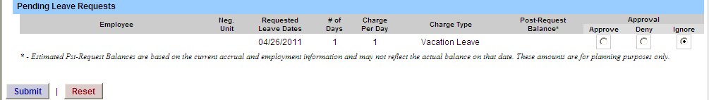

* Same steps noted above apply to approve, deny and/or ignore Pending Leave Requests.

Employee Roster:

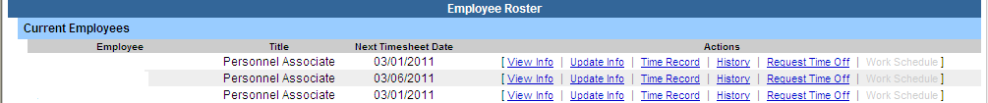

* Is a list of all employees that reports to the supervisor.
* Supervisors are able to view Employee Information Detail, Time Record, History and Time off Requests from their work roster.
* If […] appears under an employee’s name, this indicates the employee is also a supervisor within the department.  If you click on the […] icon their supervisor work roster will be brought up, and you have all the same supervisor privileges.

Notes:

* Supervisors have access to set up a Proxy for their employees (see separate instructions on how to set up a proxy).
* Supervisors are automatic proxies for their employees to submit time records.
* All Time off Requests must be approved by the supervisor before employees are able to submit their time record for that particular month.