Time and Attendance System - Supervisor Role
Classified Employee

Sign On:
Employees will sign into the Time and Attendance System (TAS) using the link below and enter their existing user id and password. user id to your SUNY ID assigned in the system. Click on Submit Answers.
- https://www.suny.edu/time

TAS Home Page:
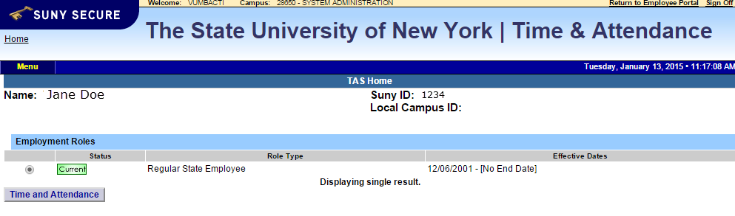
From the TAS Home Page (shown above), click on the Time and Attendance button to be brought into your Time Record, Time off Request or Supervisor Work Roster.

Supervisor Pending Approval Roster:
Employee: Time Record | History | Request Time Off | Home | Supervisor: Work Roster
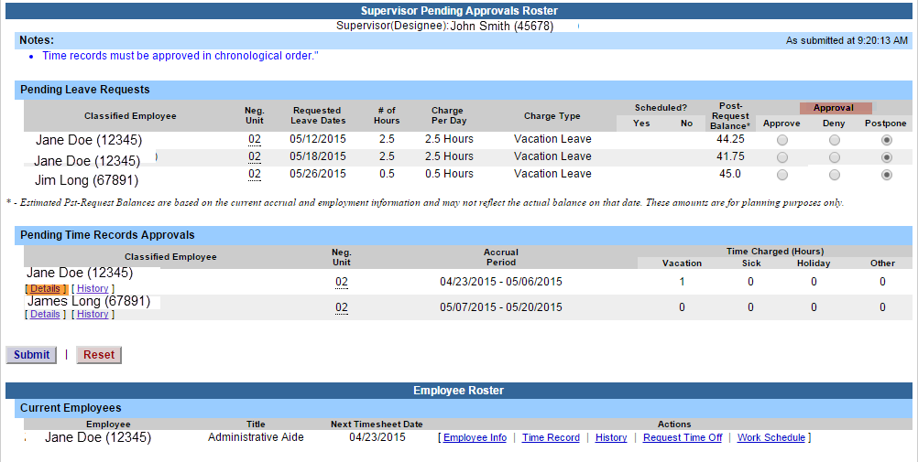
To begin working on any pending time records and/or time off requests, click on Supervisor Work Roster highlighted in yellow on the tool bar above.
Pending Time off Request will be listed first on the supervisor work roster and must be approve or denied before the time record within the same pay period.
Supervisors have the ability to approve, deny or postpone time off requests by selecting the appropriate radio button under Approval (highlighted above in pink).
- Approve
- Deny - If a time record is denied, comments are required. Once the Deny button is selected the comment field will open to allow comments to be entered.
- Postpone – can be selected if supervisor does not wish to take action on the employee’s time record at that time. The time record will remain on the supervisors work roster until further action is taken.

Supervisor must select whether the sick leave was scheduled or not before taking action on any sick leave request.
- Once action has been selected, click Submit.

To take action on an employee’s time record, supervisors must select Details (see above in orange) to view the time record in its entirety.
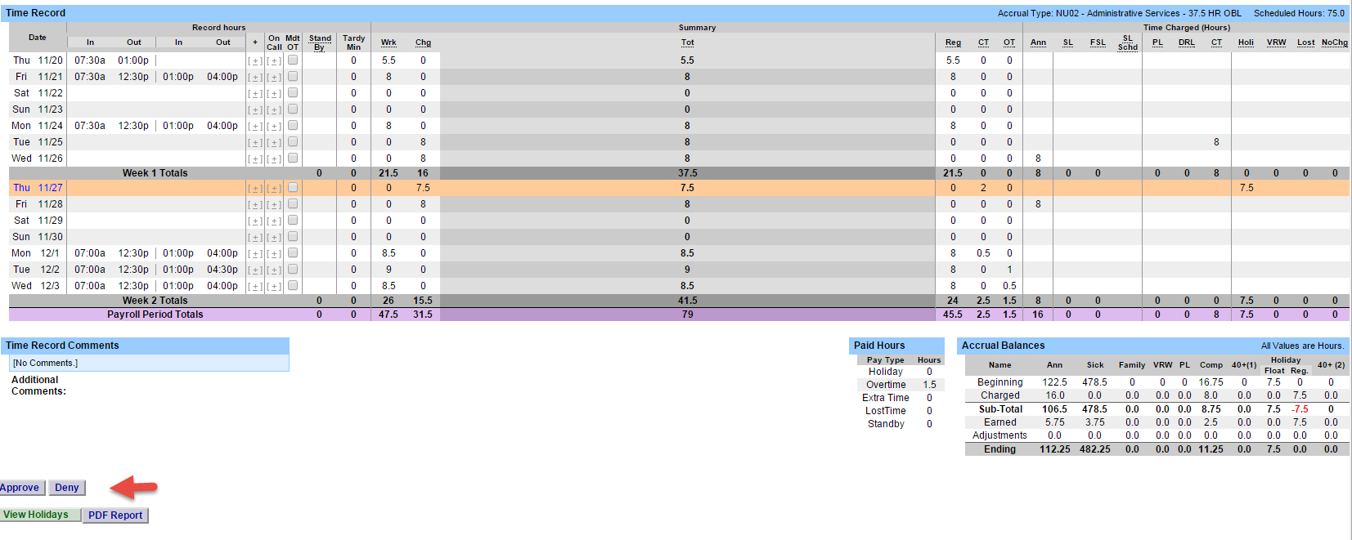
Once the time record has been reviewed, the supervisor should take appropriate action to either approve or deny. If time record is denied, comments are required to be entered letting the employee know the reason for the denial. The employee will then be able to correct their time record as necessary and resubmit to the supervisor.

Employee Roster: - Is a list of all employees that report directly to the supervisor (shown below).
Supervisors are able to view Employee Information Detail, Time Record, History and Work Schedule from their work roster.
If […] icon appears under an employee’s name, this indicates the employee is also a supervisor within the department. If you click on the […] icon their supervisor work roster will be brought up, and you have all the same supervisor privileges.

