**[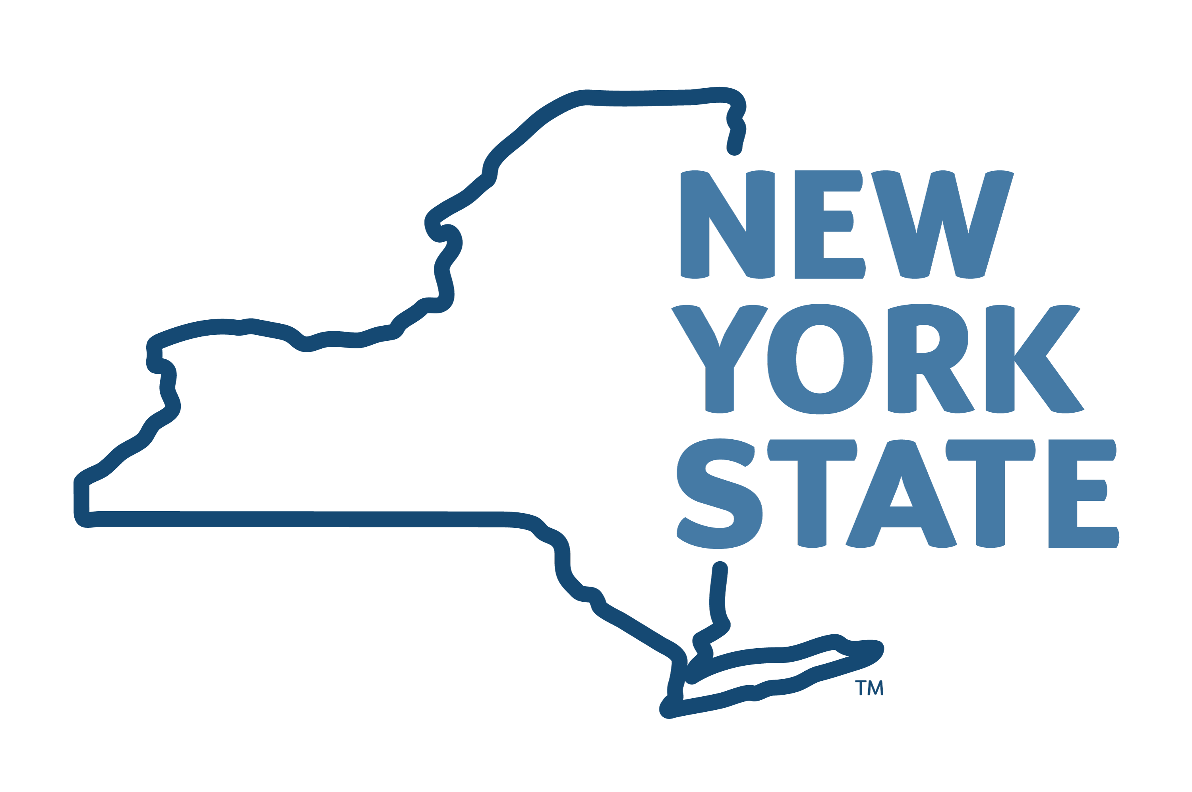](https://oer.ny.gov/)**

**Public Service Loan Forgiveness Program**

**As a New York State Employee, You May Be Eligible to Have Student Loans Forgiven**

**Other Benefits NYS Employees Enjoy:**

* Dental and Vision Care
* Life Insurance
* Long-Term Care Insurance
* Direct Deposit Paychecks
* [Employee Assistance Program](https://oer.ny.gov/eap)
* [Flex Spending Account](https://oer.ny.gov/fsa)
* [Deferred Compensation Plan](https://www.nysdcp.com/rsc-web-preauth/index.html)
* [Tuition Benefits](https://oer.ny.gov/managementconfidential-mc-training-programs)

**­**

## **CONTACT: The Human Resources Department, 934-420-2107, HR@farmingdale.edu**

## **WWW.FARMINGDALE.EDU**

## **MORE INFO:** [**oer.ny.gov/public-service-loan-forgiveness**](https://oer.ny.gov/public-service-loan-forgiveness)

## **Learn More:** [oer.ny.gov/public-service-loan-forgiveness](https://oer.ny.gov/public-service-loan-forgiveness)

**About the Federal Public Service Loan Forgiveness Program**

As a New York State employee, you may qualify to participate in the [Federal Public Service Loan Forgiveness Program](https://studentaid.gov/manage-loans/forgiveness-cancellation/public-service) (PSLF). The PSLF Program forgives the remaining balance on your Direct Loans after you have made 120 qualifying monthly payments under an [accepted repayment plan](https://studentaid.gov/manage-loans/forgiveness-cancellation/public-service#qualifying-repayment-plans) and while working full-time for an [eligible](https://studentaid.gov/manage-loans/forgiveness-cancellation/public-service#qualifying-employment) employer.

9/24