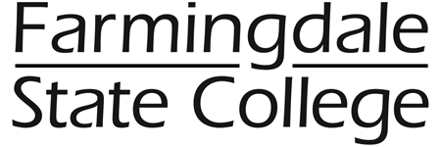

TO: All Employees

FROM: Marybeth Incandela, Director of Human Resources

RE: Paycheck Distribution Procedures New Year’s Eve

DATE: December 2, 2014

The holidays are approaching and New Year’s Eve, December 31st is a pay day. On that day, all direct deposit slips, (a.k.a check advices), will be mailed. As is always the case, Adjunct paychecks and advices will be mailed also. Since the Physical Plant will be operational, checks for those employees will be delivered to that area. **All other employees may pick up their checks at University Police between the hours of 11 a.m. and 1 p.m.** If an individual wants a paycheck mailed to their home, they must send a signed memo to Human Resources by December 19th, see sample memo attached.

Any checks not picked up will be available in the office of Keri Franklin, Room 167, Horton Hall beginning January 5, 2015.

There is still time to sign up for Direct Deposit. The form is available on the website at: <http://www.farmingdale.edu/administration/administration-finance/human-resources/pdf/DirectDeposit.pdf>

You can also pick up a direct deposit form in Human Resources/Payroll. If you have any questions, please call anyone in Human Resources or Payroll and they will be able to assist you.



**PERMISSION TO MAIL PAYCHECK**

I hereby give permission for my pay check dated December 31, 2014 to be mailed to my address on file.

Print name: _____________________________

Signature: ______________________________

Date: _______________________________

Return this form to Human Resources on or before December 19, 2014