2026
Q2

RAM-BO’S RENOVATIONS
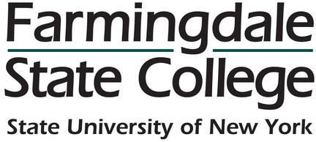

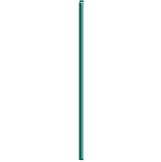
QUARTERLY NEWSLETTER

OFFICES FOR CAPITAL PROJECTS & CONSTRUCTION AND FACILITIES OPERATIONS





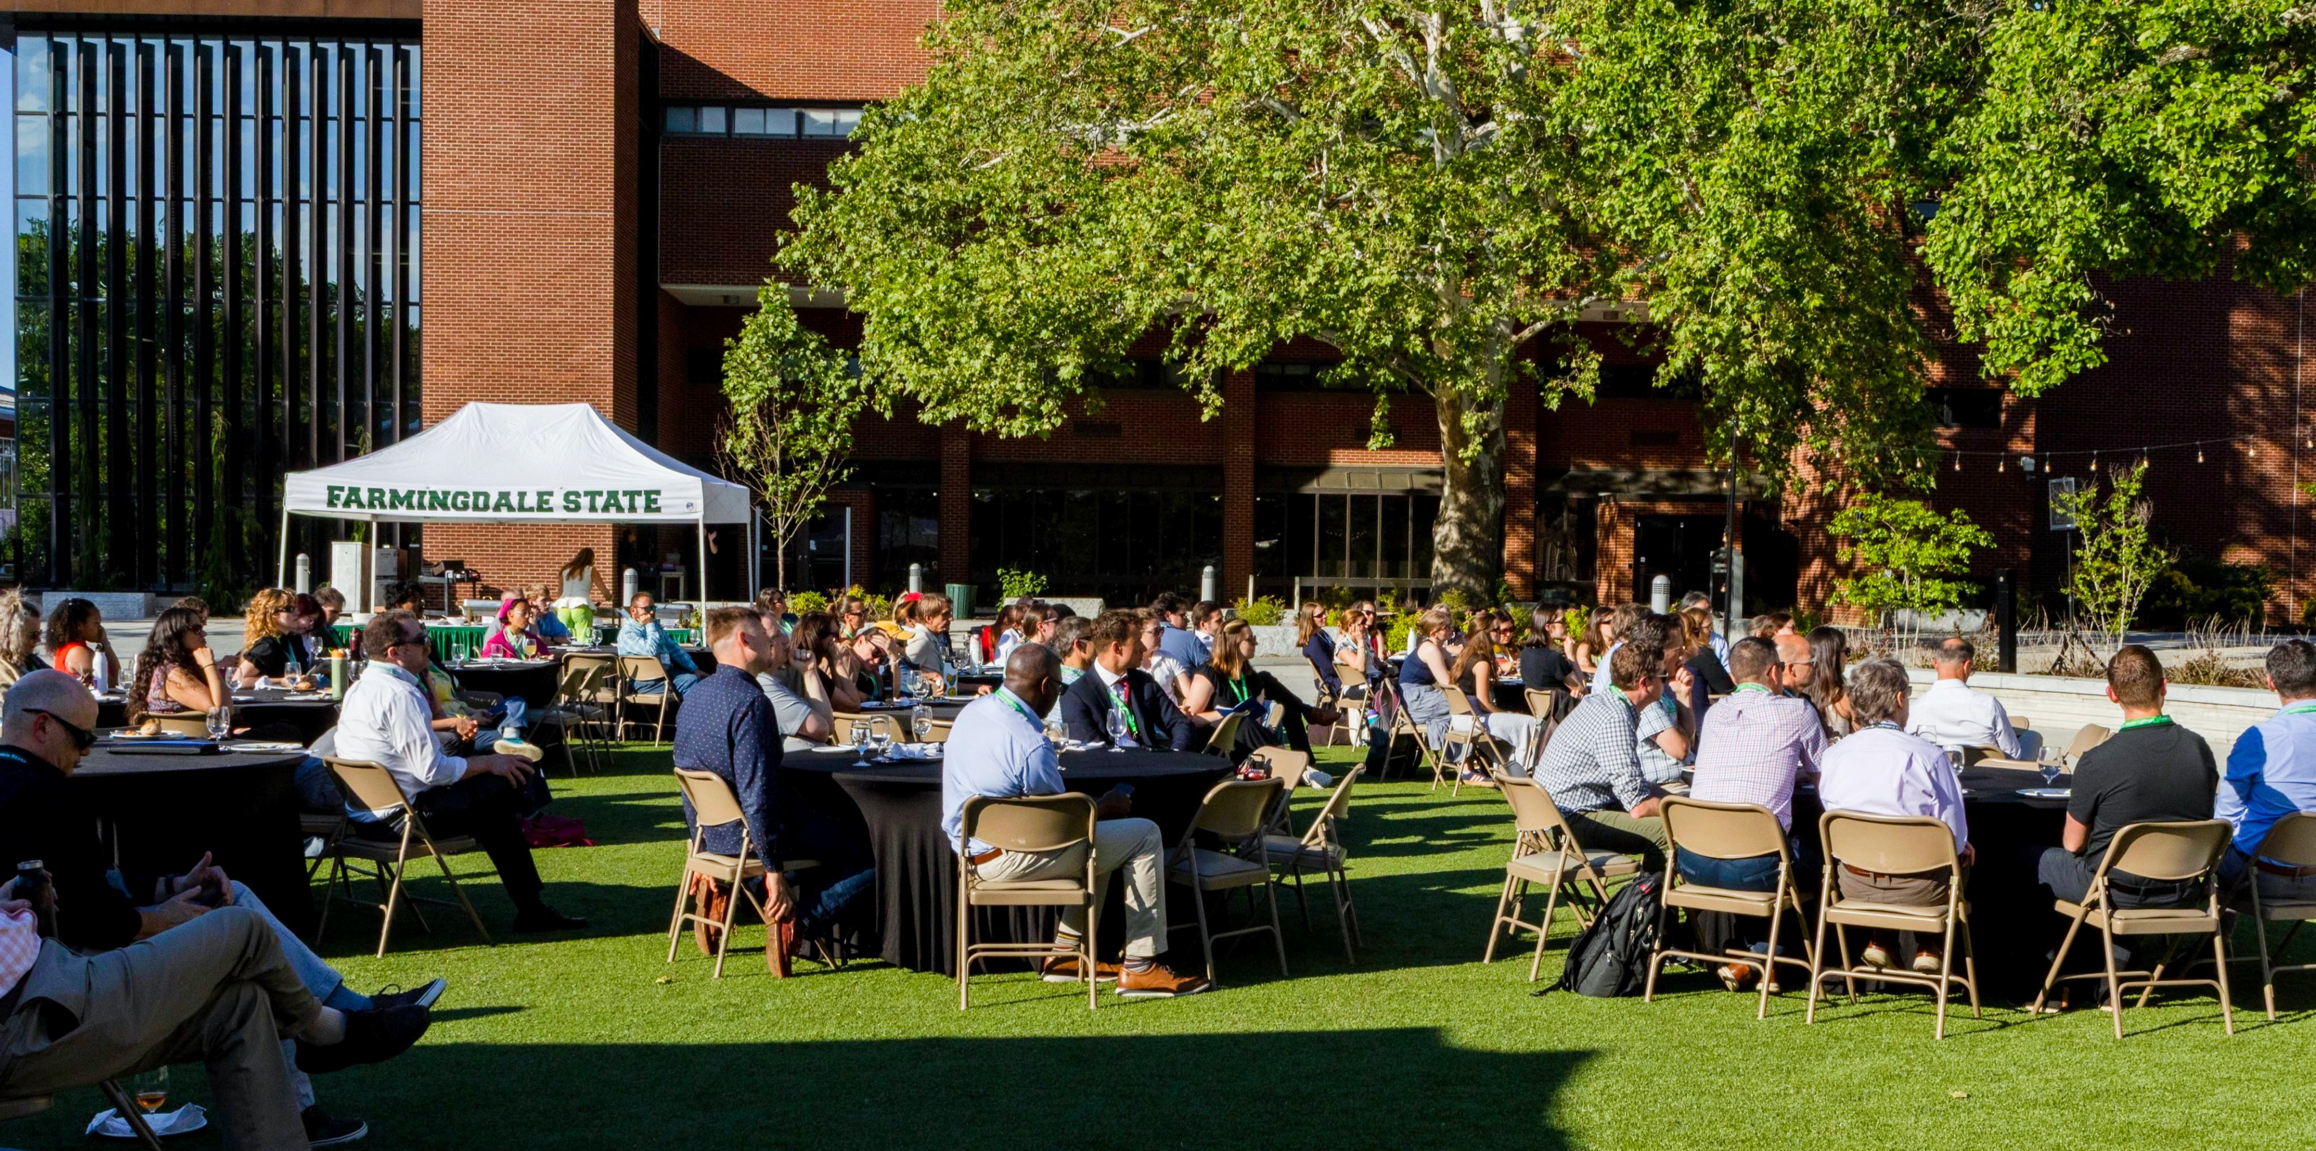
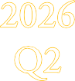
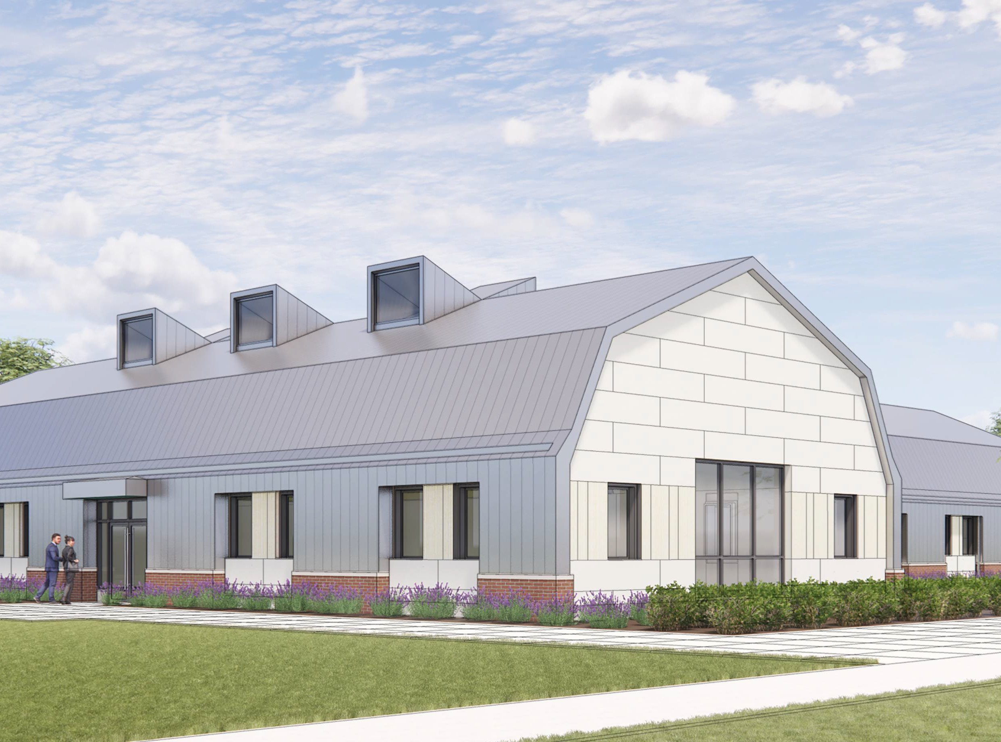
2026 SUNY Sustainability Conference
The Office of Sustainability proudly hosted the 2026 SUNY Sustainability Conference (June 9–11), welcoming professionals, educators, researchers, and students from across SUNY and beyond to share ideas, address challenges, and strengthen partnerships advancing sustainability in New York State. The conference featured engaging sessions, networking opportunities, and a keynote by New York Times climate journalist David Wallace-Wells, leaving attendees with valuable insights and lasting connections.
Great job to Maia Roseval, who played a key role in organizing a successful and impactful event, while showcasing Farmingdale’s commitment to sustainability!
Contact:
Capital Projects & Construction: (934) 420-5327
Facilities Operations: (934) 420-2017
Big Changes Are Coming to Campus Commons!

A piece of campus history is being re-imagined! Campus Commons, one of the oldest buildings on campus, is undergoing a major renovation that will transform it into a centralized space that will house Academic Advising, Student Affairs, and the Office of the Dean of Students.
Originally built in 1915, with an additional wing added in the 1940s, the building has long served multiple purposes, including housing the Small Business Development Center.
While the updated design brings a fresh, contemporary feel, it also honors the past—drawing exterior inspiration from Quintyne Hall and preserving the original farm-style
character inside.







Summer Hours, Full Power.

The Middle Ground:

Where MCM Fits In
Have you ever wondered what falls between routine maintenance and a capital project? Facilities maintenance covers regular, scheduled work that keeps campus spaces operating efficiently. Capital projects, by contrast, are larger in scope, with greater complexity, longer timelines, and clearly defined start and end dates.
Between the two is Minor Critical Maintenance (MCM). MCM projects are more complex than routine upkeep but do not meet the scale of a full capital project. They focus on targeted improvements that can be completed within 12 months and remain under a $150,000 budget.
MCM helps ensure that important work is addressed in a timely and cost-effective way, without requiring the resources of a larger project.

Current Project Update:
The second floor of Alumni Hall is getting a major refresh! The men’s and women’s bathrooms are being completely renovated with brand-new floors, walls, vanities, plumbing, and modern light fixtures. At the same time, the entire interior of the building is getting a fresh coat of paint. It’s a busy and exciting time, for Facilities.
Meanwhile, the former Barnes & Noble Campus Bookstore is transforming into the new Ram-Bo & Co. Campus Store, featuring a refreshed layout, expanded apparel and merchandise, a lounge area, and convenient online textbook ordering. Finally, POPs is getting a fresh new look with upgraded seating, new food stations, and enhancements to your favorite dining options!

Let’s build something great together!

Shred & Spread the Fun!
Shred Day 2026
Shred Day is coming on July 8, 2026! Join us for this annual campus-wide event and take the opportunity to clean out your file cabinets, organize your digital spaces, and securely dispose of records you no longer need. You can destroy outdated documents, get rid of non-record materials, and properly store items with future retention requirements. Be sure to request boxes if needed and have your forms ready once everything is packed. Plus, participants will be entered into a raffle for a chance to win a prize!

Hammer Time Highlight
Crew in the Spotlight

This quarter’s team member spotlight is on Bert Rathjen!
Bert consistently exceeds expectations in all aspects of his work. He approaches project planning, construction management, and
administrative tasks with a team-first mindset, always prioritizing the campus’s best interests.
Whether it’s stepping in to support projects
outside his scope or jumping into a last-minute fire drill, he is someone others can rely on
without hesitation. His dedication, flexibility, and positive attitude make a meaningful impact
every day and can be felt across the entire campus.
Keep it up, Bert!!

Gearing up with Ram-Bo!

The Info Hub

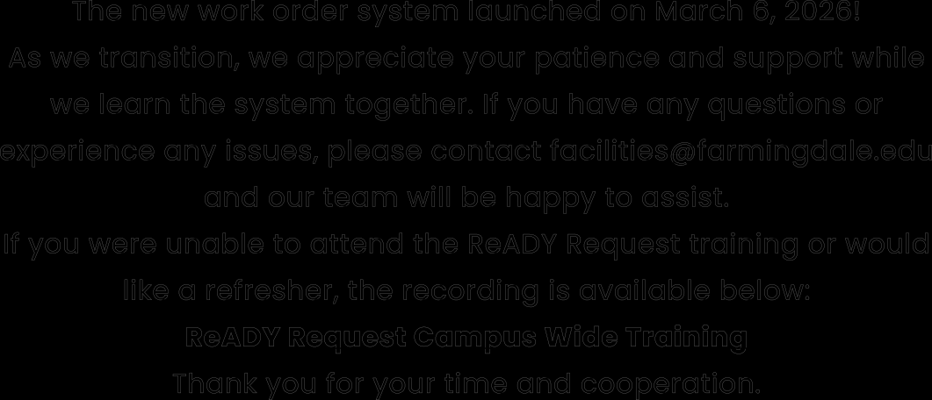
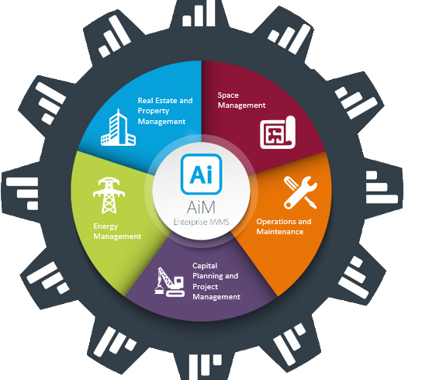
Work Order Training Resources

The new work order system launched on March 6, 2026!
As we transition, we appreciate your patience and support while we learn the system together. If you have any questions or
experience any issues, please contact facilities@farmingdale.edu and our team will be happy to assist.
If you were unable to attend the ReADY Request training or would like a refresher, the recording is available below:
ReADY Request Campus Wide Training
Thank you for your time and cooperation.



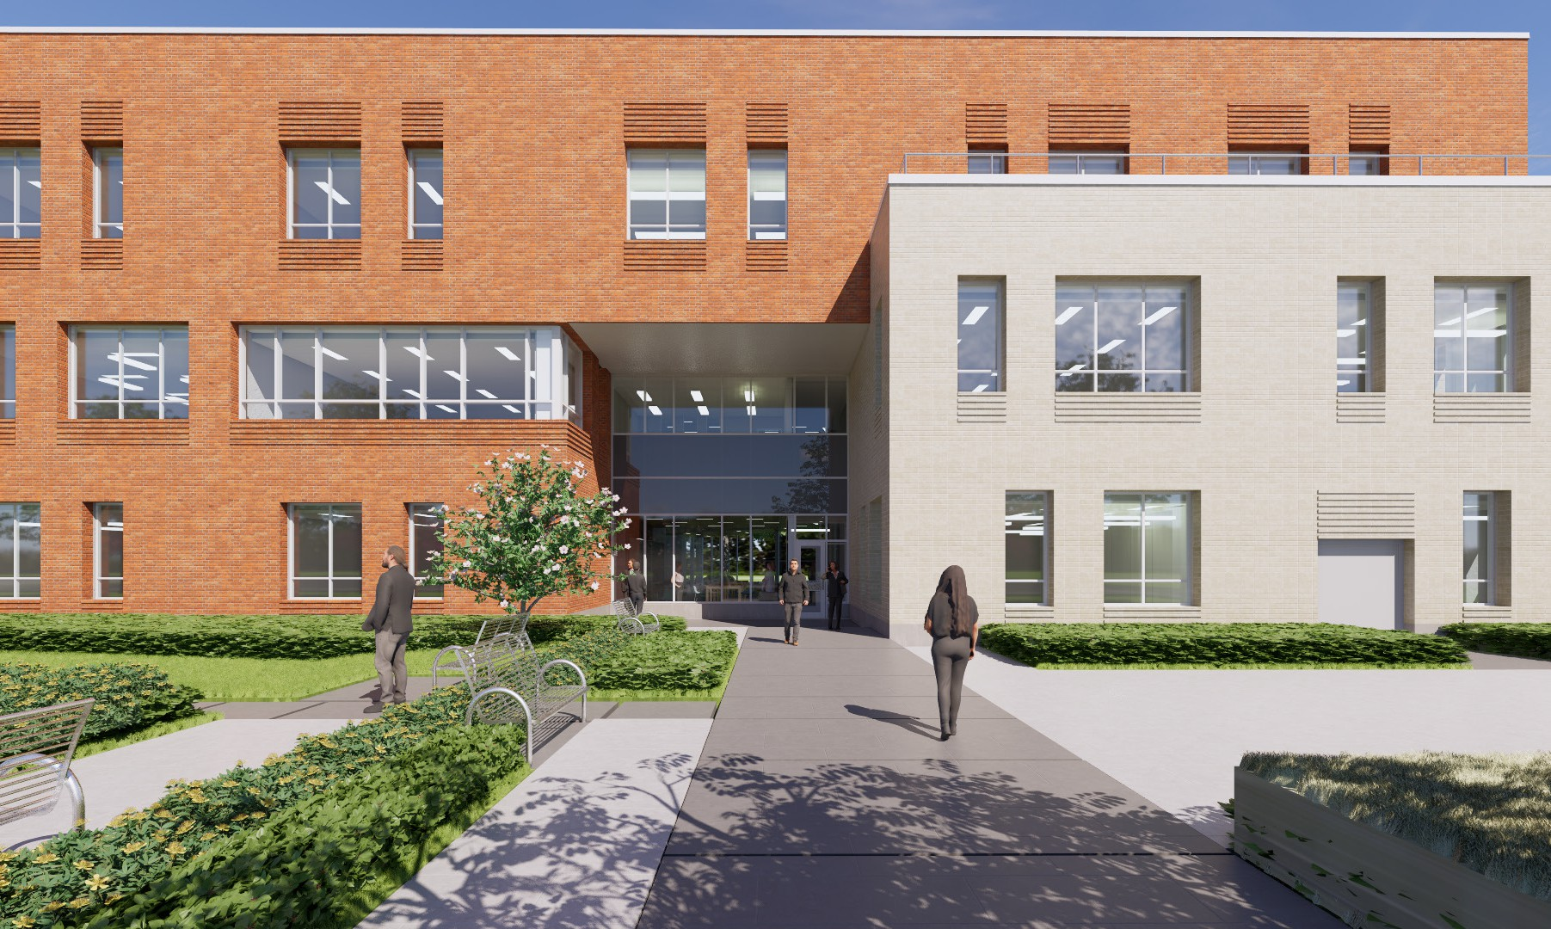
How to Find and Fill Out a Work Order?
The new work order system can be accessed here:
Submit a Work Order
- In the search bar, type in workorder.farmingdale.edu
OR
Visit the Facilities Operations webpage at
farmingdale.edu/facilities-operations/
- First time users, go to Settings, User Profile and add your FSC phone
number.
- Carefully select a tile that best fits your Request.
- Fill out the applicable fields.
- Review your request details.
- Submit your request.

Are you smarter than a freshman?

Q: What is a Summer Bridge?
A: a free two-week program designed to assist

Innovation Under Construction
Construction is progressing on Farmingdale’s new 52,000-sq-ft
Computer Sciences Center, a modern hub for innovation and
technology-focused learning. Site excavation is complete, foundation work is underway, and surrounding
infrastructure improvements continue.
Scheduled for completion in 2028, the facility will feature advanced computer and cybersecurity labs, collaborative
learning spaces, and become the
College's first Zero-Net-Carbon-Ready building, supporting innovation,
sustainability, and the next generation of technology leaders.

The future is taking shape at CSI!
with the transition from high school to college

