OPTING OUT OF THE INCLUSIVE ACCESS PROGRAM
If your course is participating in the Inclusive Access, you will automatically be opted into the program, but participation is optional. If you do NOT wish to participate in Inclusive Access, you have 14 days after the start of your class to opt out and receive a refund. You can opt out by accessing the “Course Materials by eCampus” link found in your Brightspace course.
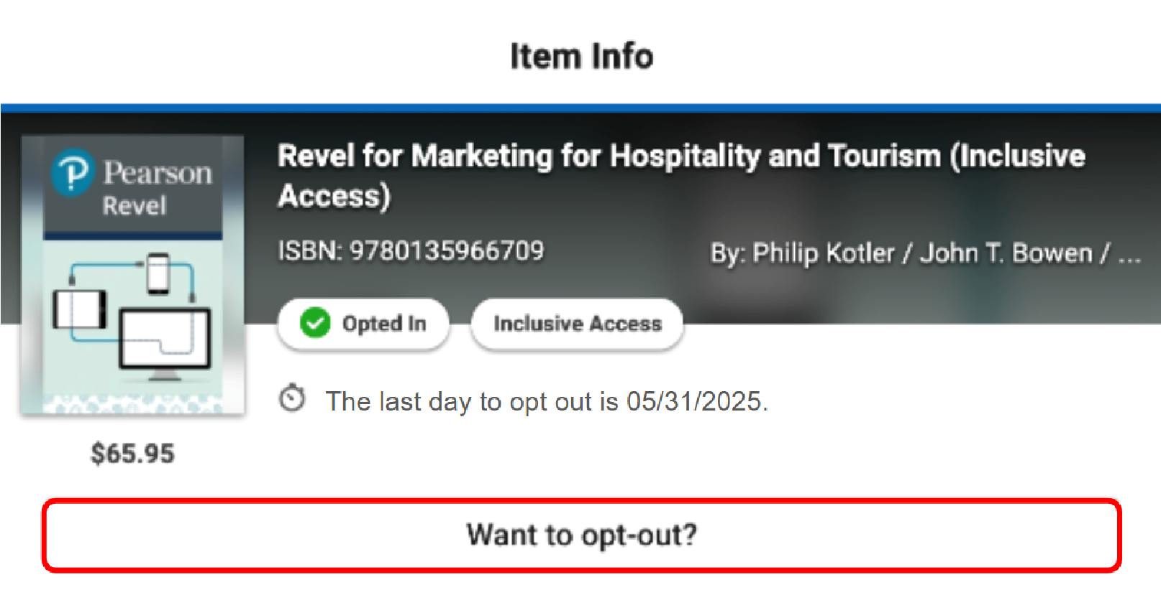
If you are unable to locate the “Want to opt-out?” option, please email iasupport@ecampus.com and include your course information.

Please note that if you opt out of the IA program, you will no longer have access to the required course materials through the Brightspace link. You will be expected to purchase materials elsewhere.

