
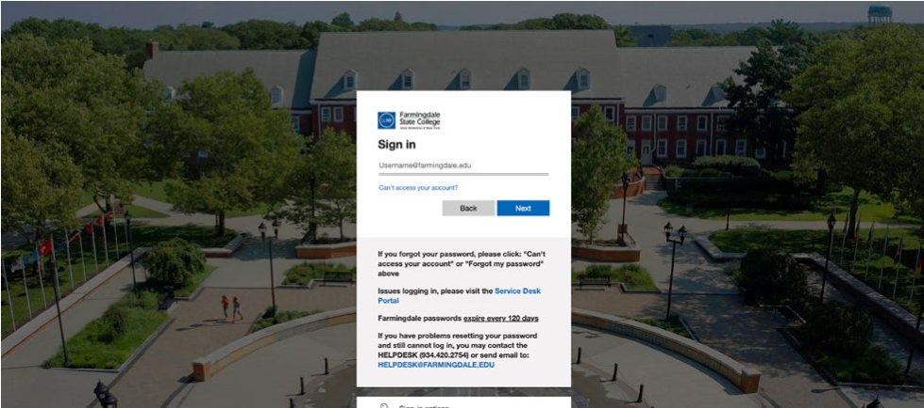
Visit fast.ecampus.com/school/farmingdale. Sign in to FAST by entering your Farmingdale State College credentials. 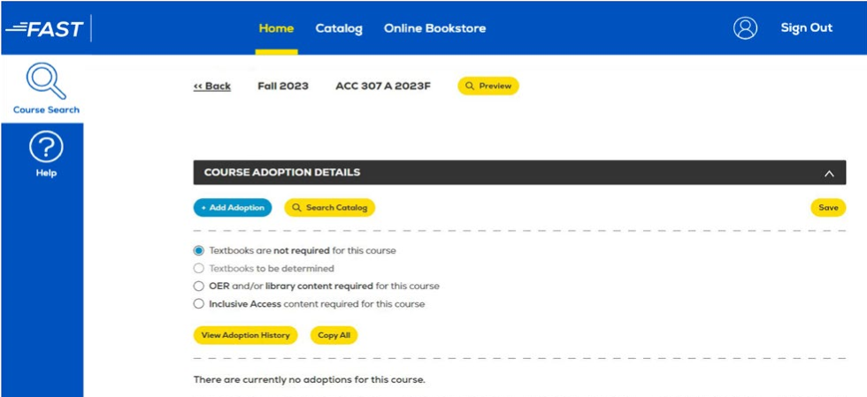 4
1
2
3
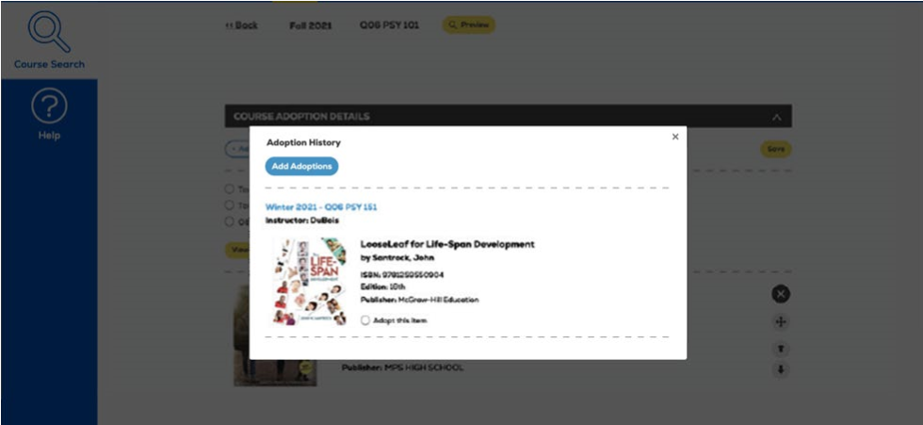
To add an adoption, select the Add Adoptions button below Course Adoption Details. If there are no course materials required, select the box next to Textbooks are not required for this course and select Save.
5
How to Submit
Course Materials
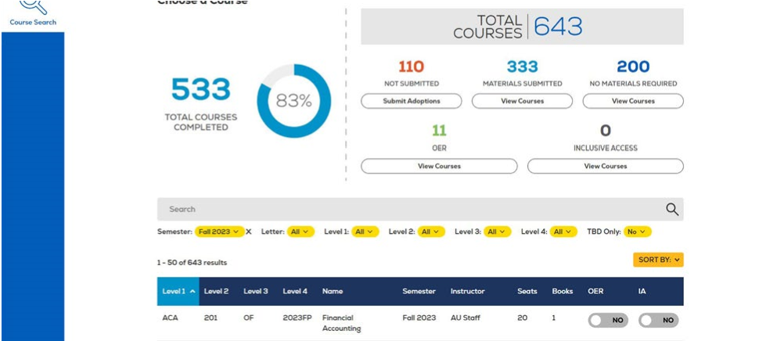
Upon signing in, your course list should automatically appear. Choose the course you wish to edit. You may also use the search bar to locate a specific course or change the semester by selecting the filters underneath it.
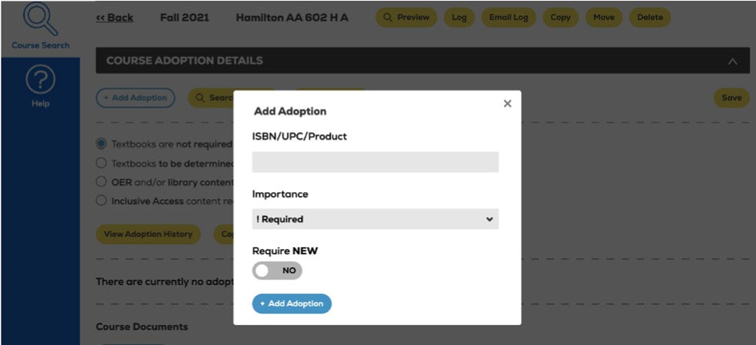
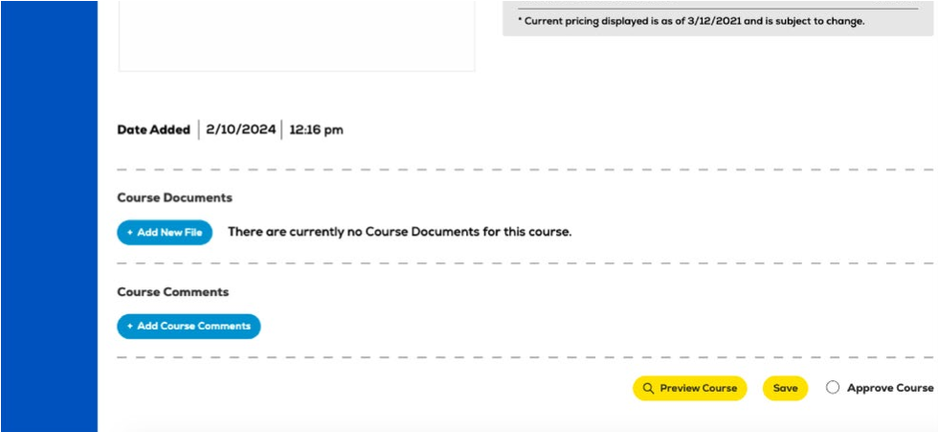
Enter the ISBN into the ISBN/UPC/Product field and choose the Importance level. If the item you are adding should only be purchased in new condition, toggle the Require New button to YES and select Add Adoption.
6

You may view past adoptions by selecting the View Adoption History button. To add a previously used adoption, select the button next to Adopt this item and select Add Adoptions at the top. Once a text is added, you may add a Book Comment, re-sort, and delete items as needed. You may also utilize the Copy All feature to add the adoption(s) across multiple courses that require the same material(s).
Any time a change is made to a course, select Save. To view how the course will appear to students on the Online Bookstore, select the Preview Course button.

Selecting Required New will only allow students to purchase the item in new condition. All other purchasing options will be hidden if Required New is selected. If books are added after the deadline, a course will automatically be marked as “Textbooks to be determined” for 24-48 hours. This allows the Online Bookstore Team enough time to confirm publisher availability.
Questions? farmingdale@ecampus.com

