Time and Attendance System
Classified Employee

Sign On:
Employees will sign into the Time and Attendance System (TAS) using the link below and enter their existing user id and password.
- https://www.suny.edu/time
.
TAS Home Page:
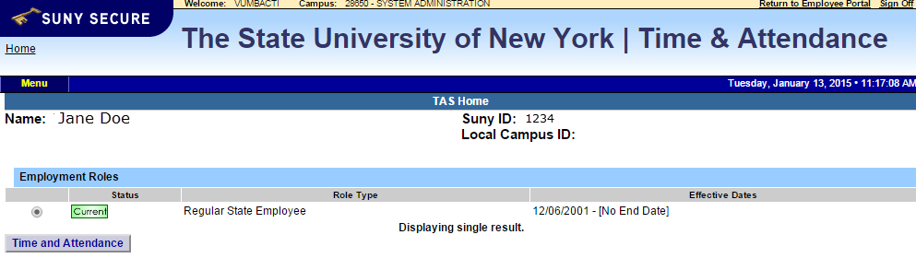
- Select Current Employment Role (shown above). If you only have one role, the radio button will be defaulted to the current role.
- Click on Time and Attendance button to work on your Time Record or Time off Request.

Time Off Request:
Time off Request function allows employees to request time off from their supervisor. To complete a Request Time Off:
- Select Request Time Off from the menu bar located at the top of the screen (shown below).
- Double click on the day you wish to request and/or update on the calendar.
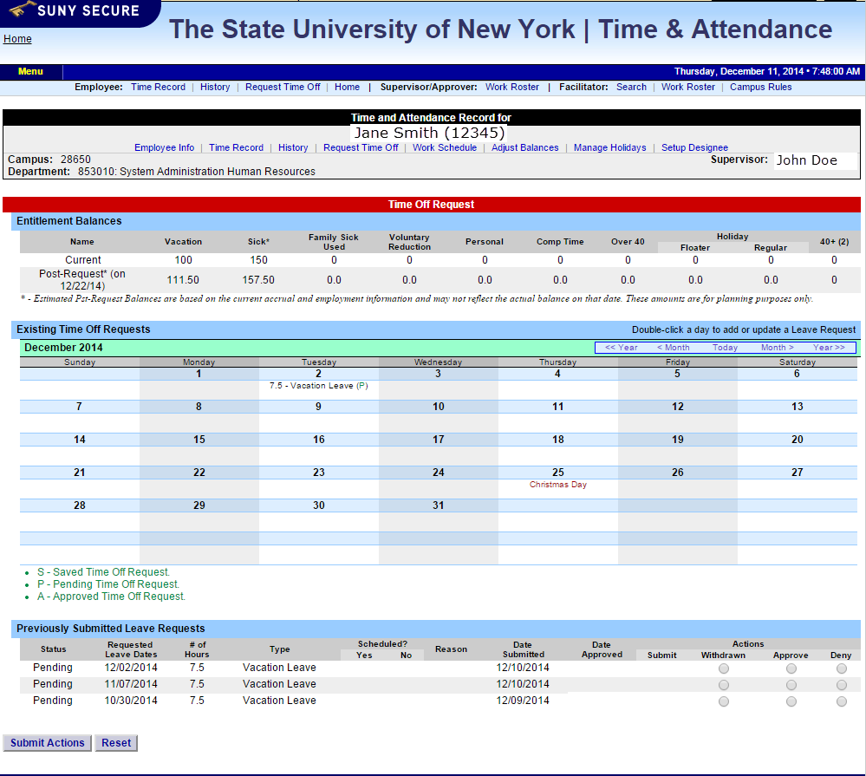

- A separate pop up box will open (shown below) to enter a single day time off request. The from date will be automatically populated from the date that was slected from the calendar on.
- Enter appropriate number of hours (increments of quarter hours) in accrual category you wish to charge.
- To submit multi day requests, click on Show Multi-day button on the upper right hand corner of the pop up box. The FROM DATE field will be populated from the date you selected from the calendar. A TO DATE field will now be available to enter a date range. Enter number of consecutive days and select the accrual/leave type from the drop down.
- For Non-Chargeable time, enter appropriate number of days (increments of .25 hours) and select the non-chargeable type from the drop down selection.
- Click on Save if you wish to save your request and not submit to your supervisor at this time. Or Save and Submit, Save your request and submit to your supervisor for action (approve or deny).
- The day/s requested will now appear on your time off request calendar and listed below under Previously Submitted Leave Requests.

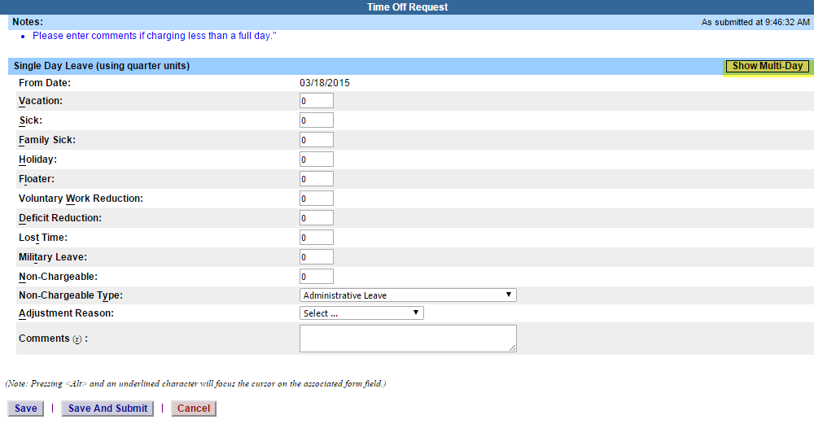
To submit your request to your supervisor, clicks on the radio button next to the appropriate time off request then click SUBMIT to supervisor.

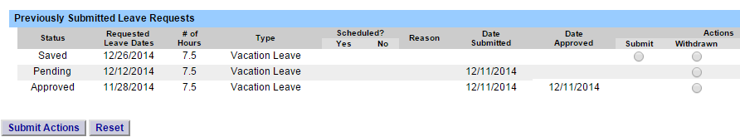

- Saved – time off request has been saved, not yet submitted to supervisor.
- Pending – submitted to supervisor pending approval.
- Approved – time off request has been approved by the supervisor.

Notes:
- Time off Request is required.
- Pending time off request will automatically appear on appropriate time record.
- If you need to change a time off request and it has not been approved by your supervisor, go back into your Time off Request calendar to update.
- Employees are able to submit a time record that has pending time off request.

To Complete Time and Attendance Record:
- Select the Accrual Period (pay period) from the drop down menu that you wish to enter and then click the change period button (shown below).
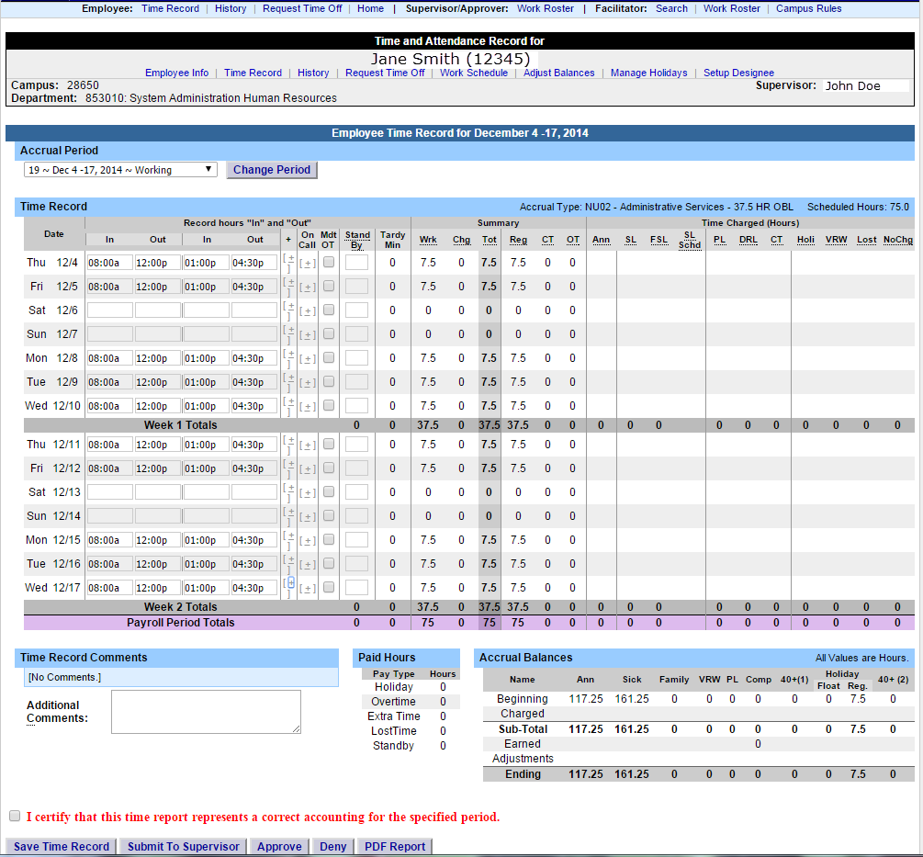

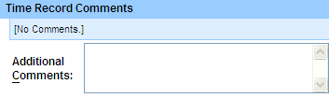

- Time Record Comments (shown above) – available if employee would like to submit comments attached to the time record for their supervisor.

- Once time record is complete, check the box to certify that the information entered is accurate before submitting to supervisor (shown above).
- If time record is complete and you wish to send it to your supervisor, click on Submit to Supervisor. If time record is not complete, click Save which will allow you to go back into your time record to add or update before submitting to supervisor.
- If you do not wish to save or submit your time record simply click Cancel/Return to Home.
Notes:
- If a Time Record is disapproved by the supervisor, the time record will show back in the Accrual Period drop down in work status. You will then be able to make any changes as appropriate and resubmit to your supervisor.
- View Holiday – list of employee’s holidays/floaters that have been accrued along with expiration date.
- PDF Report – allows employees ability to print time record.
- Existing Time Off Request – lists any existing time off request the employee has pending approval from supervisor. Employee will be unable to submit
- Audit Details – keeps an audit of add/updates or denials to time record.
- Message Board – automatic messages to employee making them aware of overdue time records, expiring holidays, and approaching max limit by year end, etc.

History:
- Shows a 12 month Employee history of all accrual balances.

